Construction of Bridge Finished Bridge
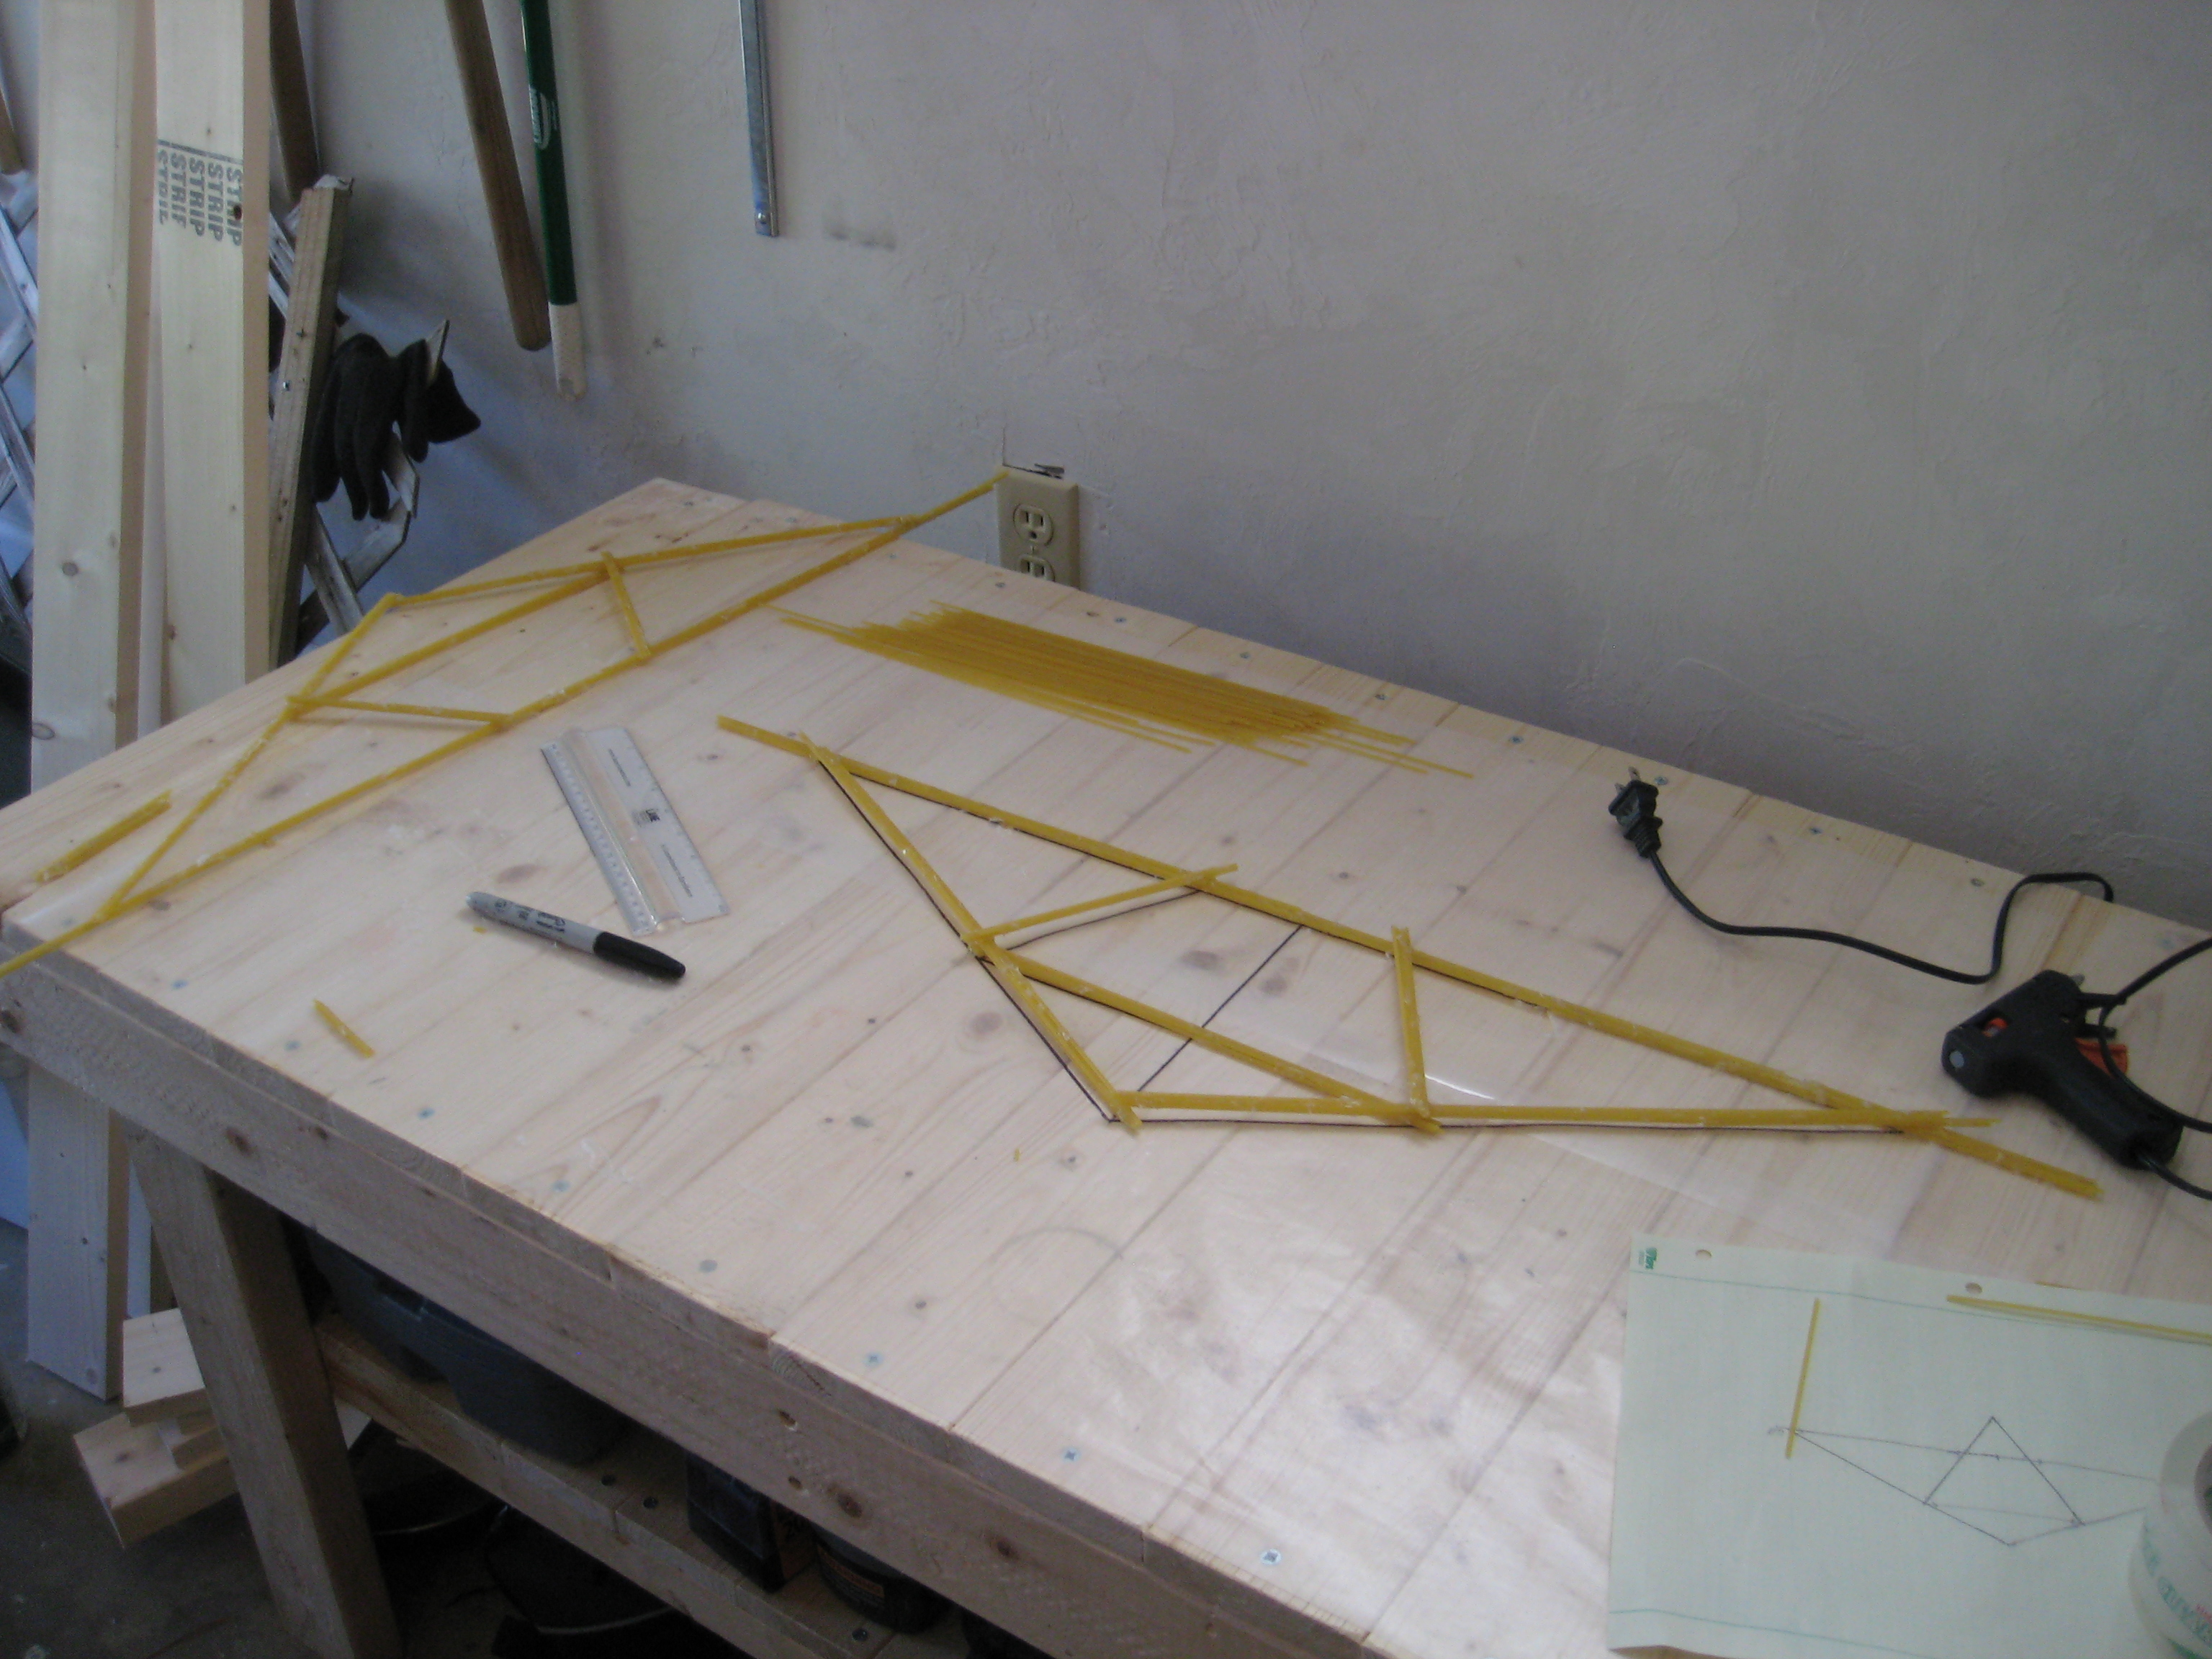  After deciding on a design, we drew an outline on wax paper to place the spaghetti in the correct position. Then we glued the spaghetti together with a hot glue gun. | 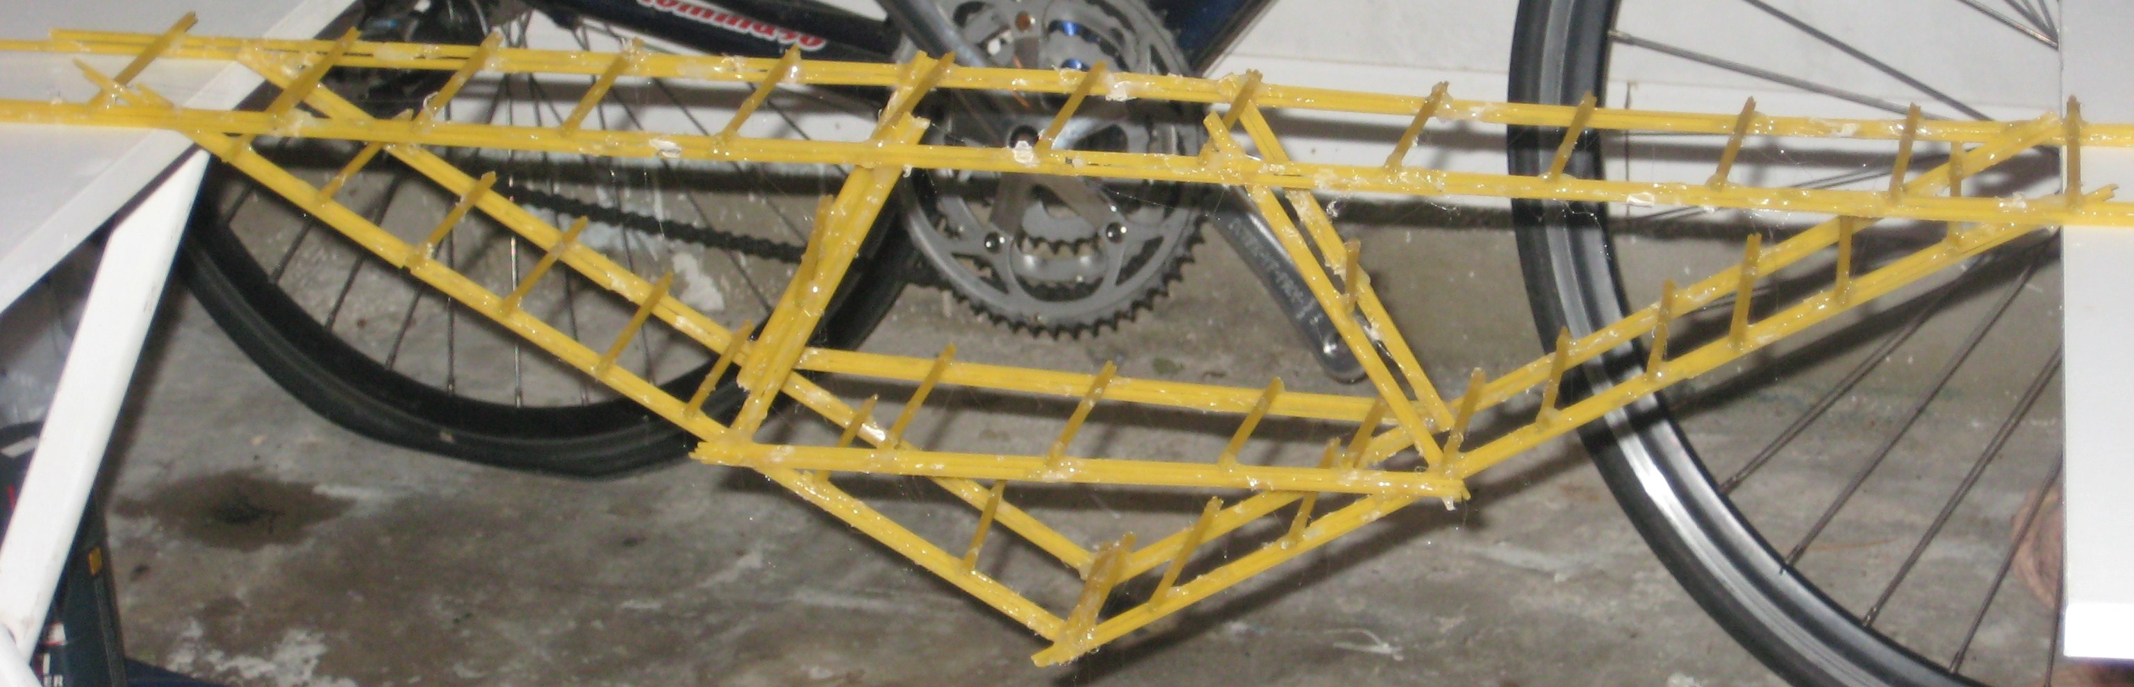  The finished bridge dimensions are two feet long starting at the triangle, 7 in high, and 2.5 in wide.

Construction Crew
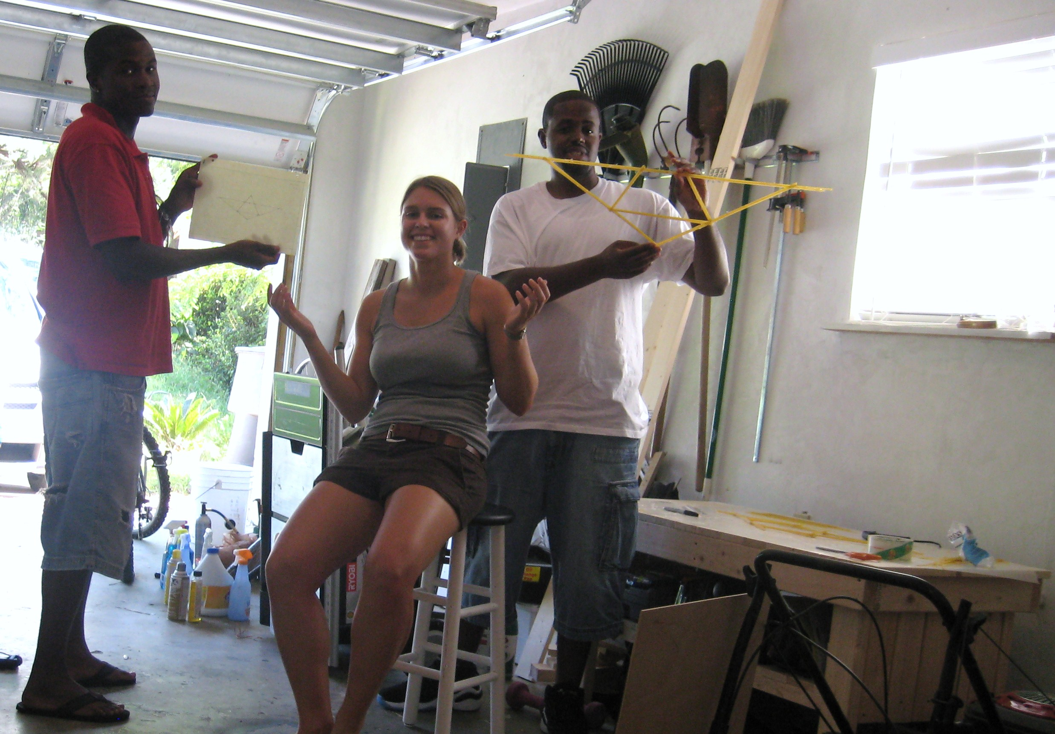 Created on September 8, 2008
On the left holding the design is Todd Ruff, in the center is Alicia Christie,
and Desmond Bourgeois is on the right holding part of the spaghetti bridge.

