Project Scope

Problem Statement

Navigate through the obstacle course and transport rocks to a specific area in a timely manner.

Justification/Background

- Who will be served?
  - Future company applications- Based on the Phoenix Mars Lander’s success in collecting soil sample we are hoping the tasks of our robot can be implemented in robots for future space missions.
  - The team- Learning about robotics, team work, time management and organization for a product based design project.
- Where the product will be used?
  - Used for a competition in a regulation obstacle course with three barriers of 2x4’s or 4x4’s, taped off boundary and typical flooring.
- Existing Solution

Robotic Arm built by the Jet Propulsion Laboratory (California Institute of Technology), Alliance Space-systems and Honeybee Robotics lead by Dr. Robert Bonitz

The arm was built for the Phoenix Lander to dig trenches, scoop up sand and water ice samples and deliver the samples to instruments for analysis. It operates with four degrees of freedom with an elbow joint in the middle: (1) up and down, (2) side to side, (3) back and forth, and (4) rotate around.
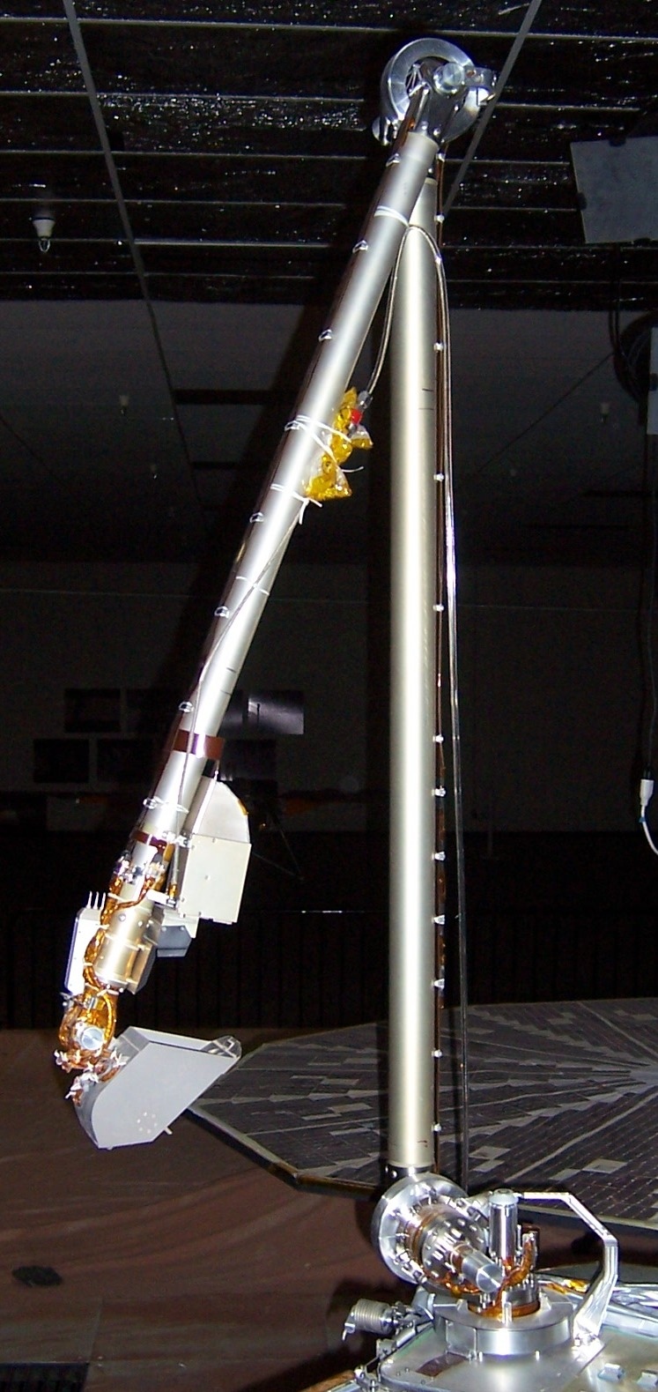
Phoenix Mars Lander Robotic Arm
http://phoenix.lpl.arizona.edu/science_ra.php

Society of Robots – Robot Arm Tutorial

This site discusses robot arms with different degrees of freedom and how to calculate the forces on the joints to determine what kind of motor to use. Pictured below are a few designs from the website. http://www.societyofrobots.com/robot_arm_tutorial.shtml

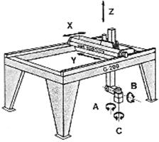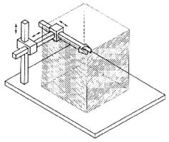
Cartesian Gantry Robot Arm

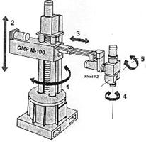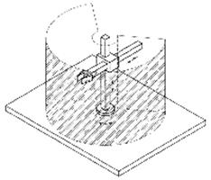
Cylindrical Robot Arm
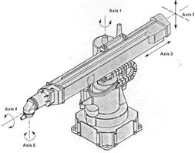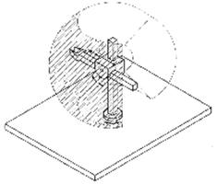

Spherical Robot Arm

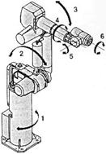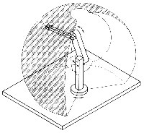
Articulated Robot Arm

Drive Train Options

TANK DRIVE

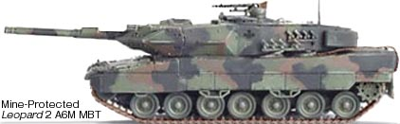

ACKERMAN STEER

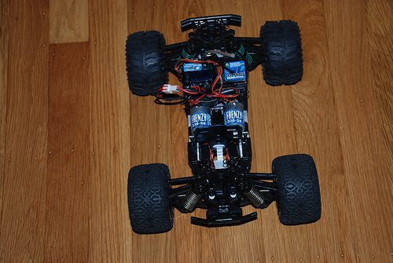

TANK DRIVE HYBRID

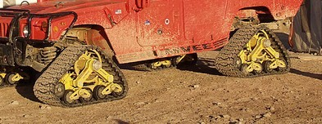

3 WHEEL CONFIGURATION (COMMON ROVER DESIGN)

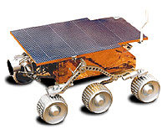

Assembled Robots Today

PackBot is a series of robots by iRobot. PackBot EOD (Explosive ordnance disposal) can be controlled by radio or wired control to handle situations involving potential explosives, thereby reducing the risk of personal injury. The Packbot scout is the basic configuration. It has five payload bays for assignable purposes and can be dropped from a height of six feet (1.83m) onto concrete without causing self-inflicted damage. The Packbot scout version weighs in at about 40 pounds (18kg). PackBot explorer has a camera head equipped with multiple cameras, laser pointers, audio and other sensors. More than 1500 PackBots are currently on station in Iraq and Afghanistan, (which is low to the total amount of Robots in Iraq) with hundreds more on the way.

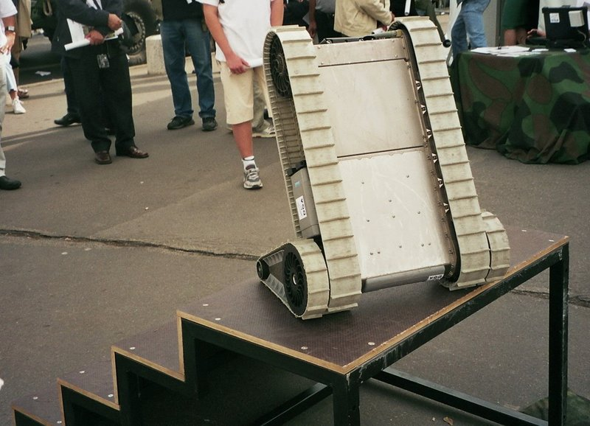
Packbot climbing up stairs
http://en.wikipedia.org/wiki/PackBot

NASA's Mars Exploration Rover (MER) Mission is an ongoing robotic mission of exploring Mars, which began in 2003 with the sending of two rovers — Spirit and Opportunity — to explore the Martian surface and geology.

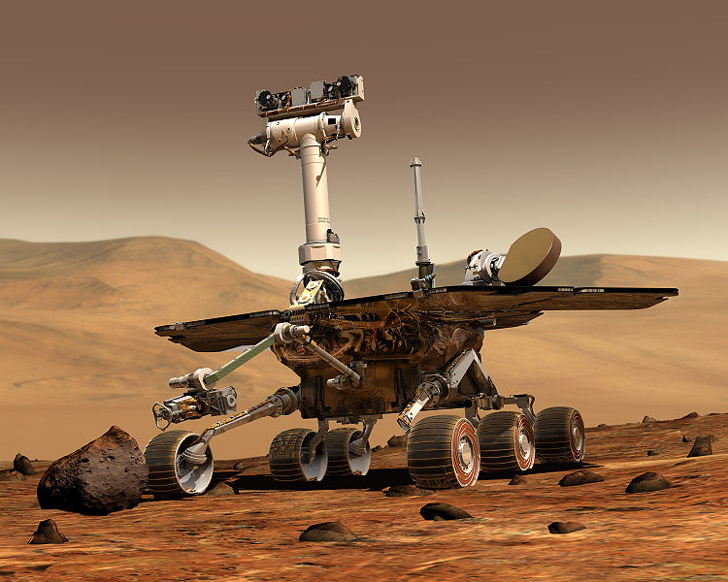
Mars Exploration Rover
http://en.wikipedia.org/wiki/Image:NASA_Mars_Rover.jpg
ASIMO (アシモ, ashimo?) is a humanoid robot created by Honda Motor Company. Standing at 130 centimeters (4 feet 3 inches) and weighing 54 kilograms (119 pounds). The robot resembles a small astronaut wearing a backpack and can walk or run on two feet at speeds up to 6 km/h (4.3 mph)[1]. ASIMO was created at Honda's Research & Development Wako Fundamental Technical Research Center in Japan. It is the current model in a line of eleven that began in 1986 with E0.

Officially, the name is an acronym for "Advanced Step in Innovative MObility". Honda's official statements [2] indicate that the robot's name is not a reference to science fiction writer and inventor of the Three Laws of Robotics, Isaac Asimov.

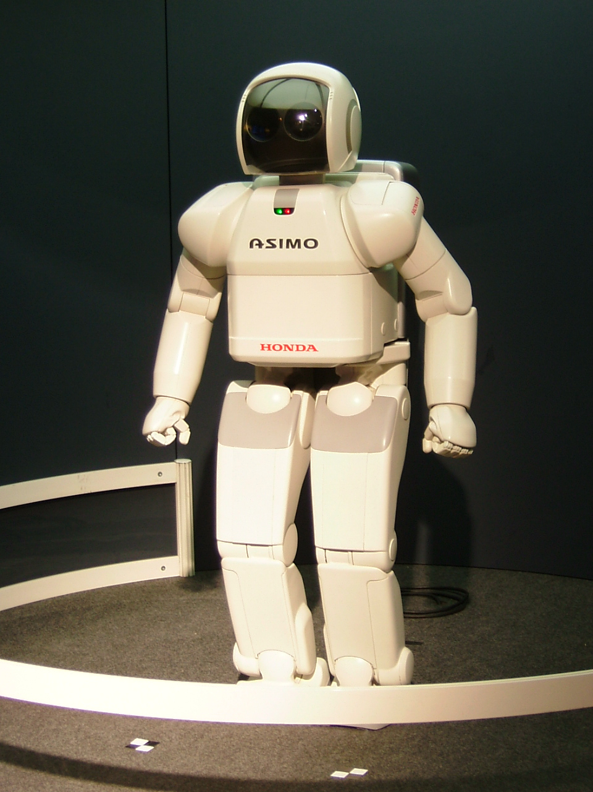
Asimo
http://en.wikipedia.org/wiki/ASIMO

Objective

Design a robot operated by a controller. It needs to be able to maneuver the robot through a course and climb over barriers (two joined 2x4’s or a 4x4) to collect rocks of increasing value as the robot moves further away from the parking area within four minutes maximum by April 2009.

Methodology

The method that we chose is the Quality Function Deployment process. Within this process is the House of Quality matrix. This methodology was chosen due to the fact that it is widely accepted on engineering projects large and small. This method was established in Japan in the late 1960’s and has been known to save up to one-third-production cost and up to sixty percent from concept to production. Through steps ranging from customer needs up to the assembly process. This semester will mainly focus on the first two phases of this decision making process.

The House of Quality

Steps to the House of Quality

Step-1.

Customer Requirements - "Voice of the Customer"
The first step in a QFD project is to determine what market segments will be analyzed during the process and to identify who the customers are. The team then gathers information from customers on the requirements they have for the product or service. In order to organize and evaluate this data, the team uses simple quality tools like Affinity Diagrams or Tree Diagrams.

Step-2.

Regulatory Requirements
Not all product or service requirements are known to the customer, so the team must document requirements that are dictated by management or regulatory standards that the product must adhere to.

Step-3.

Customer Importance Ratings
On a scale from 1 - 5, customers then rate the importance of each requirement. This number will be used later in the relationship matrix.

Step-4.

Customer Rating of the Competition
Understanding how customers rate the competition can be a tremendous competitive advantage. In this step of the QFD process, it is also a good idea to ask customers how your product or service rates in relation to the competition. There is remodeling that can take place in this part of the House of Quality. Additional rooms that identify sales opportunities, goals for continuous improvement, customer complaints, etc., can be added.

Step-5.

Technical Descriptors - "Voice of the Engineer"
The technical descriptors are attributes about the product or service that can be measured and benchmarked against the competition. Technical descriptors may exist that your organization is already using to determine product specification, however new measurements can be created to ensure that your product is meeting customer needs.

Step-6.

Direction of Improvement
As the team defines the technical descriptors, a determination must be made as to the direction of movement for each descriptor.

Step-7.

Relationship Matrix
The relationship matrix is where the team determines the relationship between customer needs and the company's ability to meet those needs. The team asks the question, "if I control this technical descriptor, will it have a positive impact on the customer's need?" Relationships can either be weak, moderate, or strong and carry a numeric value of 1, 3 or 9.

Step-8.

Technical Analysis of Competitor Products
To better understand the competition, engineering then conducts a comparison of competitor technical descriptors. This process involves reverse engineering competitor products to determine specific values for competitor technical descriptors.

Step-9.

Target Values for Technical Descriptors
At this stage in the process, the QFD team begins to establish target values for each technical descriptor. Target values represent "how much" for the technical descriptors.

Step-10.

Correlation Matrix
This room in the matrix is where the term House of Quality comes from because it makes the matrix look like a house with a roof. The correlation matrix is probably the least used room in the House of Quality; however, this room is a big help to the design engineers in the next phase of a comprehensive QFD project. Team members must examine how each of the technical descriptors impact each other. The team should document strong negative relationships between technical descriptors and work to eliminate physical contradictions.

Step-11.

Absolute Importance
Finally, the team calculates the absolute importance for each technical descriptor. This numerical calculation is the product of the cell value and the customer importance rating. Numbers are then added up in their respective columns to determine the importance for each technical descriptor. Now you know which technical aspects of your product matters the most to your customer!

Copyright ©, Becker Associates Incorporated, 1994-2008.
http://www.becker-associates.com/house_of_quality.HTM

Expected Results

Perform all tasks in as quickly as possible to optimize our score.
Constraints

Class Constraints

- Budget - $1500
- Time
  - Design Selection – End of November
    - Drawings
    - Components
    - Materials
  - Finished product – April
    - Course Testing
    - Working robot

Competition Constraints
- Time – 4 minutes maximum
- Weight – Counts against our total points for every gram
- Size – Must fit in parking area
- Accuracy – Keep rocks in circles and stay within lines, make sure no part of robot is over the parking area when parked

