Method for Concept Generation
The success of the Phoenix Mars Lander led to NASA wanting to send a remote control vehicle to Mars that can be operated from a space ship or earth. The main objective of the vehicle is to collect rocks in order to determine if life has ever existed on Mars. To do this the vehicle must also be able to surmount small obstacles. So our objective for the design competition is to build a robotic vehicle which can accomplish similar tasks. We also need to be able to drop the rocks off in a certain area with a high degree of accuracy. So for success in the competition we need to maximize our score by using the following equation given to us in the competition rules (Eq. A). The test course can be seen in Fig. 1.

S = Σ (R*t) +1000P - W - A - 1000T – 5s (Eq. A)
Where,
R = designated rock score- rocks further from receiving area are worth more
t = target multiplier in the receiving area- center of drop off area is worth 2x rock value, next concentric circle is worth 1.5x, and within biggest is worth 1x
W = Weight of the vehicle in grams
A = milliamp-hours available to the device according to the battery labels
T = Times device touches border tape
s = seconds to complete task, maximum 240
P = bonus for parking vehicle at end of task (1 = parked, 0 = not parked)

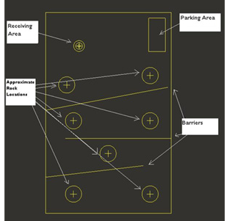
Fig. 1- Schematic of Test Course

The design competition is broken down into three sub-problems, which can be seen in the flow chart below. Since this is a design competition, all of the sub-problems are equally important. If we can not get our robot over the wall, then we can not collect the rocks over the first barrier to get a high enough score to offset the weight of our robot and the power it uses. If we can not handle the rocks, then we do not get any points. Finally, if we can not place our rocks in the receiving area, then we do not get any points.

R/C Vehicle for ASME Design Competition
Collection and Transportation
Maneuver over obstacles swiftly

Dropping off rocks in receiving area
Sub Problems _ _

External Solution Search
During our external solution search we searched a variety of sources for possible solutions to our sub problems. Below are the top existing robots that were looked to for inspiration with a brief description. The following images are print screen images of the robots in motion taken off of youtube.

Getting over the Barrier
Stair Climbing Robot - Mechatronics, Ariel University Center- This existing robot uses a locking 3 wheel configuration to navigate steps.
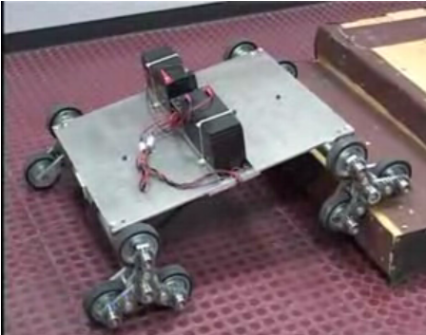

Zaurus- This robot incorporates a combination of a walking leg robot and a traditional wheeled robot to move up steps.
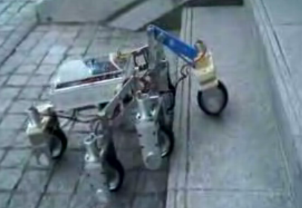

Spiral Stair Climber - Mechatronics, Ariel University Center- This robot uses a cork screw configuration of wheel that rotate a bout a common axis to climb stairs
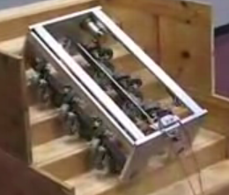

Packbot- This robot employs 2 sets of tank treads with one set that rotates 360 degrees to pull the robot up and over steps.
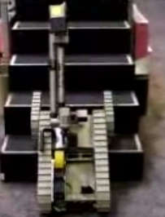
Rock Collection, Handling, and Transportation
Front-end Loader- The bucket collects and stores the rocks and then is able to rotate so that the rocks do not fall out when transporting them to the receiving area. The bucket will also have a lip on the edge so that rocks are able to go into the bucket and not fall out when collecting additional rocks.

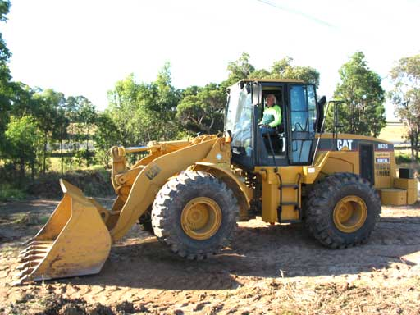

Phoenix Mars Lander Robotic Arm- The arm was built for the Phoenix Lander to dig trenches, scoop up sand and water ice samples and deliver the samples to instruments for analysis. It operates with four degrees of freedom with an elbow joint in the middle: (1) up and down, (2) side to side, (3) back and forth, and (4) rotate around.

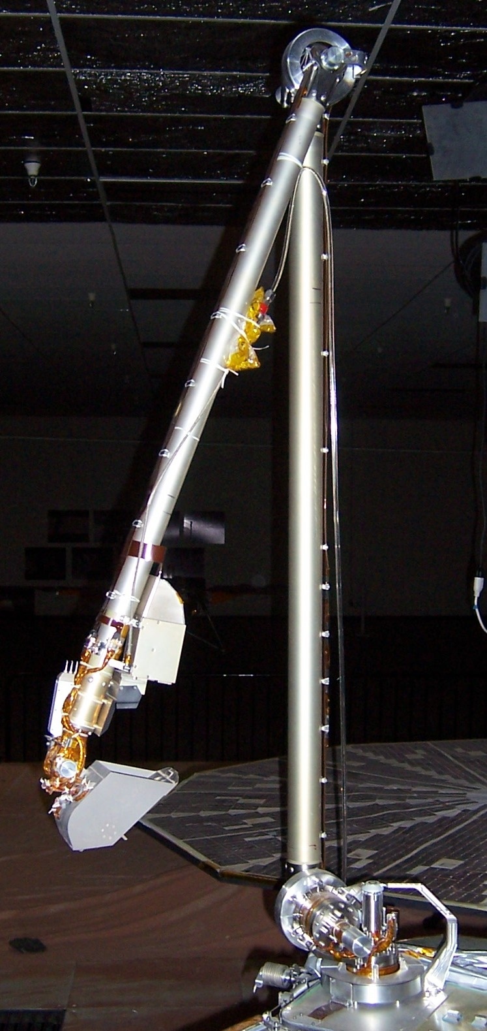

Internal Solution Search

Through the process of brainstorming we generated the following sketches to satisfy our sub-problem of the overall competition. Below are rough sketches and brief descriptions of each internal solution.

Getting Over the Barrier

Ramp Carrying Robot – R/C car that places ramp over obstacle and is left behind on course.
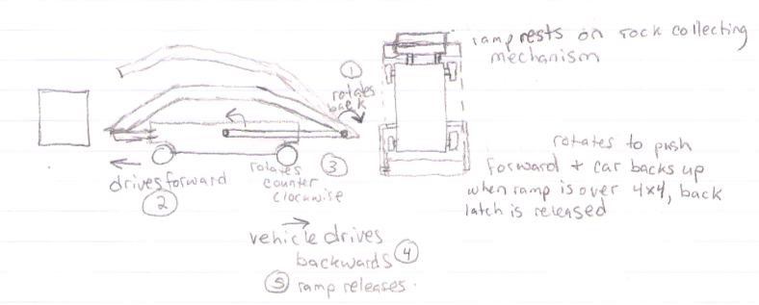

Three Wheel Climbing Robot – The three wheels in a triangular configuration that rotate independently (depicted in figure); this configuration can lock all three wheels and rotate about the middle axle thus allowing a climbing action.
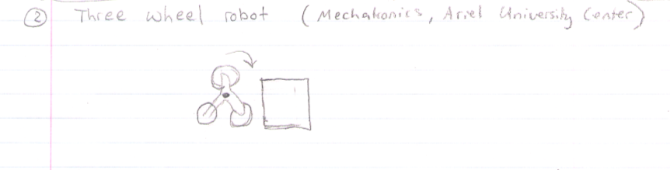

Tank Drive – Operates in the manner of traditional tank drive, placing an emphasis on the tank treads to navigate over obstacles.

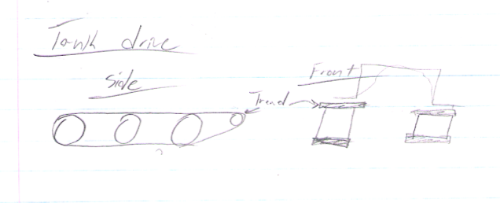

Individual Tank Treads – utilize treads in the same fashion as the traditional tank drive. However, this set up has the ability to steer with its front treads.
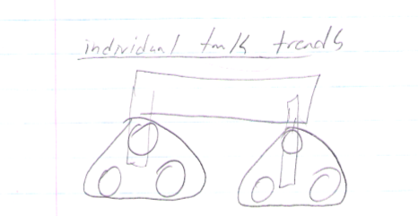

Rock Collection, Handling, and Transportation

Chassis Drop Down (Internal Storage) – Chassis lowers to scope rocks.
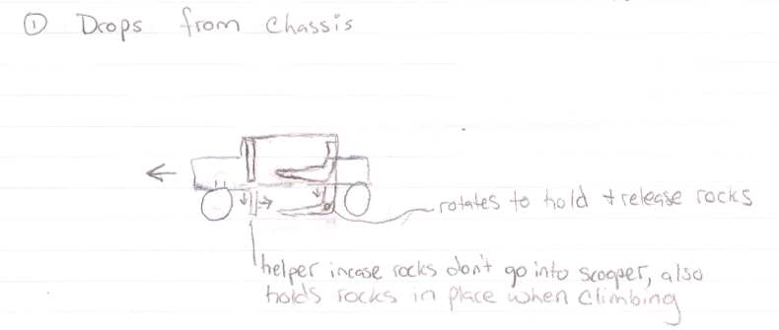

Robotic Arm – Arm operates in the manner any robotic arm with one motor for every degree of desired motion.
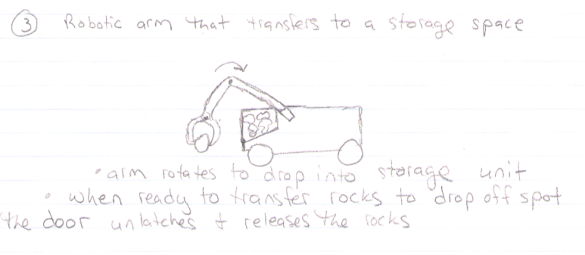

Trap Door – Double panels release from rock collecting module.

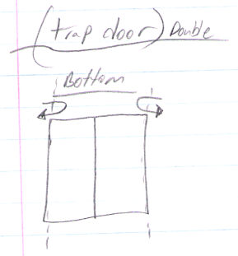

Single Door – Operates in the same manner as double door, but single door slides to dump rocks.
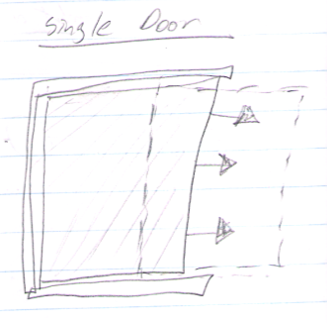

Dump Truck Style – Operates in traditional dump truck hopper fashion.
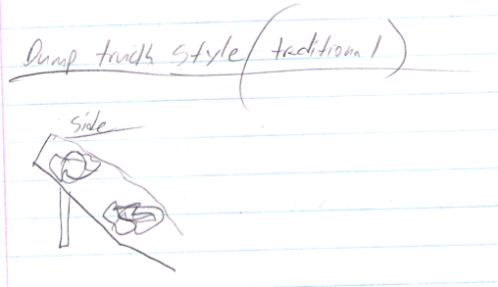

Street Sweeper – This method utilizes brushes to propel rocks into collection area inside robot.

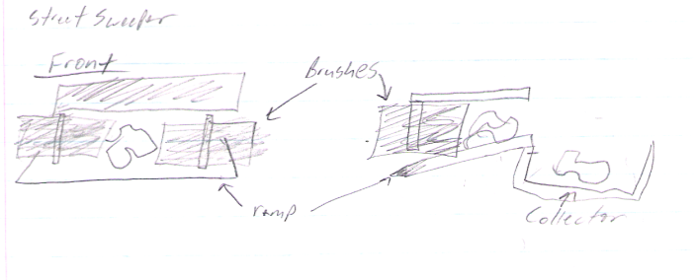

Air Jet – Functions in the same way as street sweeper, but employs the use of air jets to collect rocks and store in the robot.
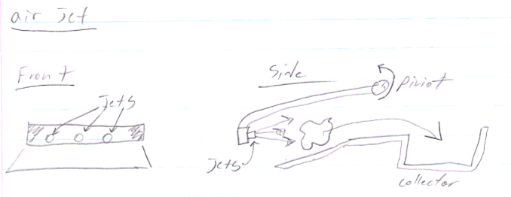

Decision Matrix
We decided to make three decision matrices for important tasks we need to accomplish during the competition. The tasks are how to get over the wooden barrier, handling and transporting the rocks, and movement of the vehicle. We came up with several ideas after doing research and threw a couple out based on difficulty to design and manufacture and a general consensus of the group. The following tables are what we decided on, and we were able to make a selection for our design based on the top choices from each matrix.

The weight for each criteria was determined by deciding how important each criteria is in relation to the others. For example, in the matrix for getting over the barrier cost was the least important, weight, power consumed, accuracy in performing task, and time to get over the barrier were all the most important because they contributed to the score, and the rest fell in the middle. So, we gave cost a 1, the most important criteria a 3, and the rest a 2. Then the sum of the values was found to be 17, so each value was divided by 17 to get a weight. If the concepts were all relatively equal for the different criterion then a rating of 3 was given, if the concept stood out in a certain category as being exceptionally good it was given a 9, and bad a 1. The rating was then multiplied by the weight and a sum for each concept was found and compared.

Getting Over the Barrier
 |  | Concepts
 |  | Ramp |  | 3 Wheels |  | Expandable Legs |  | Front Spiral |  | Packbot
Criteria | Weight | Ratings | Score | Ratings | Score | Ratings | Score | Ratings | Score | Ratings | Score
cost | 0.0588 | 3 | 0.176 | 3 | 0.176 | 1 | 0.059 | 3 | 0.176 | 1 | 0.059
weight | 0.1765 | 3 | 0.529 | 3 | 0.529 | 3 | 0.529 | 3 | 0.529 | 1 | 0.176
power consumed | 0.1765 | 3 | 0.529 | 3 | 0.529 | 1 | 0.176 | 3 | 0.529 | 3 | 0.529
ease of manufacturing | 0.1176 | 9 | 1.059 | 1 | 0.118 | 3 | 0.353 | 3 | 0.353 | 1 | 0.118
ease of control | 0.1176 | 1 | 0.118 | 3 | 0.353 | 1 | 0.118 | 1 | 0.118 | 3 | 0.353
accuracy in performing task | 0.1765 | 3 | 0.529 | 9 | 1.588 | 3 | 0.529 | 3 | 0.529 | 9 | 1.588
Time to get over barrier | 0.1765 | 3 | 0.529 | 9 | 1.588 | 3 | 0.529 | 3 | 0.529 | 9 | 1.588
Total | 1 |  | 3.471 |  | 4.882 |  | 2.294 |  | 2.765 |  | 4.412

Handling and Transporting the Rocks
 |  | Concepts
 |  | Internal Storage |  | Front End Loader |  | Street Sweeper |  | Robotic Arm
Criteria | Weight | Ratings | Score | Ratings | Score | Ratings | Score | Ratings | Score
cost | 0.0435 | 3 | 0.130 | 3 | 0.130 | 3 | 0.130 | 1 | 0.043
weight | 0.1304 | 3 | 0.391 | 3 | 0.391 | 3 | 0.391 | 3 | 0.391
power consumed | 0.1304 | 3 | 0.391 | 3 | 0.391 | 3 | 0.391 | 1 | 0.130
ease of manufacturing | 0.087 | 1 | 0.087 | 3 | 0.261 | 3 | 0.261 | 1 | 0.087
ease of control | 0.087 | 3 | 0.261 | 3 | 0.261 | 3 | 0.261 | 1 | 0.087
accuracy in performing task | 0.1304 | 3 | 0.391 | 3 | 0.391 | 3 | 0.391 | 3 | 0.391
storage of rocks | 0.1304 | 3 | 0.391 | 3 | 0.391 | 3 | 0.391 | 3 | 0.391
transporting to receiving area | 0.1304 | 1 | 0.130 | 3 | 0.391 | 3 | 0.391 | 9 | 1.174
time in handling rock | 0.1304 | 3 | 0.391 | 3 | 0.391 | 9 | 1.174 | 1 | 0.130
Total | 1 |  | 2.565 |  | 3 |  | 3.783 |  | 2.826

 |  | Concepts
 |  | Wheels |  | Tracks |  | Legs
Criteria | Weight | Ratings | Score | Ratings | Score | Ratings | Score
cost | 0.0588 | 9 | 0.529 | 3 | 0.176 | 1 | 0.059
weight | 0.1765 | 3 | 0.529 | 3 | 0.529 | 3 | 0.529
power consumed | 0.1765 | 3 | 0.529 | 3 | 0.529 | 1 | 0.176
ease of manufacturing | 0.1176 | 9 | 1.059 | 3 | 0.353 | 1 | 0.118
ease of control | 0.1176 | 3 | 0.353 | 1 | 0.118 | 1 | 0.118
accuracy in performing task | 0.1765 | 9 | 1.588 | 3 | 0.529 | 1 | 0.176
efficiency of movement | 0.1765 | 9 | 1.588 | 3 | 0.529 | 1 | 0.176
Total | 1 |  | 6.176 |  | 2.765 |  | 1.353

Moving the Robot

Rankings
 | Getting Over the Barrier | Handling the Rocks | Moving the Robot
Rank
1 | 3 Wheels | Street Sweeper | Wheels
2 | Packbot | Front End Loader | Tracks
3 | Ramp | Robotic Arm | Legs
4 | Front Spiral | Internal Storage
5 | Expandable Legs

Selection
Based on the results of the decision matrix, we arrived at the concept selection of using a three wheel configuration on each side of the front and back axel, based on the idea of the stair climbing robot pictured above, with some sort of street sweeper to collect the rocks. It is obvious that wheels would be our choice for moving the robot in a three wheeled design, but it is good that it worked out with our decision matrix. We have already thought of an idea to incorporate the two concepts into a single design, so the combination will work (Design Combination 1).

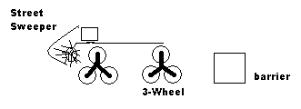
Design Combination 1

