

Automated Medication Dispensing
System for Prisoners:

Operation Manual


Senior Design Group 4:
Zachary Collier
Brandon Vogt
Chad Freeland
Chris Underhill
Table of Contents

Introduction……………………………………………….3

General Safety Guidelines………………………………...4

Operating Instructions…………………………………….5

Maintenance………………………………………………6

Support……………………………………………………9

Introduction

Thank you for purchasing Avocare’s Automated Medication Dispensing System for Prisoners. This unique system is equipped to store, retrieve, and deliver medications, pill by pill, to the user in as short of a time as possible. By purchasing and using our product in your prison facility, the speed that inmates receive their medications is increased, the man hours put in by nurses is reduced, and the accuracy of the medications being delivered to the inmates is increased.
Working in a prison, three major parameters must be maximized for any day to day operation – Accuracy, Speed, and Security. The internal inventory database and multiple safeguards within the system provide for the accurate retrieval of the desired medication. Speed is achieved because the whole process, from user input to pill delivery, takes from 30 – 90 seconds, depending on the number of pills needing to be extracted. The whole system is locked and very hard to break into, giving you the peace of mind knowing that the medications are secure inside.

With the Automated Medication Dispensing System for Prisoners, your operations will become more streamlined, your nurses will have to work less hours, and your inmates will receive the quality healthcare they need.

General Safety Guidelines
 Caution: The following safety guidelines should be followed at all times to avoid personal injury or damage to the apparatus.
- Do not stick your hands or any portion of your body into any part of the Automated Medication Dispensing System (hereafter “machine”), especially while it is operating.
- Avoid spilling liquids on the user input station, including keyboard.
- Keep magnets away from any electronic portion of the machine as this could cause damage.
- Do not store the machine in environments that experience extreme hot or cold temperatures. Keep away from open flame.
- If equipped to a cart, do not push up or down steep grades
- Do not attemt to “rock” or “shake” the machine. This may cause tipping and bodilly injury
- Do not bang on, attempt to pry, dissasemble, or in any other way try to tamper with or modify the machine in any way, shape, or form.
- As with any electrical device, it is suggested that it be plugged into a surge protector, fuse box, or some other similar protective safeguard to protect internal components from a damaging surge
- Wait until the medication for one prisoner is dispensed and the internal operations have ceased before starting the process of entering information about the next prisoner.
- Use this produt for its intended purposes only.
- In case of a malfunction, discontinue use immediately and contact help. Further information can be found in the Support section of this manual.
- Breif all users and operators on the safety precautions laid out herein to ensure smooth and safe operation.
- Refer to the Maintenance section of this manual for more specific instructions and precautions relating to the loading of new medications into the system.

Operating Instructions
In addition to speed, accuracy, and security, the Automated Medication Dispensing System for Prisoners was designed to be very user friendly. The only interaction the prisoner will have with the system is very limited and self explainitory.
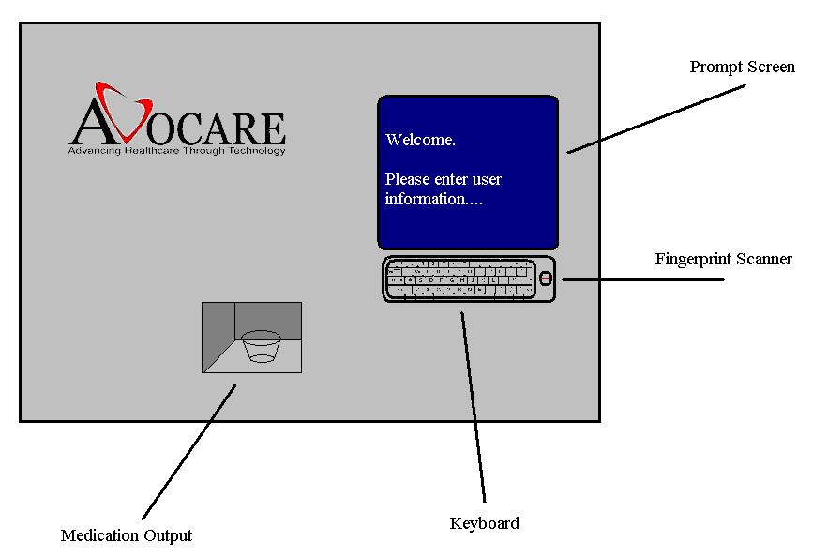
User Operations:
- Step 1: Prisoner scans his fingerprint using the fingerprint scanner located next to the keyboard.
- Step 2: The prisoner will then be prompted to enter in an additional identification verification input, whether it be social security number, prisoner ID number, or password, as decided by the prison staff. The prompts are displayed on the prompt screen and the input is entered using the keyboard.
- Step 3: The user enters in any other information prompted by the prompt screen and finally press the Enter key when ready for operation.
- Step 4: At this point everything is left to the machine. It will process the data and select the correct medications and output them into a cup sitting in the medication output location.
- Step 5: The prisoner removes the cup of medication from the output location. The medication is ingested and the next prisoner can begin entering in their own information.

Maintenance
The major maintenance operation that is needed to be performed on the Automated Medication Dispensing System is the insertion of new medication. Our system utilizes pills individually sealed in what are known as “bingo cards” or “blister packs”, depicted below. Bingo cards are basically cardboard cards lined with a layer of thin foil on the back. Each pill is sealed in its own plastic bubble and can be removed by breaking the foil backing. Medication can be packaged to specifications in repackaging plants. Contact your local repackaging plant for more information on acquiring bingo cards.
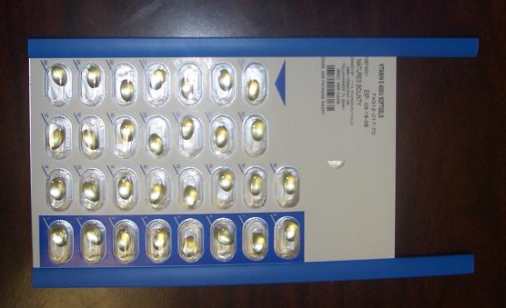
The system is equipped with an internal inventory database, keeping track of the number and type of pills left. When a certain medication is depleted, simply follow the simple steps below.
- Step 1: Acquire a new bingo card containing the same medication.
- Step 2: Make sure the system is not operating. Unlock the side door.
- Step 3: Find the location of the empty bingo card that matches the same medication needing replacement.
- Step 4: From the blue card holding rails, pull the empty bingo card out.
- Step 5: Slide in the new bingo card between the blue rails. Place the new card in the same orientation as the old card was.
- Step 6: Close the side door and lock it.
The following cautionary reminders are specifically mentioned here because to the card loading process.
Caution: The following safety guidelines should be followed at all times to avoid personal injury or damage to the apparatus.
- Make sure that the machine is in an off position (non-operational) when performing any maintenance activity requiring any part of the body to be inside the system
- Be especially cautious when operating near any electronics or the blades connected to the Vacuum Removal Device (VRD) used to pierce the foil back sides of the bingo cards.
- Always put the new bingo cards in the location where the old bingo cards of the same medication were placed. The system assumes that certain medications are in certain locations and incorrect placement could lead to incorrect pill retrieval. An incorrect pill can cause a violent allergic reaction in a prisoner.
- Make sure to always place the bingo cards in the same orientation with the foil side all facing the same direction. Otherwise the VRD cannot puncture the foil.
- If any bingo cards are received from the repackager that seem to be contaminated, partially filled, or otherwise incorrect, discard that bingo card. If the problem continues, contact your repackaging plant.
- Do not drop any debris on or inside any part of the internal components of the machine.
- Always ensure that when the bingo cards are inserted, to close and lock the side access door.

Support
For any customer comments, questions, suggestions, technical assistance or questions about any of our other healthcare products, please feel free to contact us:

Phone Numbers:
General: (850) 702-0099
Business Development: (850) 702-0084
Production: (850) 702-0097
Fax: (850) 222-8771

Address:
3411-B Capital Medical Boulevard
Tallahassee, FL 32308

Email:
contact@avocarehealth.com
support@avocarehealth.com

Also visit us on the web!
http://www.avocarehealth.com/index.html

Avocare – Advancing Healthcare Through Technology

