

Oceanic Thermal Energy Conversion System
USER’S manual

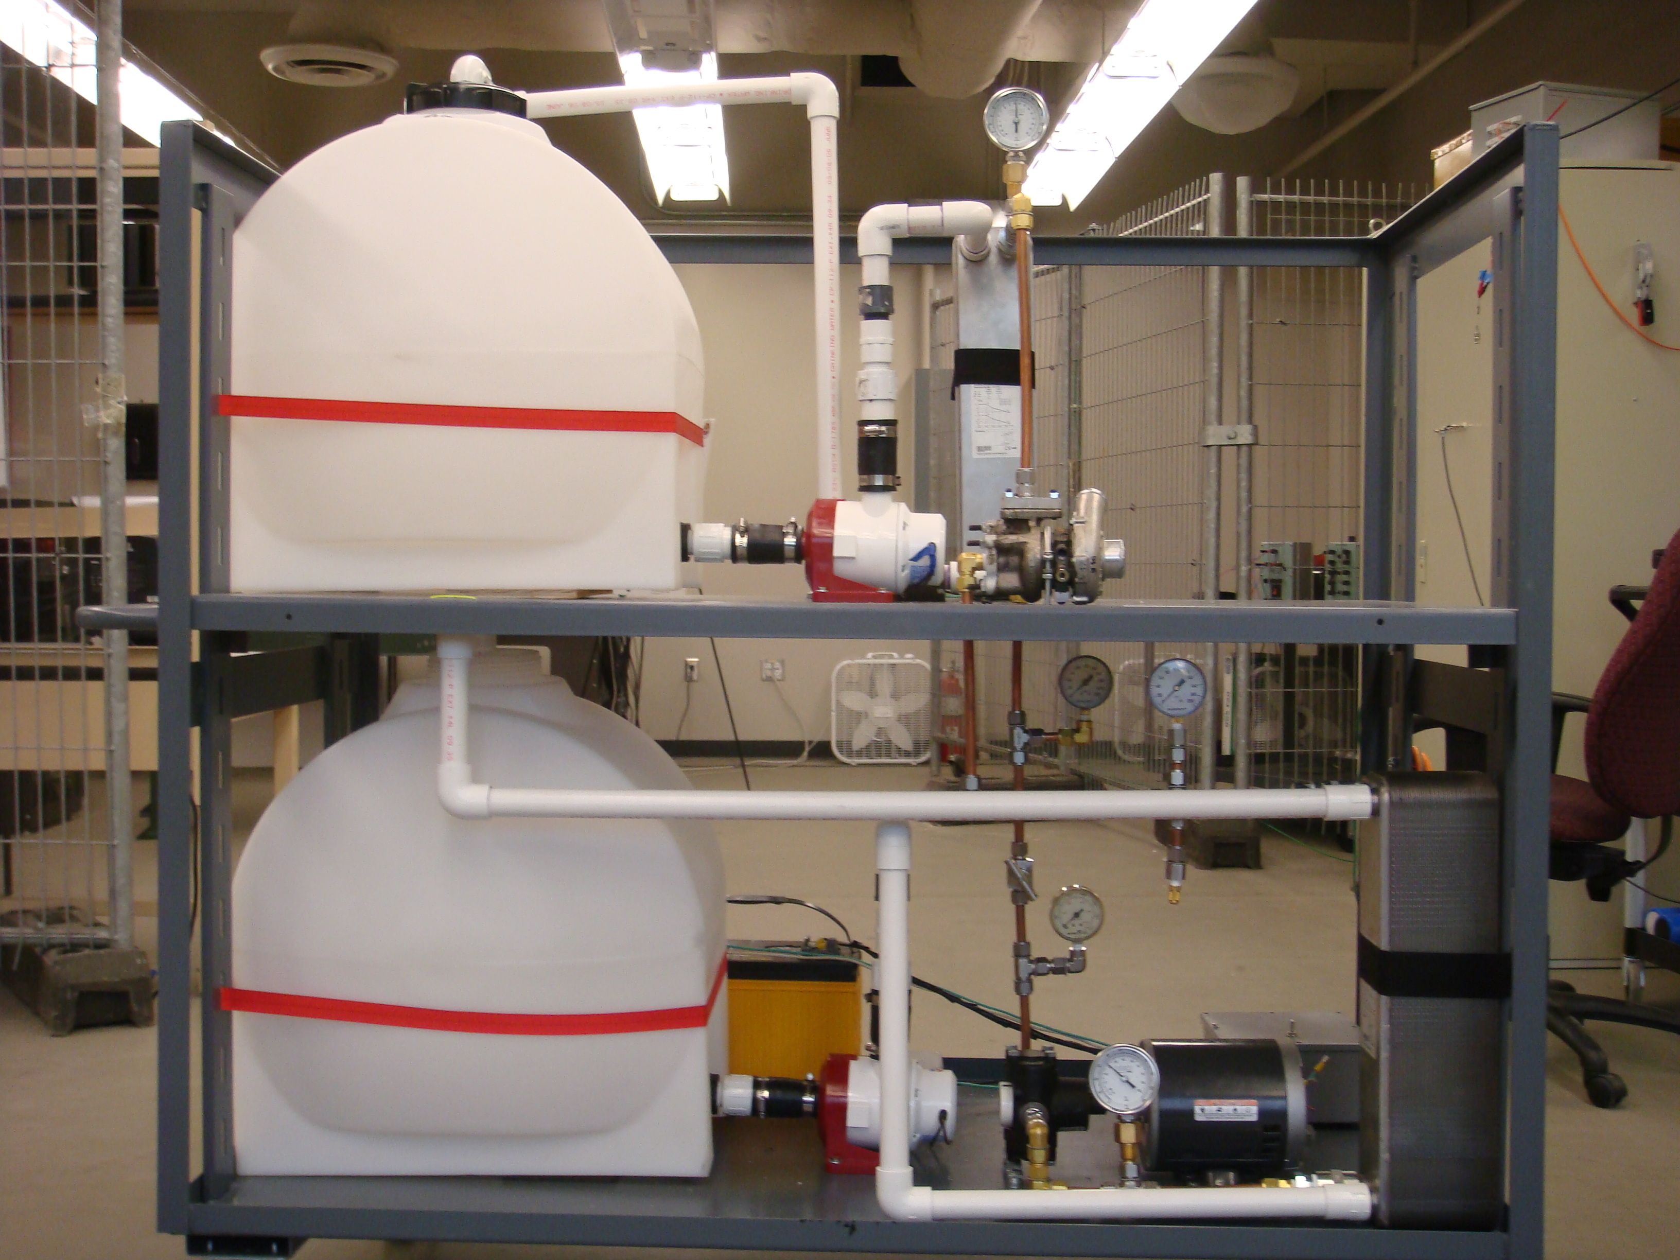


Charging the System with R-410a:

1. Before charging the system, leak and pressure test the system with an inert gas such as nitrogen. After there are no palpable leaks within the system proceed to pressurize the system again, and determine whether the pressure drops below the maximum pressure as time elapses. If the pressure decreases over time, you must remedy the leaks before charging the system with the working fluid. (Note: Our group could not determine the location of the minute leaks within our system, therefore we could not continue beyond this step.)
2. After checking the system for leaks, connect a vacuum pump to the Schrader fitting in the bottom of the copper piping leading to the condenser and evacuate the system of all air.
3. Fill the system to approximately 130psi; this pressure was determined by summing the volumes of all the components within which the working fluid will be liquid within the system at the evaporation pressure of the system. The mass of working fluid to achieve the evaporation pressure at that specified volume will be the total mass needed to fill the system. This mass, when initially charged, will fill the entire system and thus be at a lower pressure than the evaporation pressure specified in the system. Due to the fact that the density (and thus mass) of the working fluid vapor is negligible compared to the density of liquid, we do not need to consider the added mass of the gaseous phase when charging the system.

Starting the Circulation System and Pumps:
1. Disconnect the negative terminal on the battery.
2. Fill the upper hot water reservoir with warm water (room temperature or above) and fill the bottom cold water reservoir with sufficient ice and cold water to keep the bottom reservoir at a constant temperature of 0°C.
3. Make sure that all of the electrical switches in the electrical control box are pointed to the front of the project as shown by the diagram below.
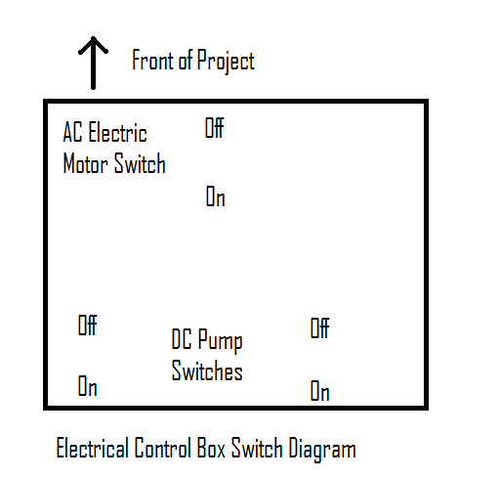

4. Make sure that all of the circulation piping is back into its original place, and then reconnect the negative terminal on the batter and proceed to move both switches for the DC Pumps to the “On” position, the circulation pumps should immediately turn on and begin circulating the water through the heat exchangers.

Working Fluid Pump and System:
1. Make sure the working fluid pump switch is on the “Off” position and the throttling valve for the system is completely open.
2. Turn the working fluid pump to the “On” position and allow the working fluid to circulate through the system for approximately a minute.
3. Slowly close the needle throttling valve while closely monitoring the pressure just after the throttling valve, this should reach approximately 220psi, after this pressure gauge reaches 220 psi let the system run for approximately 5 to 10 minutes to let the system reach steady state.
4. Monitor the pressures and temperatures throughout the system and determine whether the working fluid is changing states correctly through each of the four components within the Rankine Cycle.

System Shut-Down:
1. Turn the switches for the working fluid pump, and DC Pumps to the off position and make sure that all components shut down.
2. Then unplug the outlet to the electrical motor and disconnect the negative leads to the battery.

