User Manual

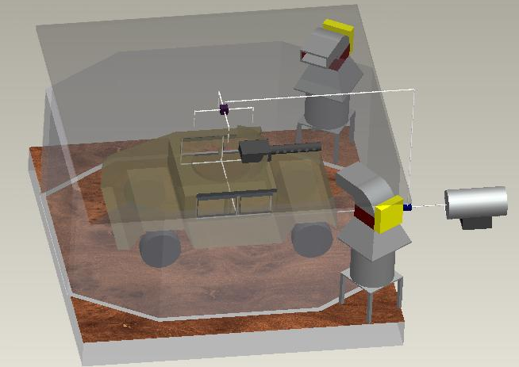

Vehicle Movement System &
IED/Explosion System
Table of Contents

Vehicle Movement System 3
Safety 3
Assembly 4
System Operation 5
Specifications 7
IED/Explosion System 9
Safety 9
Assembly 10
System Operation 11
Specifications 13

Vehicle Movement System

Safety

- Become familiar with the parts of the system, via this manual, before attempting to assemble or operate it.
- Make sure that the power source is sufficient to meet the requirements of the fan and the duct heater.
- Do not operate system in areas that are unventilated or areas that have flammables present.
- Prior to plugging in the fan, make sure that the switch is in the “OFF” position.
- Always ensure that the system is secured properly before operating.
- Keep all loose objects clear of the vent.
- To avoid risks of electric shock, use only with a grounded plug or extension cord.
- Do not operate system in pooled water.
- To prevent the overheating of the fan, ensure that the fan has a clear air intake at all times.
- To prevent a fire from occurring, do not block or clog the air intake of the fan.
- Do not sit or stand on the system, or lean anything against it.
- To avoid harm from any debris that could have entered the system, do not position anybody parts directly in front of the vent of the system.
- Always provide sufficient airflow to the duct heater to prevent overheating and nuisance tripping of the thermal cutouts. (See minimum air velocity chart in the specifications section)
- Before cleaning or servicing the unit, always unplug it first.
- The electrical components of the system should be replaced or repaired by a qualified technician only.

Assembly

Vehicle Movement Assembly:

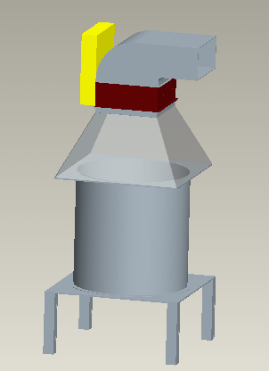

Vehicle Movement Exploded View Assemblies:

Vent
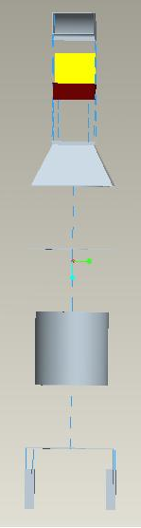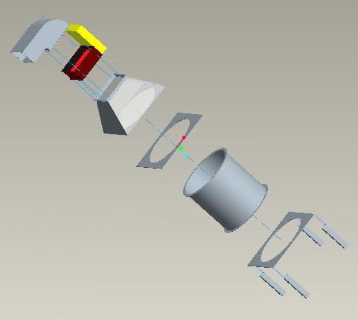
Direct Drive Fan
Reducer
Top Baseplate
Bottom Baseplate

Footings
Heat Duct

System Operation

Wind simulation will be produced by an axial fan that will channel air through an aluminum duct system and out of a vent near the ceiling of the training module. The Variable Frequency Drive motor in the fan is designed to be controlled by software that is compatible with that of the client. A heat duct will also be installed to heat the airflow between 70 and 100°F. The heat duct is essentially a duct with a number of heat coils on the inside and a controller box on the outside of the duct that controls the amount of voltage the coils receive at a given period of time. The heat duct uses an SCR controller with an available RS-232 port output. The only devices that the client requested to be software-controllable were the fan and the heat duct; both of these components were selected with integration requirements in mind so that they permit total custom control by the user.

427 Direct-Drive Duct Fan
- The 427 Direct-Drive Duct Fan will include an inverter-duty motor with the variable frequency drive (VFD). The addition of the Variable Frequency Drive motor will allow motor speeds to be varied by changing the input frequency to the AC motor through computer control.

Heat Coils
- The SCR proportional power controller with an electronic step controller will also be needed. The SCR controller has the RS-232 port which will connect the client’s system to the heating system which will allow for simple integration and control with Lockheed Martin’s software.

Vehicle Movement System Operation Schematic:

Specifications

Fan
Voltage | 115 Volts  220 Volts
Maximum Air Volume | 28,000 CFM
Motor | 8.1 HP
Fan Speed (RPM) | L 875  H 1150
Attached Cord | 25 ft.
Speeds | 2
Weight | 396 lbs
Unit Height | 91 ¼ in.
Outer Diameter | 52 in.

Heat Duct
Volts | 220
Power Rating | 117 kW
Maximum air inlet temp. | 100° F

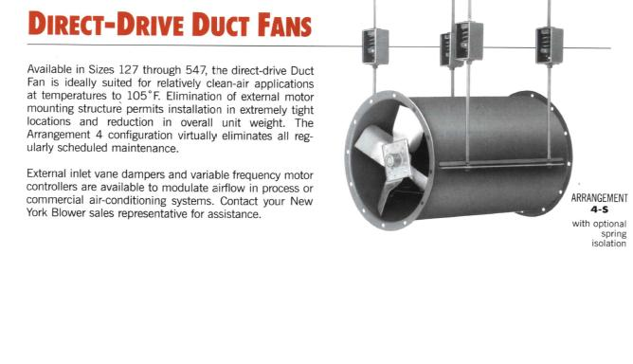

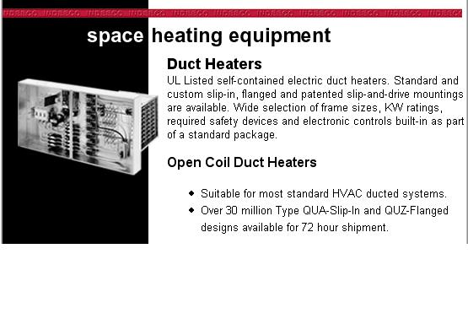

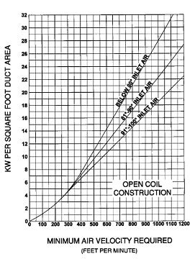
Determining Min. Required Air Velocity

1. Determine the duct area in which the heater will be installed.

2. Determine KW used per square ft.

3. Using the curve that represents the maximum inlet temperature of your system, locate its intersection with the KW used per sq. ft.

4. At this intersection, move down to the corresponding value on the x-axis; this is the minimum required air velocity for your system.

5. Compare the velocity of the air in your system with this minimum velocity; the velocity of the air in your system should exceed this minimum to ensure there is no overheating of the duct heater.
(See example below)

Example for determining the minimum required air velocity: Is the minimum air velocity requirement met for a 10KW open coil heater installed in a 24” by 12” high duct operating with 1000 cubic feet per minute (CFM) of air at a maximum inlet temp. of 82 deg F? Following the steps above, it is determined that the duct area is 2 sq ft, while the KW per sq ft is 5. According to the chart, at 82 deg the minimum air velocity is approximately 310 ft/min. From the CFM of the system, it is determined that the velocity is 500 ft/min. Since this 500 ft/min is greater than the 310 minimum velocity, the installation of the duct in this system is safe.

IED/Explosion System

Safety

- Become familiar with the parts of the system, via this manual, before attempting to assemble or operate it.
- Make sure that the power source is sufficient to meet the requirements of the system.
- To avoid serious injury from flying parts, never operate the compressor if the guards are missing.
- Always operate the system in a well ventilated area free of combustible materials, gasoline or solvent vapors.
- Do not place any objects on or against the top of the compressor of the system.
- Never position nozzles for the system any closer than 12” from passengers’ in vehicle, to avoid soft tissue damage or possible ear damage.
- To avoid serious burns, never touch any of the exposed metal parts on the compressor during or immediately after operation.
- To avoid the risk of serious injury or death from toxic vapors that may be present in the compressed air, never use system to supply air for human consumption.
- Before attempting maintenance or attaching accessories to the compressor, always ensure that it is off and that the pressure is bled from the air hose and the tank.
- Do not operate in confined spaces.
- To avoid rusting and or thinning of the steel tank, always drain tank after use.
- Never drill into the tank or make modifications to it.
- The system should never be used to inflate small low pressure objects.
- The electrical components of the system should be replaced or repaired by a qualified technician only.

Assembly

IED/Explosion System Assembly:

System Components:
- Air Compressor/Tank
- Electronically Actuated Valves
  - 3-Way Valve
  - 5-Way Valve
- Exterior and Interior Air Nozzles
- Air Hoses
- Fittings
T-Fitting
Air hose
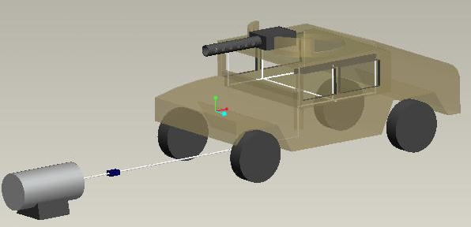
Compressor and tank

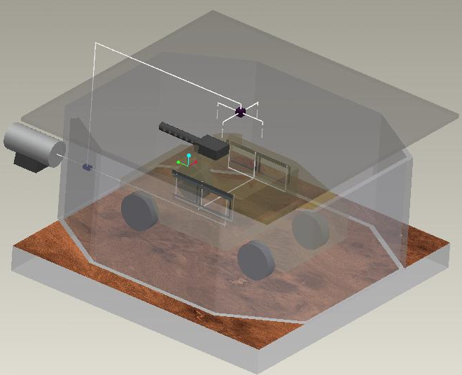

System Operation

Electrically Actuated Valves
The only components that require electronic controlling for the IED/Explosion System are the electrically actuated valves. Electrically Actuated Valves allow the opening and closing of valves to be controlled by a voltage input. These valves were specifically designed to work with the client’s programmable logic controller (PLC).

IED/Explosion System Operation Schematic:

Specifications

Nozzles

EXAIR 1100SS Air Nozzle (Interior Nozzles)
Force | 13 oz.
Pressure | 80 psi.
Noise Level | 74 dBA
Inlet Size | 1/4 in.

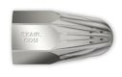

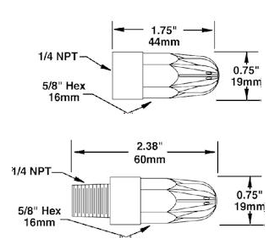

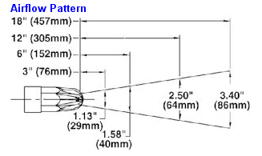

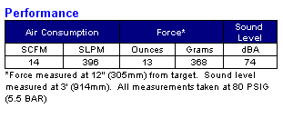

EXAIR 1105 Super Air Nozzle (Exterior Nozzles)
Force | 30 oz.
Pressure | 80 psi.
Noise Level | 82 dBA
Inlet Size | 3/8 in.

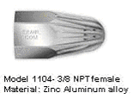

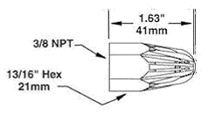

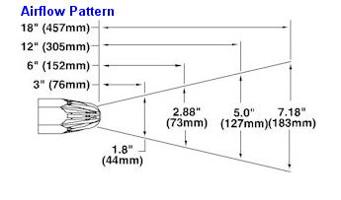
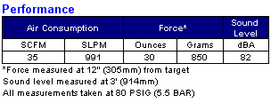

Valves

3-Way Valves
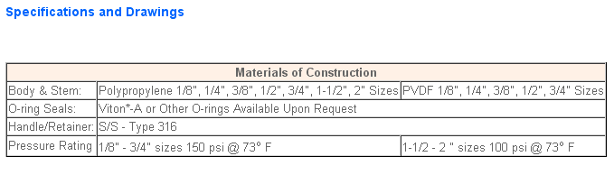
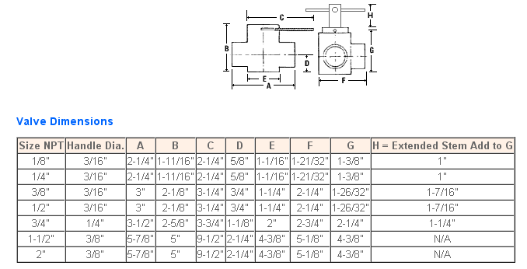
*Note: The Electrically Actuated Valve does not have an extended stem (H- above in the figure and dimensions chart) but all other dimensions are exact.

5-Way Valves
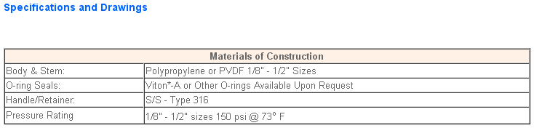

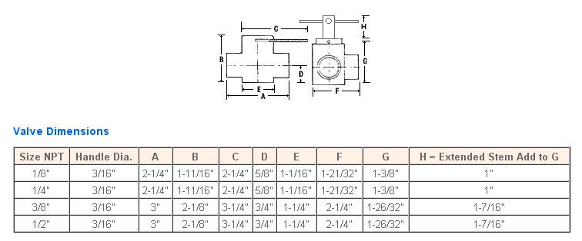
*Note: The Electrically Actuated Valve does not have an extended stem (H- above in the figure and valve dimensions chart) but all other dimensions are exact.

