Table of Contents

Executive Summary 1
Project Definition 2
Needs Assessment 2
Project Scope 4
Specifications 4
Concept Generation and Selection 6
Original Selection – Tricycle 6
Final Selection – Inverted Tricycle 15
Design Description 17
Brakes 17
Steering 18
Frame 20
Drive Train 23
Cost Analysis 24
Future Plans 29
Summer Proposal 29
Spring Calendar 30
Appendix 32
Calculations 32
Detailed Engineering Drawings 41

Executive Summary

The Senior Design Team #7 ASME is entering into the Human Powered Vehicle Challenge. The team will participate in the Single rider category of the competition. Besides being a class deliverable, the following report will help in accomplishing the goal of winning the HPV competition. The group has gone through the design process to achieve the scope. Specifications have been determined through research and calculations, and the vehicle has been designed to perform to the standard of these specifications. While designing the vehicle, the team first decided upon a tricycle configuration. However, upon establishing contact with human powered vehicle design professionals, it has been concluded an inverted tricycle design will give our vehicle the performance it needs to make the team a viable force at the competition this summer. The team is also very happy to be under budget with the purchase of the EZ-TAD SX Tadpole tricycle from Sun Bikes for necessary components.

Project Definition

Needs Assessment

Below is a list of the needs that should be met for the ASME Human Powered Vehicle Senior Design Project:
- Local ASME Chapter
  - Every member of the Senior Design group must become active members in the local ASME chapter in order to participate in the project.
  - Recruit other ASME members, especially underclassmen, to help with the project in order to keep the chapter involved, make a better vehicle, and maintain interest for future vehicles.
  - Maintain active communication with local ASME sponsor, Dr. Dave Cartes.
  - Attend ASME meetings and set up additional meetings with interested ASME members.
- Competition Needs
  - All vehicles in all classes of competition are required to have a full or partial aerodynamic fairing.
  - All vehicles and teams in all classes must abide by all the safety requirements.
  - The design event will consist of both a formal written report and an oral presentation.
  - The Single Rider event includes a 65 kilometer and 100 meter courses.
  - Be ready for competition on time. (Date still to be determined by ASME)
- Senior Design Class
  - Complete and submit all required deliverables.
  - Meet with Dr. Luongo periodically to discuss progress on project.
  - At end of first semester must complete project design and give presentation.
  - Produce web page outlining the design process and key deliverables for the public.
  - Participate in FAMU/FSU College of Engineering Open House showcasing senior design projects.
  - Produce a Final Report.

Project Scope

The American Society of Mechanical Engineering (ASME) holds multiple design competitions each year. One such competition is the Human Powered Vehicle Challenge. This annual competition is broken up into three categories: single-rider, multi-rider, and utility. Each category has its own specifications and rules on what the vehicle is supposed to accomplish. This year’s event will be held in Orlando, FL on May 11-13, 2007 at the University of Central Florida. This competition is open to all ASME chapters and will be used by the FAMU/FSU College of Engineering as the capstone project for the ASME senior design group.
The group has decided to participate in the single rider category of the competition. The goal is to create a competitive vehicle that will out perform other vehicles in a speed race. This vehicle will be used to compete in both the design and single-rider event during the ASME Human Powered Vehicle Challenge. The event will consist of a 100 meter timed course preceded by 300 to 400 meters given to contestants in order to gain speed and followed by at least 200 meters of track allowed for the vehicles to slow down. The single-rider event will also include an endurance portion in which the vehicles will compete in a grand prix style road race of approximately 65 kilometers (40 miles). Overall design of the vehicle will also be an important factor during the competition. The Design competition will focus on both a formal written report and an oral presentation. There will be an emphasis on originality and the soundness of the design.
The point of the competition is the elegance and ingenuity of the design, including presentation, practicality and safety. In order to enter into the competition the vehicle will be required to meet specific safety requirements. Another necessary component is the utilization of a fairing. The fairing is not only required but also will be important for the aerodynamics of the vehicle.

Specifications

Once the project scope was defined it was crucial to determine parameters for design. Many of the following specifications were taken directly from competition rules and regulations included on the ASME website. The specs not explicitly detailed on the website were determined by the group’s working knowledge of vehicle design, research and calculations.
Dimension Specifications:
- Overall Max width: 5 feet
- Overall Max length: 6.5 feet
- Overall Max height: 6 feet
- Maximum Weight: 125 pounds
- Fairing Covering: at least 1/3 frontal area
- Minimum Ground Clearance: 6 inches
Performance Specifications:
- Minimum Top Speed: 15 mph
- Minimum Acceleration: 23.5 ft/s²
- Obstacles
  - Clear speed bumps of at least 6 inches
  - Travel up an incline of 30 degrees
- Steering
  - Maximum Turning Radius: 25 foot
  - Travel in a straight line for 100ft
- Braking: stop in a distance of 20 feet from a speed of 15 miles per hour
- Must be able to operate for a distance of 10 kilometers
Load Specifications:
- Driver
  - Height Range: 5’3” to 6’1”
  - Max Weight: 250 pounds
Safety Specifications:
- Provide rollover protection for driver, equivalent to chrome-molybdenum steel tubing with an outer diameter of 1.5 inches and a wall thickness of no less than 0.049 inches
- Needs seat belt or shoulder harness, in accordance to the rulebook
Cost Specifications:
- Cost Max: $2000

Concept Generation and Selection

Original Selection – Tricycle

The purpose of this section is to present the different design concepts the group considered for the Human Powered Vehicle and discuss the reasoning behind the group’s first design choice. This will focus on the overall design of the vehicle options, meaning the general configuration of the body. There were many different subcomponents that were still to be determined at this point in the design process, and these will be discussed in the Detailed Design section. During the concept generation phase of the project each member presented a different design for the HPV. Each of the four group members’ design was considered and a selection was made from a decision matrix that every member agreed upon. The four designs that were considered include: bicycle with cart, tricycle, inverse tricycle, and a four wheel vehicle. By using the decision matrix it was determined that the tricycle configuration was the best choice.
The first design that was considered consisted of a regular bicycle and a cart for carrying the required load. This option was dismissed at first because it seemed to be too simple but was later revisited. It was important for the group not to reinvent a simple bicycle for a few reasons. Bicycles are the most obvious and common human powered vehicle there is. Companies have been making them for many years and it is doubtful that there could have been improvement upon current designs. Another reason like this option was disliked was the lack of ingenuity. It seemed almost too easy to recreate something we are already familiar with.
The second design was a four wheeled vehicle, similar to a go-cart. A four wheeled vehicle is the most common option found in regular vehicles; generally not human powered however. The advantage of this design was its familiarity, its load carrying capability and stability, but once again it seemed to lack ingenuity in design.
When researching human powered vehicles many current designs consisted of three wheel vehicles. The three wheeled vehicles seemed to offer the best combination of practicality and ingenuity. The third design was an inverse tricycle design, two wheels in the back and one wheel in the front. The main difference between this design and the regular tricycle design was the steering mechanism. For the inverse tricycle design there are two options for steering, either steer the single wheel in the back or the two wheels in the front. Steering the single wheel in the rear would be a little awkward, much like pushing a grocery cart backwards.
The decision matrix is the main tool being used to make project related decisions. A decision matrix helps the group to focus on the design specifications and goals of the project. It also provides a way for every team member to contribute equally and makes the decision that is made the overall consensus of the group. The first step to making the decision matrix is to determine what decision needs to be made and the possible choices available. Next the group decides on what categories to use to score the possible choices. These categories should be related to meeting the project’s objective. Then the team assigns a weight to each category based on its importance, the more important the category is, the higher the weight. In general the intent is to make the entire weights sum up to 1. After the weights are assigned, each member scores each option based on the category. The score is between one and ten and the average of every member’s score is used. When most members have similar scores, within three or so, there is little discussion over why that way was chosen. On the other hand when the individual scores are not similar some time is taken to discuss why the individuals gave the scores in question. Finally after averaging all of the scores for each selection and category the scores for each option are compared. As long as there are no major objections the option with the highest score is winner.

 | Cost | Complexity | Safety | Braking | Steering | Speed | Weight | Sleekness | Score
 | 0.17 | 0.10 | 0.20 | 0.11 | 0.10 | 0.10 | 0.12 | 0.10 | 1.00
Bicycle w/cart | 7.75 | 9.00 | 4.00 | 4.75 | 6.25 | 8.50 | 8.00 | 8.00 | 6.78
Tricycle | 7.00 | 7.25 | 7.00 | 7.75 | 7.75 | 8.25 | 7.50 | 7.50 | 7.42
Inverted Tricycle | 6.50 | 6.25 | 7.25 | 7.25 | 5.50 | 7.00 | 7.25 | 5.25 | 6.62
Four Wheel | 3.75 | 5.00 | 9.50 | 7.25 | 5.25 | 5.50 | 3.50 | 4.75 | 5.81
Figure 1: The decision matrix created to decide on our vehicle’s conceptual design.

The reasoning behind the inclusion of each category is as follows:
Cost- The cost of the vehicle is related to the overall size of the vehicle as well as the number of components. The bigger the vehicle is the more material is required to make it.
Complexity- This category is related to how difficult the vehicle is to build. It is related to the total number of parts required as well as the overall size of the vehicle.
Safety- Stability of the vehicle was one of the main concerns when determining the safety scores for each of the vehicles. Another concern is the ability to incorporate the necessary safety cage in the vehicle’s design. This category carries the most weight because safety of design is always of utmost importance and contest regulations describe more safety specifications than any other design category.
Braking- This category was related to the total number of wheels since the most likely braking system used will focus on stopping the wheels. It is likely the braking mechanism will be similar to the standard brakes found on bicycles. The more wheels that are in contact with the ground the more braking force can be applied.
Steering- This category is important for the objective of designing a speed vehicle because the contest consists of a grand prix style road race. In this course there may be several tight turns and ease of steering will be crucial for these sections of the course. Steering also directly impacts one of the specifications of having a maximum turning radius of 25 feet. The decisions are also based on ease of designing the steering mechanism.
Speed- This category is directly related to the overall weight of the vehicle as well as the maneuverability. Top speed is important but in the utility category acceleration is another important factor.
Weight- The weight of the vehicle is simply based on how large the vehicle is going to be. This factor was important not only for speed and acceleration of the vehicle but also for how tired it makes the driver to operate, especially up inclines and such.
Sleekness- All designs will require an aerodynamic fairing to cover 1/3 of the front of the vehicle. It is important for the vehicle to be narrow, especially in the front. Another concern for sleekness was the style or overall “coolness” of the vehicle but this was strongly related to how aerodynamic the vehicle was.
Keeping these categories and the project objectives and specifications in mind, the decisions were pretty straight forward. In the decision matrix, one of the options considered was a four wheel design. This design seemed like it would cost the most because of how many more parts and how much more material would be needed to make the design. Next is the complexity category. This design would be harder to build because there are design factors that take more thinking and more parts to build. The steering column, for example, needs a more complex design because it has to turn two wheels on one axle instead of one. And because the two turning wheels are separate there has to be two different turning angles on the wheels. Because of these factors the design received low scores in cost and complexity.
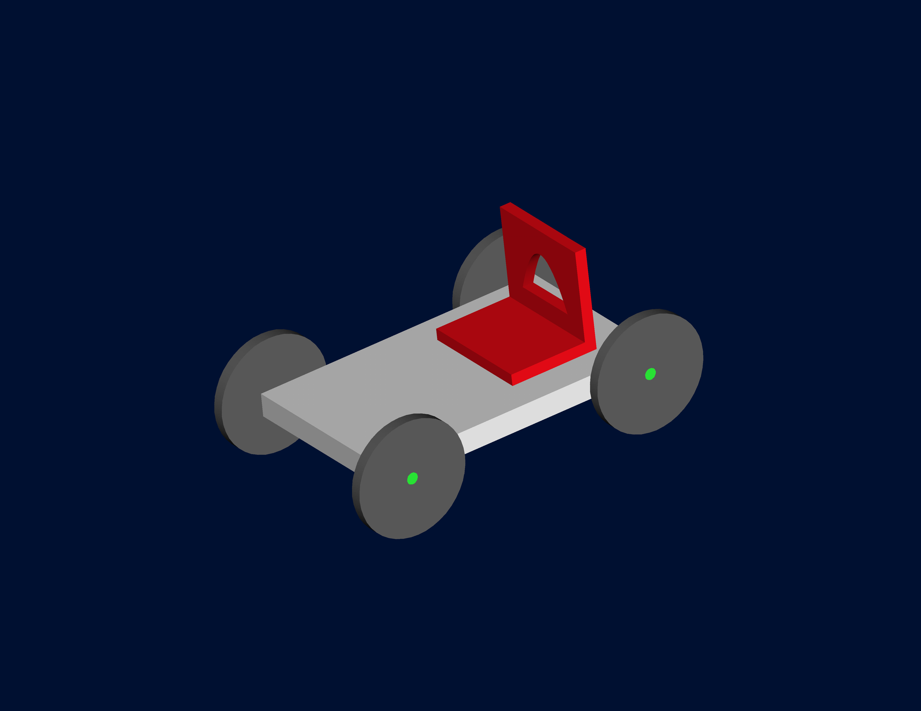
Figure 2: Four wheel design, Pro-Engineering image.

The four wheel design is the most stable design because of its symmetry and equal distribution of mass and weight. It is less likely to flip over or tilt. It received an average score for braking because brakes can be put on all four wheels to help it stop but with the amount of mass that is moving it takes a bigger force than all of the other designs to bring it to a halt. Because of the complexity of the steering column and because steering in four wheel vehicles causes wider turns than other designs the four wheel design received a lower score in the matrix. This design is probably more stable for speeding but once again the mass of the design would take more force to accelerate it. Furthermore, the four wheel model is a wider design making it less aerodynamic. This is also a factor that limits speed. This is why the design received lower ratings in the speed department. After thinking about the design, however the four wheel design would probably have been rated somewhat higher in speed because it has more chances and more room to facilitate a speedy design than the other models. Because of the mass and extra parts already mentioned that may be needed to complete the structure, the four wheel is obviously heavier than any other model. Because a light weight vehicle is desired this design received a low score for weight. The last category of consideration was sleekness. It was decided that this particular design was least likely to be as sleek as any of the other designs submitted for consideration; therefore, it did not score high in that category either. Overall when taken into consideration the four wheel design was the least efficient design.
The next design that was suggested and considered was the inverse tricycle design. This design consists of two wheels in the front and a single wheel in the back. It is very similar to the normal tricycle design and often received similar scores. The steering mechanism for this design can be either on the two front wheels or the single back wheel. In general, the steering mechanism for a two-wheel axel is more complicated than a single wheel. Because of this, it would seem easier to steer using the single wheel in the rear of the vehicle. This is similar in thought to the normal tricycle design but the normal tricycle design has an advantage. If both tricycle designs use a single wheel for steering the inverse tricycle would be more awkward to control since it would be the rear wheel steering. This would result in a similar experience to pushing a grocery cart backwards.
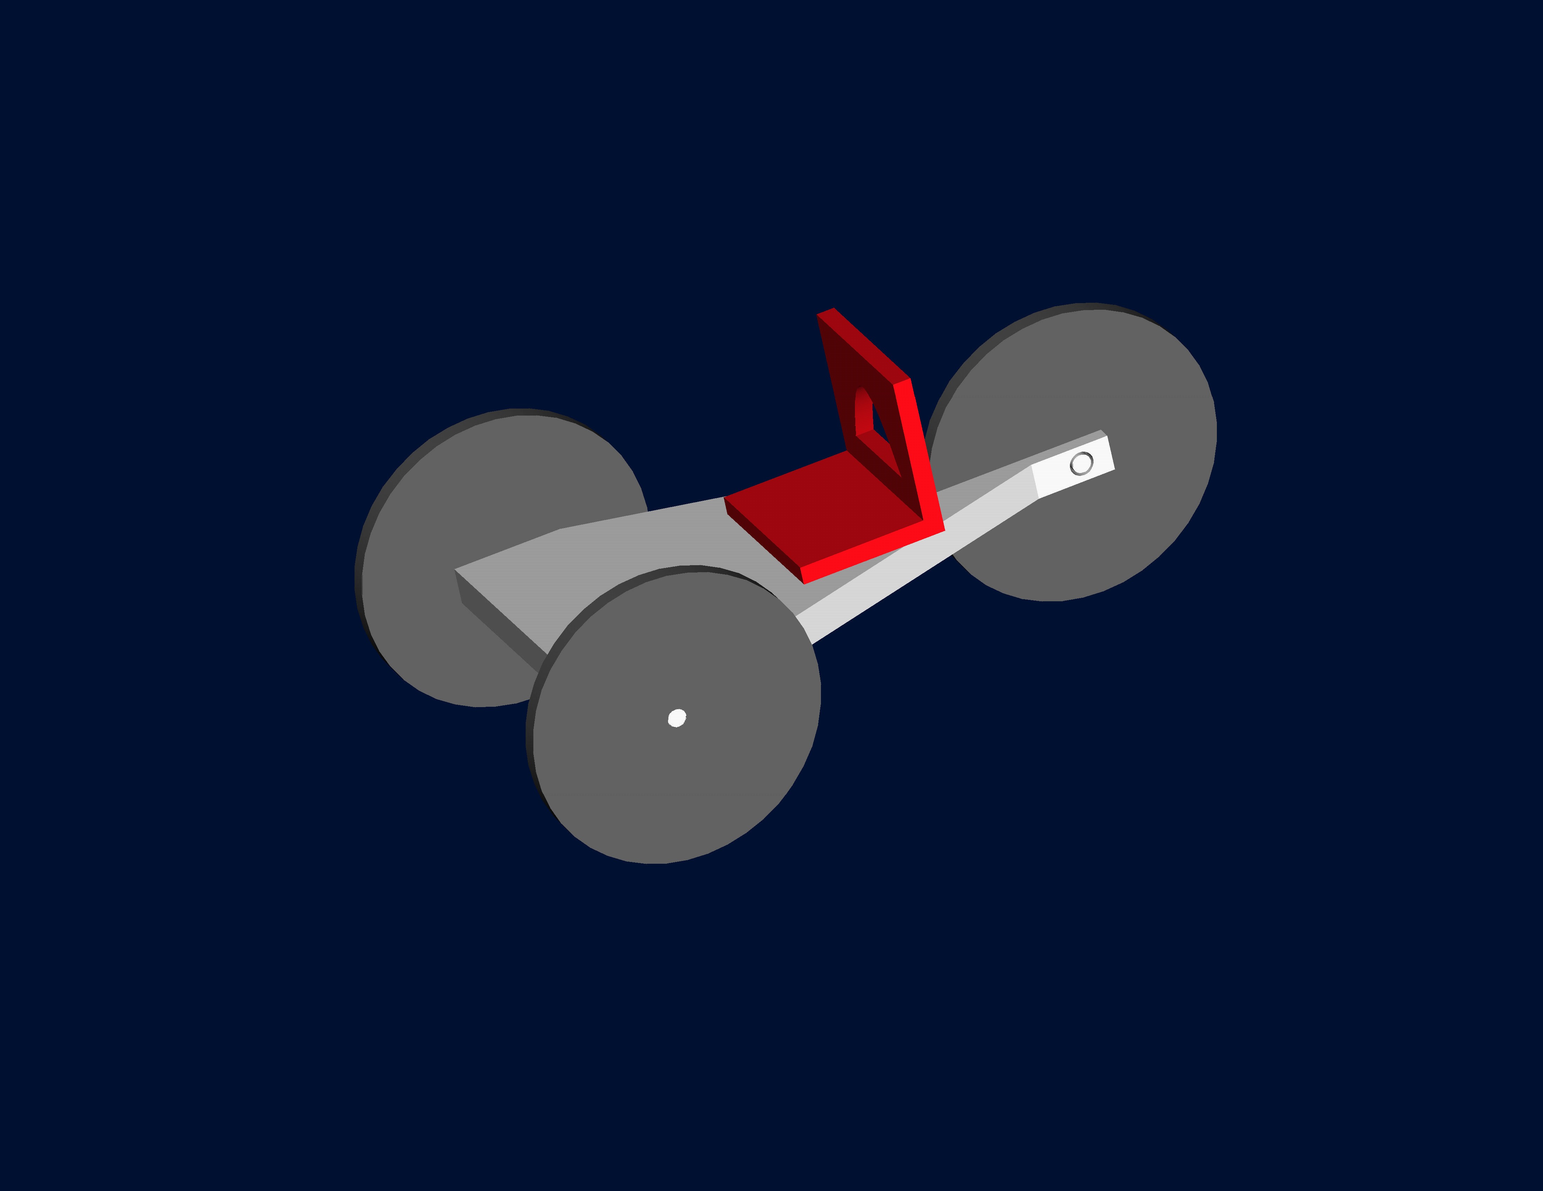
Figure 3: Inverse tricycle design, Pro-Engineering image.

The overall safety of each design was a function of its stability. A vehicle with three wheels is more stable than a bicycle and less stable than a four-wheeled vehicle. Also the inverse tricycle provided enough room to build the required cage and seatbelt system. When scoring the inverse tricycle on braking the team felt it would be more likely to use the two wheels in the front. This would be a benefit since braking would be applied to two wheels instead of one. The team felt that two wheels braking in the front would be better than two wheels braking in the rear as far as stopping force but might be dangerous if it caused a flipping issue. Weight and speed were closely related categories. Acceleration is important since it can make the difference between winning and losing a race. The lighter something is the faster it can go and the faster it can accelerate. Once again it was similar to the normal tricycle, scored between a bicycle and a four-wheeled vehicle. The final two categories were complexity and cost. The cost of the inverse tricycle is moderate compared to the other options. It is in the middle as far as size and would not require too many complex parts. A major factor for complexity is the steering mechanism, which for the inverse tricycle could be one of two options. If the simpler option of steering using the rear wheel were employed then the design would not be as complex as it would be if one were steering the front wheels. In the end the inverse tricycle design was good but not as good as the other three wheeled design.
The bicycle with attached cart is an excellent configuration. It is a tried and true design for a human powered vehicle, helping to make the bicycle the least complex design option. Because the bicycle is the smallest of the four design choices and requires the fewest components, it won in both the weight and cost categories. The bicycle has aerodynamics ingrained in the shape and size of the design, which helped it gain points in the speed and sleekness categories. However, the shape of the design also contributed to a low score in safety. With the two wheels being in a line, balance is just one of the safety issues for the bicycle. Considering the total design, a bicycle with an attached cart to facilitate cargo transport, the cart could cause tipping when the vehicle picks up speed on a decline. The braking decision was impacted by the bicycle having only two wheels to connect breaking mechanisms to, while possible steering mechanisms would not likely make up for the steering difficulties offered by the addition of the cart to an otherwise streamline design.
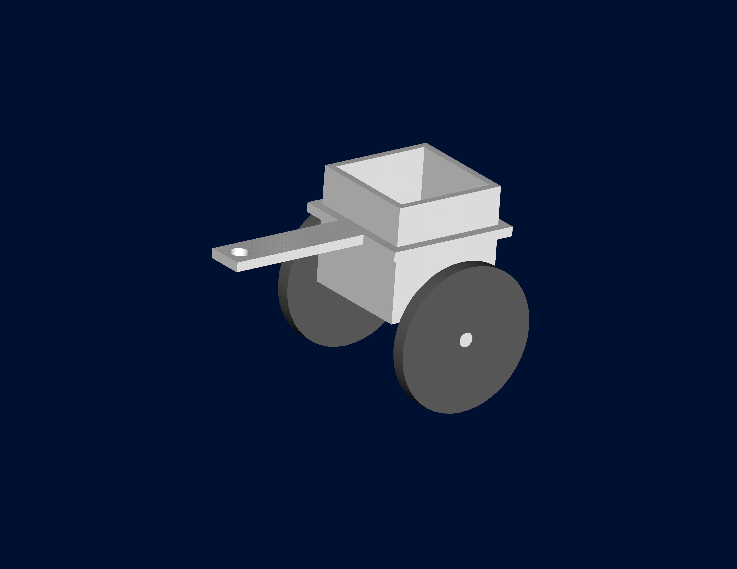
Figure 4: Cart attachment for bicycle design, Pro-Engineering image.

The standard tricycle configuration is a familiar design. Due to its single front wheel the tricycle would require a simpler steering mechanism than the inverted tricycle and the four wheel design. However, the two wheeled rear axel adds complexity to the tricycle configuration when compared to the bicycle design. Thus, the standard tricycle design ranked second in complexity considerations.

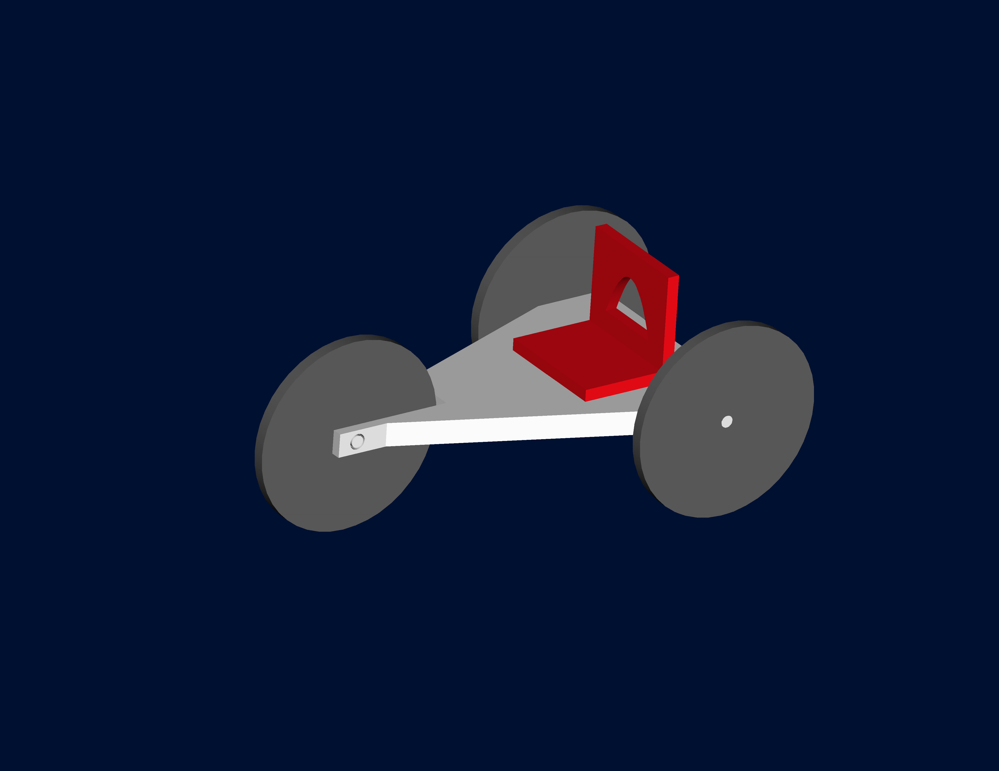
Figure 5: Tricycle design, Pro-Engineering image.

Due to the comparative simplicity of the standard tricycle’s steering, braking, and power generation systems, it was considered less costly to manufacture than the inverted tricycle and four-wheel designs. However, the tricycle design would inherently require more components than the simpler bicycle design. Thus, the standard tricycle design ranked second in cost considerations.
Stability was the dominant factor in safety considerations. The standard tricycle design was considered to be less stable than the four-wheeled design. The standard and inverted tricycles were generally considered to be equally stable. The bicycle was considered to be the least stable design due to its greater ability to tip. Thus, the standard tricycle design placed in an approximate tie for second in safety considerations.
A two wheeled rear axel was considered to be inherently beneficial for braking. Thus the standard tricycle design was considered to be superior to the bicycle and inverted tricycle design in braking considerations. The standard tricycle was considered to be inherently superior to the four-wheel design due to its comparative weight benefit. For these reasons, the standard tricycle design ranked first in braking considerations.
The standard tricycle configuration was considered to be inherently superior to the four-wheel design in speed/acceleration considerations, due its weight benefit. The standard tricycle configuration was considered to be inherently superior to the inverted tricycle design in speed/acceleration considerations, due its aerodynamic benefit. However, the standard tricycle configuration would be heavier and cause a greater drag force and therefore be inherently slower than the bicycle design. Thus, the standard tricycle design ranked second in speed considerations.
The single front wheel axels of the standard tricycle and bicycle designs allow for simpler and more effective steering mechanisms than the inverted tricycle and four wheel designs. The standard tricycle configuration was considered less nimble than the bicycle configuration. Thus, the standard tricycle design ranked second in steering considerations.
Overall, the tricycle ranked highest of all presented design options. By utilizing the decision matrix which incorporated key factors to consider for our objective, this design was chosen. From here the group can focus our intellectual resources on creating a detailed design that will meet the project’s specifications and manufacturing a vehicle that will be a strong competitor in the American Society of Mechanical Engineers Human Powered Vehicle contest.

Final Selection – Inverted Tricycle
The original design that was agreed upon by the group was the traditional tricycle design; however, after further consideration it was decided that the vehicle should be put on an inverted tricycle chassis. Two wheels in the front allow for sharp tight turning at higher speeds, while the traditional tricycle design with one wheel in front will not allow the same maneuverability. Also the intent is to power the back of the vehicle. It was recommended by a department professor that the HPV not be powered from the front wheels but from the rear wheels. If the design had stayed as a regular tricycle pattern there would have to be a complex way to make the chain power both of the back wheels. The two back wheels would have to be driven together. If these wheels are not driven together at the same speed and at the same synchronization, the vehicle will not drive straight. This would also be the case if the two back wheels do not coast together and brake together. This is the equivalent of a car needing an alignment. There would have to be a mechanism or apparatus made to drive the two back wheels with one chain. Also there would have to be a braking mechanism that would stop the wheels together. It is easier to have the driving and the braking done by one rear wheel rather than by two. While the steering mechanism for two front wheels will be more complex than the mechanism used for one front wheel, and probably more complex than the mechanism used to power two rear wheels in the tricycle configuration, the group feels that it is more important to power the vehicle from the rear than it is to have a simple steering mechanism on an HPV that is powered by the front wheels. It is for these reasons that the group decided to change from the original design to the current one.
In trying to get advice and help with the HPV the group was able to contact a few reliable resources. Different bike shops were also visited in order to ensure that there is a sound vehicle worthy for competition made as a result of this project. Some people were helpful and some were not so helpful. There was one who never seemed to have the time to talk with the group about the project. There was also a person who referred the group to another person. The group was referred by one of the bike shop employees to a man named Dan Kavanagh. He is the owner of Organic Engines, a company based in Tallahassee which specializes in designing and fabricating human powered vehicles. Through Mr. Kavanagh the group was able to order an EZ-TAD SX for a cheaper price than usual. This price, $850.00, was better than buying all the parts separately and better than buying them from other places; this will be explained further in the Cost Analysis section. In addition, Mr. Kavanagh has offered his facility as a place to build the EZ-TAD SX, which is ideal because the group is allowed use of all tools necessary to build the vehicle and also the expertise of a professional. Mr. Kavanagh has been truly instrumental in assisting the ASME team with creating an excellent human powered vehicle
The reason the group decided to purchase the EZ-TAD SX is to get an example and a start on how to construct this human powered vehicle. It is found that it is better to use most of the parts that came with the EZ-TAD SX; however, there will be an originally designed frame used on the HPV which includes the utility storage, roll-over protection and an aerodynamic fairing. These additions are made according to the specifications determined by the rules of the ASME competition and as interpreted or desired by the ASME team. The group used the EZ-TAD SX with its current frame as a support while designing a new frame around it. The final result is a human powered vehicle that is a signature product by the ASME team.

Design Description

Brakes

The first calculation involved the braking requirements, which states the vehicle must be able to stop in 20 ft when traveling 15 mph. These two requirements can be used to create two equations with two unknowns, time and deceleration. Assuming a constant deceleration the time to stop would be 1.818 seconds and would require a deceleration of 3.68 m/s². The weight of the vehicle is unknown since it has not been built but it was approximated to be 100lbs since the purchased vehicle was 50lbs and our vehicle includes an additional roll cage. The total weight was approximated to be nearly 300lbs with the rider. After determining the deceleration and approximating the weight the force to stop the vehicle was calculated. Using the force required to stop the vehicle and the coefficient of friction for the brake pads we can determine the necessary normal force. The coefficient of friction for the brake pad had to be approximated since they are unknown, tests can be performed later to find the exact value. Since there are two wheels with two pads each the normal force required could be divided by 4, resulting in the force that the cable needs to transmit from the brake handles. Finally the squeezing force from the hand was calculated taking into account the moments about the hinge of the brake handle. The final squeezing force was found to be approximately 370N which is below the average grip strength of 470N, according to the Department of Labor and Industries. Our braking system should be more than acceptable for our vehicle since the required squeezing force is way less than the average grip strength. Some of these variables might need to be adjusted in the future such as the coefficient of friction for the brake pad and the total weight of the vehicle. Both of these variables were approximated on the cautious side, the weight was on the high side making the stopping force high, and the coefficient of friction was low meaning a higher normal force would be necessary.

Steering

Steering is of utmost importance in any vehicle design; the vehicle should be maneuverable to the position the driver desires. During steering the vehicle follows the circumferential path of its turning circle. This turning circle has a center point which is positioned along a line extending from the axis of the fixed axle. The steered wheels must both form a 90 degree angle with a line drawn from the center of the wheel to the center point of the turning circle. Therefore, the wheels must be set at different angles to account for the difference between the arcs drawn by the inner and outer wheel.
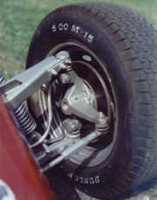
Figure 6: Example of steering mechanism – tie rod, tie rod ends, and steering arm
The solution to this angling problem is the Ackermann steering geometry which is a geometric arrangement of linkages. Rudolf Ackermann patented this arrangement in 1817. His principle arranges the angles by adjusting the steering pivot points so that they lie inwardly on a line drawn between the steering kingpins and the center of the rear (fixed) axle. The pivot points are connected by the tie rod as shown in the following figure. With this arrangement it is assured that at any given steering angle, there is a common point at which the center point of all the circles traced by all wheels converges.
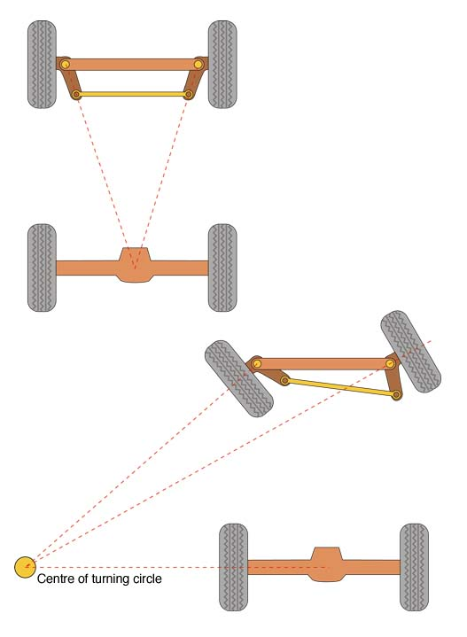
Figure 7: Modified Ackermann Steering Geometry

For the design it was necessary to determine the minimum angle that the wheels needed to rotate in order to meet the required turning radius of 25 ft. These calculations involved geometry and were performed using the computer program Smart Sketch. Two different sketches were created; the first assumed the two front tires rotating at the same angle and the second assumed them rotating independently. The first sketch would be appropriate if the two front wheels were fixed on the same rotating axis. It would provide a good first approximation. Ideally it would be best to have both front wheels pivot independently so they would both be perpendicular to the center of curvature. When creating the sketches the single rear wheel was fixed perpendicular to the center of curvature, as well as the rest of the vehicle. The first sketch placed the center of the rear wheel on the curve with the desired radius. Then a line representing the wheel base was sketch tangent to the curve, the wheel base was assumed the same as the recumbent bike purchased. Next a line was drawn from the center of curvature to the other end of the line, which represents the center of the front axel. Another line was created perpendicular to this, indicating the direction the tires needed to point. The angle created between this line and the wheel base line was 7.6 degrees. For the second sketch the first few steps were the same as before, this time at the front end of the wheel base line a parallel line was placed to form a “T”. This line represents the distance between the centers of the front wheels, the length was 12 inches. Then two lines were drawn from the center of the curve to the center of the wheels. Finally two more lines were created perpendicular to these lines representing the direction the two tires should be facing. The angle between the direction and the wheel base line was 7.3 and 7.9 degrees. Because the difference in angle is so small and the tires have some give in them the angle of rotation can be approximated to be 7.6 degrees. This means the steering mechanism will need to be able to rotate the front wheels approximately 7.6 degrees in order to achieve the minimum turning radius.

Frame

One crucial aspect of the frame besides physical dimensions and layout is the material of the frame members. In order to pinpoint a practical material for the frame design, the group utilized the material selection process. For the process a problem statement had to be made which defined the function and objective. The function of the frame members can be generalized to be a hollow cylindrical beam. The objective is to minimize the mass of the beam in order to align the design with the product specification of maximum weight and help with aerodynamics. The next step is to determine design constraints which essentially form a limit for how the objective can be achieved. Constraints are defined by the function of the design. In this case the constraint is that the frame members be able to support a bending load F without deflecting too much; therefore, the bending stiffness S is specified. Other constraints include member dimensions of length L and tube outer diameter. The free variables of the problem are those aspects which are up to the discretion of the designers. For these frame members, the free variables are the tube thickness and the actual material.
The performance of the frame members is determined by the following equation:

$$P=$$

In this format the functional requirements F, geometric parameters G, and the material properties M are all functions dependent on each other. This makes it difficult to pinpoint an optimum material for the project because not all geometric or functional details are finalized. The performance metric P is made of separable parameters to derive the equation:
$$P=f1\left(F\right)⋅f2\left(G\right)⋅f3\left(M\right)$$
This equation allows for the material index M to be optimized without knowing the concrete details of geometry or function, simplifying the problem greatly.
Once the problem has been fully defined, analysis can commence. The objective was stated to be minimization of the mass of the beam. With this objective there is a correlating objective equation:
$$m=ρ×A×L=ρ×\left(2π\text{rt}\right)×L$$
By using this objective equation and the problem’s constraint equation of:
$\begin{aligned}S=\frac{F}{δ} \\ \end{aligned}$,
The material index derived is:
$$M=\frac{E}{ρ}$$
According to the following chart, several metal composites satisfy the criteria of excellence M which the group seeks to maximize, so the best materials are those above the lines.

Figure 8: Material Properties Chart

To further diminish the selection pool, the safety specifications are referenced. The frame must offer roll over protection equivalent to that of chrome-molybdenum steel tubing with an outer diameter of 1.5 inches and a wall thickness of no less than 0.049 inches. With chrome-molybdenum being the standard, a comparable material was sought using Matweb.com an online database of materials and their respective properties. The following table shows a few properties of chrome-molybdenum and two comparable materials.

Material | Density  ρ (kg/m3) | Modulus  E (GPa) | Failure Strength  σf (GPa)
Chrome Molybdenum | 7850 | 205 | 415
Aluminum 6061 | 2700 | 69 | 130
AISI 1018  (Cold Drawn) | 7870 | 205 | 370
Figure 9: Material Properties from matweb.com

Using the given values for modulus E and density ρ, the material index for each material was calculated and the results were: M_{CrMo} = 0.0261, M_{Al} = 0.0255, M₁₀₁₈ = 0.0260. The chrome-molybdenum was the highest value but the aluminum and steel were very close. Because the AISI 1018 steel is cheaper than chrome-molybdenum and only had a 0.38% deviation from the standard of chrome-molybdenum set by the safety specifications, the material selection process has led the group to choose steel, which is also in ready supply by Mr. Kavanagh, for the fabrication of the vehicle frame.

Drive Train

The last calculations that were performed involved the gear ratio between the front gear-set and the rear gear-set. All of the gears are required to have the same in order for the chain to interact correctly with all of the gears. For the design there are 8 gears in the rear ranging from 11 teeth to 32 teeth. In the front there are three large gears with 30, 42, and 52 teeth. When the rider pedals one revolution all three of the front gears will also rotate the same one revolution, but the rotation of the back wheel is dependant on the gear combination. There are two main points of interest, first is called the velocity advantage and the other is the mechanical advantage. The velocity advantage is defined as the number of gear teeth in the front, or input, over the number of gear teeth in the rear, output. In order to maximize the velocity advantage one would want to have the largest input gear and smallest output gear, for the design this results in max velocity advantage of 4.27. These means that for every one rotation of the pedals by the rider the rear gear will rotate 4.27 times, as well as the rear tire. As a result of this increase in rotation there will be an increase in distance traveled the higher the ratio between the gears is. The higher the velocity advantage is the more force is required by the rider; this is why it is important to start out with a low velocity advantage. A high velocity advantage is used at higher velocities once the rider has some momentum to help drive the vehicle. The inverse of velocity advantage is the mechanical advantage, the ratio of the output gear over the input gear. In order to get a mechanical advantage it is necessary that the input gear be smaller than the output gear. For the given gear-set there is only one rear gear that is larger than the smallest front gear, which means there is only one mechanical advantage combination, 1.06. This means that the rider is required to pedal more than one rotation in order to rotate the back wheel once. A mechanical advantage is helpful when the rider is trying to pedal up an incline.

Cost Analysis

The group has chosen to purchase an EZ-TAD SX from Mr. Kavanagh, the professional human powered vehicle designer contact of the design team. He allowed them to purchase the kit for the wholesale price of $850.00. Below it is shown how the purchase price was better than buying all the parts separately. Listed are just a few of the necessary components to build the HPV design and their average prices according to www.performancebike.com. Without even listing all the components the tally exceeds the amount the group paid for the EZ-TAD SX kit.
Drive Chain $60.99
Drive Chain Pulley $17.99
Chain Ring $29.99
Cassette $86.98
Quad Qmd Mechanical Disks Brakes (2) @ $30.99
Brake Calipers (2) @ $81.99
Brake Pads (2) @ $9.99
Derailleur $112.99
Crank set $299.99
Handle Bars $79.99
Wheels (3) @ $119.99
Total $1294.83
The group truly found a deal that could not be passed up. With the purchase of the EX-TAD SX, the group still has over half of the $2000 budget left to purchase the material for the frame and contract the services of Mr. Kavanagh for welding.
Fairing
The fairing that will be used on the HPV is made of acrylic. It is three sheets of acrylic that will be bonded by an adhesive to the three front areas outlined by the frame of the vehicle. The fairing makes the HPV more aerodynamic, therefore increasing its velocity potential. It actually covers more than a third of the frontal area of the vehicle. The idea for the fairing also involved consideration of the sleekness or the look of the HPV. It satisfies both aerodynamic requirements and gives a desired sleek look.
Safety
Most of the ASME safety requirements have been met by the team. The roll cage has been assembled onto the HPV. It has been tested and it works well. There is one component that has yet to be purchased. That is the safety belt. It will be purchased later. While it is not essential to the operation of the vehicle, it significantly adds to the safety of it. ASME will not let the HPV be entered into competition without it. Other safety specifications require that each team member get a helmet and safety gear that is in compliance with ANSI Standard Z90.4. Failure to comply with these rules may prevent participation in the competition.

Acceptance/Performance Testing
After the HPV was constructed it had to be tested to see if it met the requirements specified by ASME. There were four major areas in which testing procedures were focused. They were turning radius, braking distance, maximum velocity and acceleration. Other tests performed were the ability to go over speed bumps and climb ramps.
Turning radius

One of the requirements of the human powered vehicle is that it should have a turning radius as small as 25 ft. The original plan to test the turning radius of the vehicle was to mark a circle with a 25 ft radius that the rider would have to follow; however, while maneuvering the vehicle it was found that the area proposed to test the turning radius was over twice as large as the area needed. There were lines marked of f by masking tape in 5 ft increments, totaling 25 ft. This test area was used for another test mentioned later, but it was also used to test the turning radius. The vehicle was tested by driving it to the first line marked off and then turning in the test area. The vehicle was able to complete a full circle in the 25 ft test area proving that the vehicle turning diameter was less than 25 ft so the radius was less than half of the radius required by the ASME specifications.

Braking Distance

Another specification that has to be met by the vehicle is a braking distance. It must be able to have come to a complete stop from 15 mph at a maximum of 20 ft from the position the vehicle was in when the brake was applied. The way to test this out is to have the rider in the vehicle drive the vehicle at 15 mph to a line. Upon reaching the line the rider must attempt to come to a complete stop before reaching 20 ft. The test area is marked by six parallel lines of masking tape line that are exactly 5 ft apart totaling 25 ft in length. Successful completion of this test means the vehicle has come to a complete stop from 15 mph without hazard before reaching the fifth line which is 20 ft from the first line. The vehicle was able to meet the specifications set by ASME. There was even one test when the vehicle had not passed the third line. The vehicle is able to come to a complete stop from the specified speed in distances as short as 10 ft without hazard.

Maximum Velocity

This is a test that was desired by the group to see if the vehicle could go fast enough to meet speed specifications and to see how the vehicle would fair in the single-rider sprint and endurance events. Although there were no exact specifications of how fast the vehicle should go, logic says that in order for the vehicle to decelerate from 15mph it would first have to reach that speed. This test is performed simply by having the rider pedal as fast as he or she can in the best gear for speed or most suitable to the rider. The speedometer is set to display the maximum speed reached. The top speed is recorded.

Acceleration

Another test that was performed is the acceleration test. The purpose of this test is to determine how fast the vehicle can reach certain speeds. There were multiple tests for this category. The procedure tests how fast the vehicle reaches 10 mph, 15 mph and 20mph. This test is done similar to the maximum velocity test. The rider starts from rest and pedals as fast as he or she can in an attempt to reach the desired speed as fast as possible. The rider calls out when he or she starts and when he or she hits the desired speed. A stop watch is used to measure the time between the start of the vehicle movement and the moment the desired speed is reached. The speed is divided by the time recorded to determine the acceleration.

Speed Bumps and Ramps

These tests were simple. The vehicle’s ability to drive over speed bumps of six inches or lower was tested by driving the vehicle over the speed bump without halting or hazard. The vehicle passed the test. There was also a test to see if the vehicle could be driven up a 30 degree incline or ramp. While the rider did not succeed in this attempt another attempt was made to drive up a 20 degree incline. The rider was successful in the attempt. This was the only test the vehicle was put through that it did not pass; however, this is not a specification for the competition, but just a performance specification that the team wanted to test, which the team has entered. So the result of this test does not affect the team negatively.

Conclusion
Completion of the human powered vehicle without going over budget is successful. The spring semester involved a lot more hands on work with the design since less time was spent on deliverables. With the help of Mr. Kavanagh the group was able to meet the goal and construct the human powered vehicle. All of the components needed to build the HPV have been successfully secured and assembled. Acceptance testing has been conducted. The team is very pleased with results of the vehicle and is confident that it will make a good entry into the competition. Support is needed for the team to go to the competition. Also some safety requirements have not been fulfilled; however, these items will be taken care of in the near future. This was a good design project and will make a good project for future senior classes. They will get a hands-on experience of the design process from concept to fabrication to testing. Also Team ASME must thank Mr. Dan Kavanaugh and Organic Engines for their help and Dr. Dave Cartes for his guidance.

Future Plans

Summer Proposal

DATE: April 10, 2007
TO: Dr. Cartes
FROM: Senior Design Team #7 ASME
SUBJECT: Proposal for Human Powered Vehicle
The design team will be participating in the ASME Human Powered Vehicle Challenge this summer in Orlando. In order to accomplish this task the team must make sure the HPV built complies with the specifications set by ASME. Also the team must travel to Orlando FL to compete in the competition.
The Problem
There is not enough money in the budget to send the team to the competition.
The Solution
The solution is to acquire funds to that will send the team and possibly other ASME members to the competition and pay for food and lodging.
Cost
Vehicle Registration $150
Individual Registration $20 x 4 = $80
HPV Transportation $70 x 3 days = $210
Gas: $160
Lodging: $100 per night x 2 nights x 4 rooms = $800
Food $50 x 8 people = $400
Helmets $30 x 4 = 120
Other Safety Outfitting $50 x 4 = 200
Vehicle Maintenance Tools and Supplies = $50_______
Total = $2170

Spring Calendar

Tasks

Relative Events for Fall Calendar

Spring Calendar - January

Spring Calendar – February

Appendix

Calculations

The calculations performed focused on the ASME requirements that are found in the design specifications. The three calculations that were performed involved the 25 ft turning radius, 20ft braking distance, and the velocity advantage.

Braking

Steering

Turning 1 Sketch
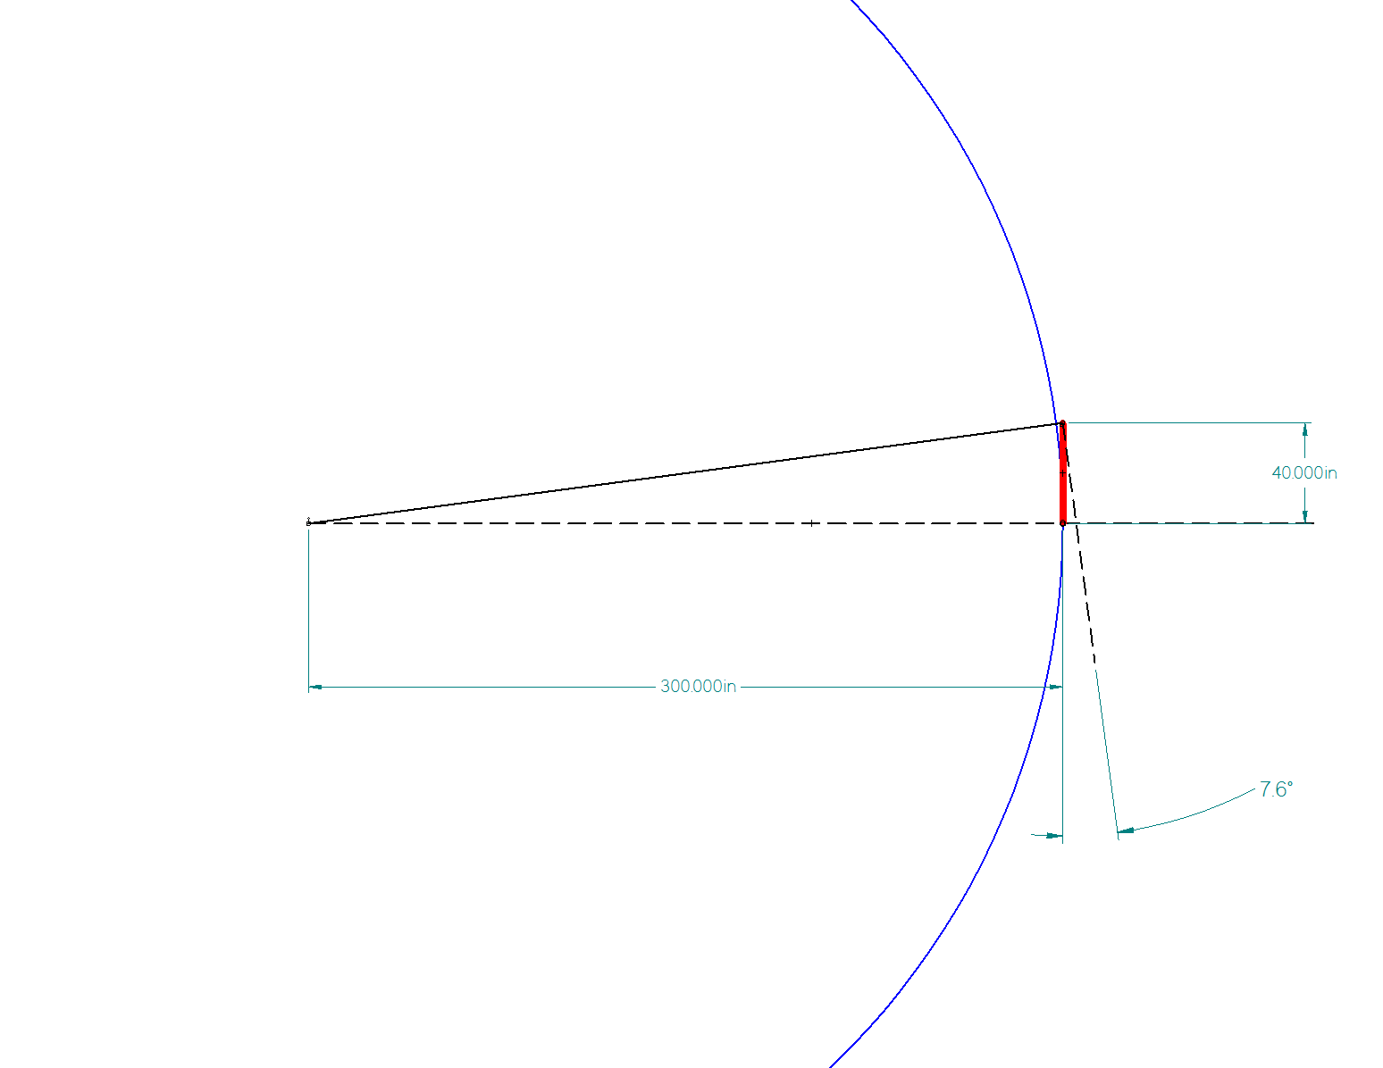

Assuming both front wheels having the same angle of rotation

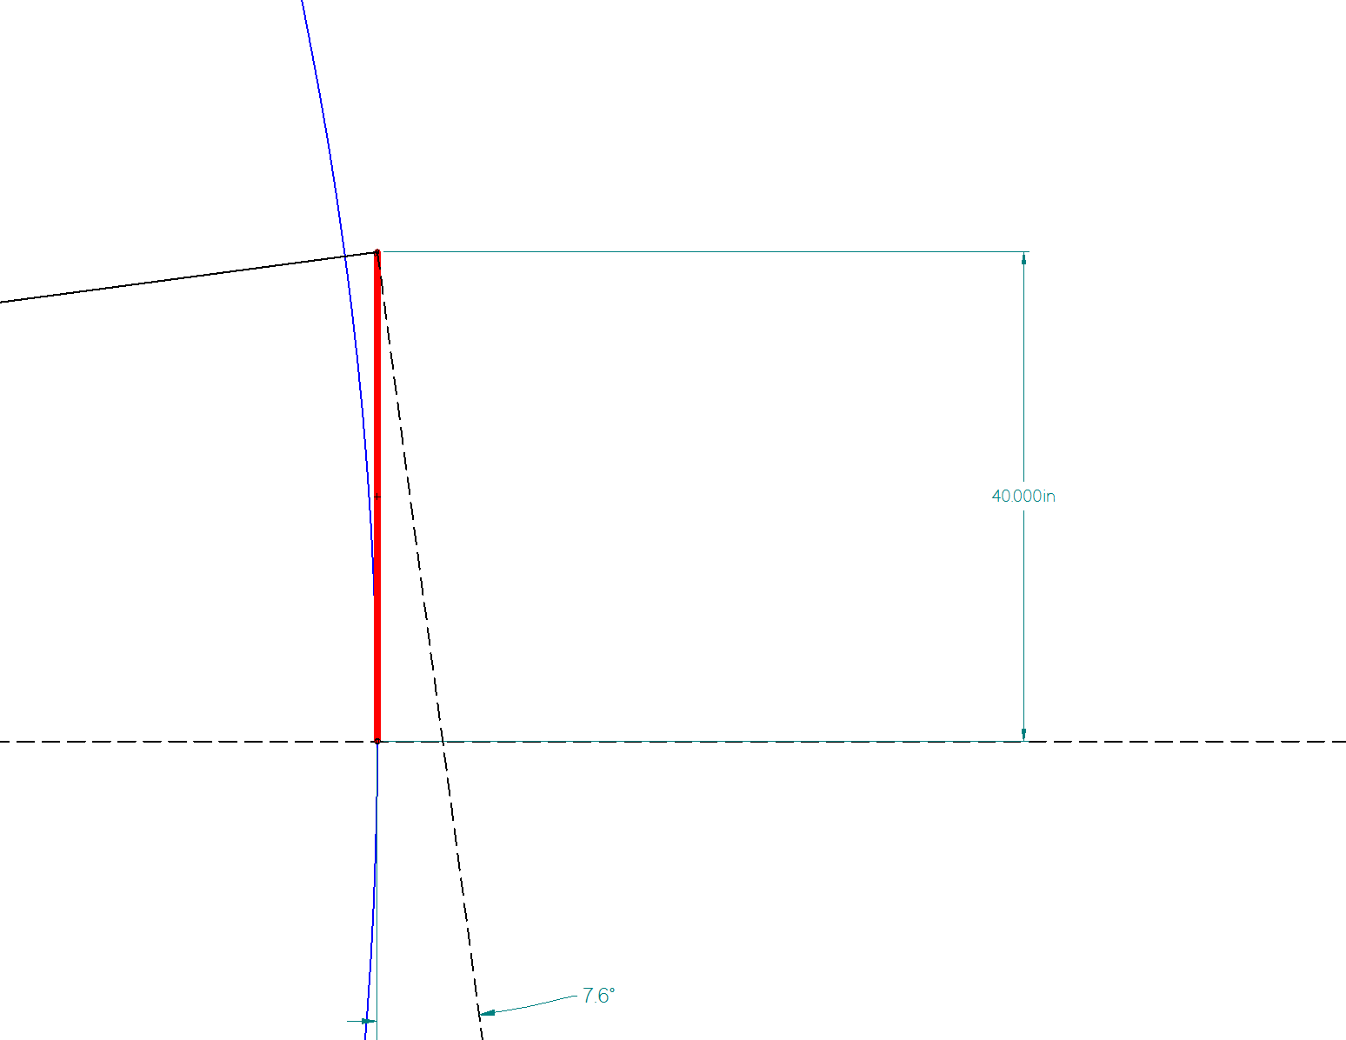

Turning 2 Sketch
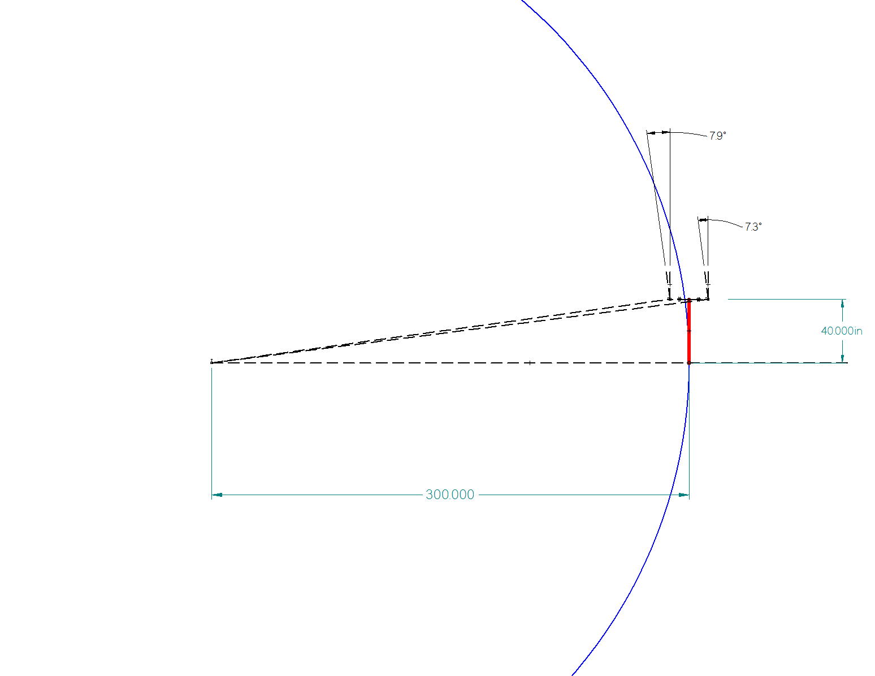

Both wheels rotate independently

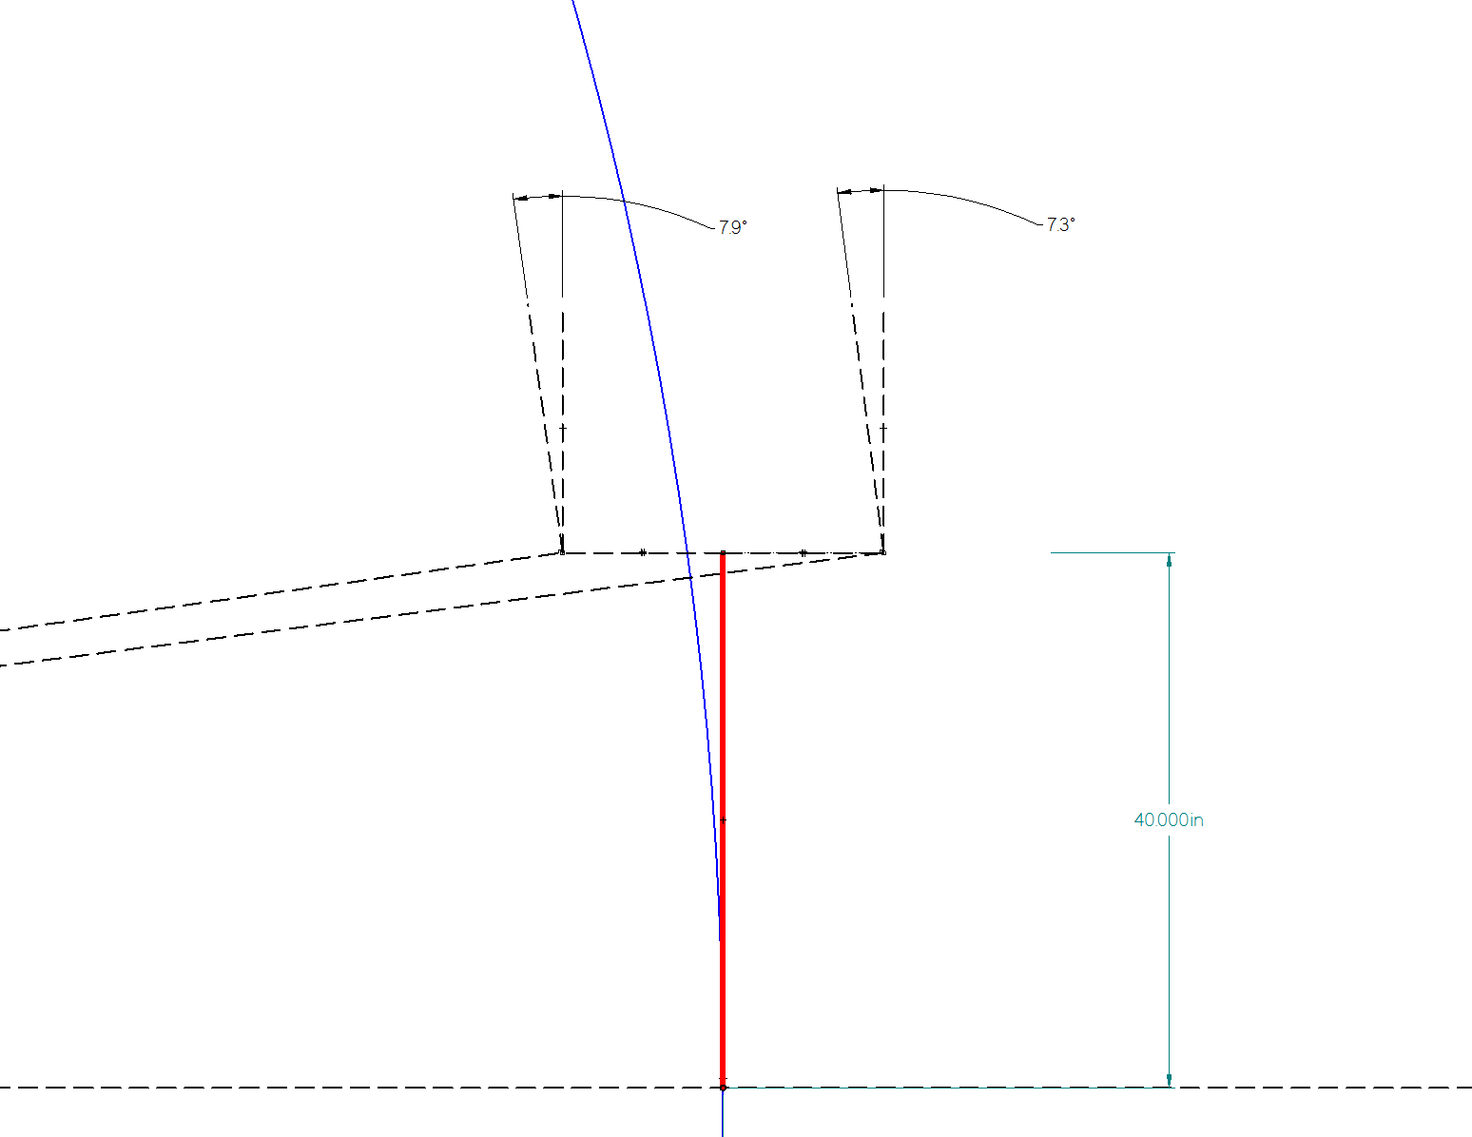

Drive Chain

Mechanical Advantage

Performance Testing
Turning Radius
Test | Radius
1 | 12 | ft
2 | 11.5 | ft
3 | 12 | ft
4 | 12 | ft
5 | 11.75 | ft
Average | 11.85 | ft
Braking Distance
Test | Distance
1 | 10 | ft
2 | 12 | ft
3 | 13 | ft
4 | 16 | ft
5 | 14 | ft
6 | 12 | ft
7 | 15 | ft
Average | 13.142857 | ft
Top Speed
Rider | Speed
Aaron | 27.41 | MPH
Valesha | 14.48 | MPH
Justin | 27.51 | MPH
David | 24.94 | MPH
Average | 23.585 | MPH
Acceleration
Test | Rider | Time
0-10 | David | 4.41 | sec
0-10 | David | 4.31 | sec
0-10 | Justin | 4.44 | sec
0-10 | Justin | 3.6 | sec
0-10 | Aaron | 4.11 | sec
0-10 | Aaron | 4.72 | sec
Average |  | 4.265 | sec
Test | Rider | Time
0-15 | David | 6.95 | sec
0-15 | David | 5.73 | sec
0-15 | Justin | 5.12 | sec
0-15 | Justin | 5.37 | sec
0-15 | Aaron | 6.45 | sec
0-15 | Aaron | 5.74 | sec
Average |  | 5.893333 | sec
Test | Rider | Time
0-20 | David | 9.39 | sec
0-20 | David | 9.19 | sec
0-20 | Justin | 10.54 | sec
0-20 | Justin | 8.72 | sec
0-20 | Aaron | 10.81 | sec
0-20 | Aaron | 11.63 | sec
Average |  | 10.04667 | sec

Detailed Engineering Drawings

