Housing

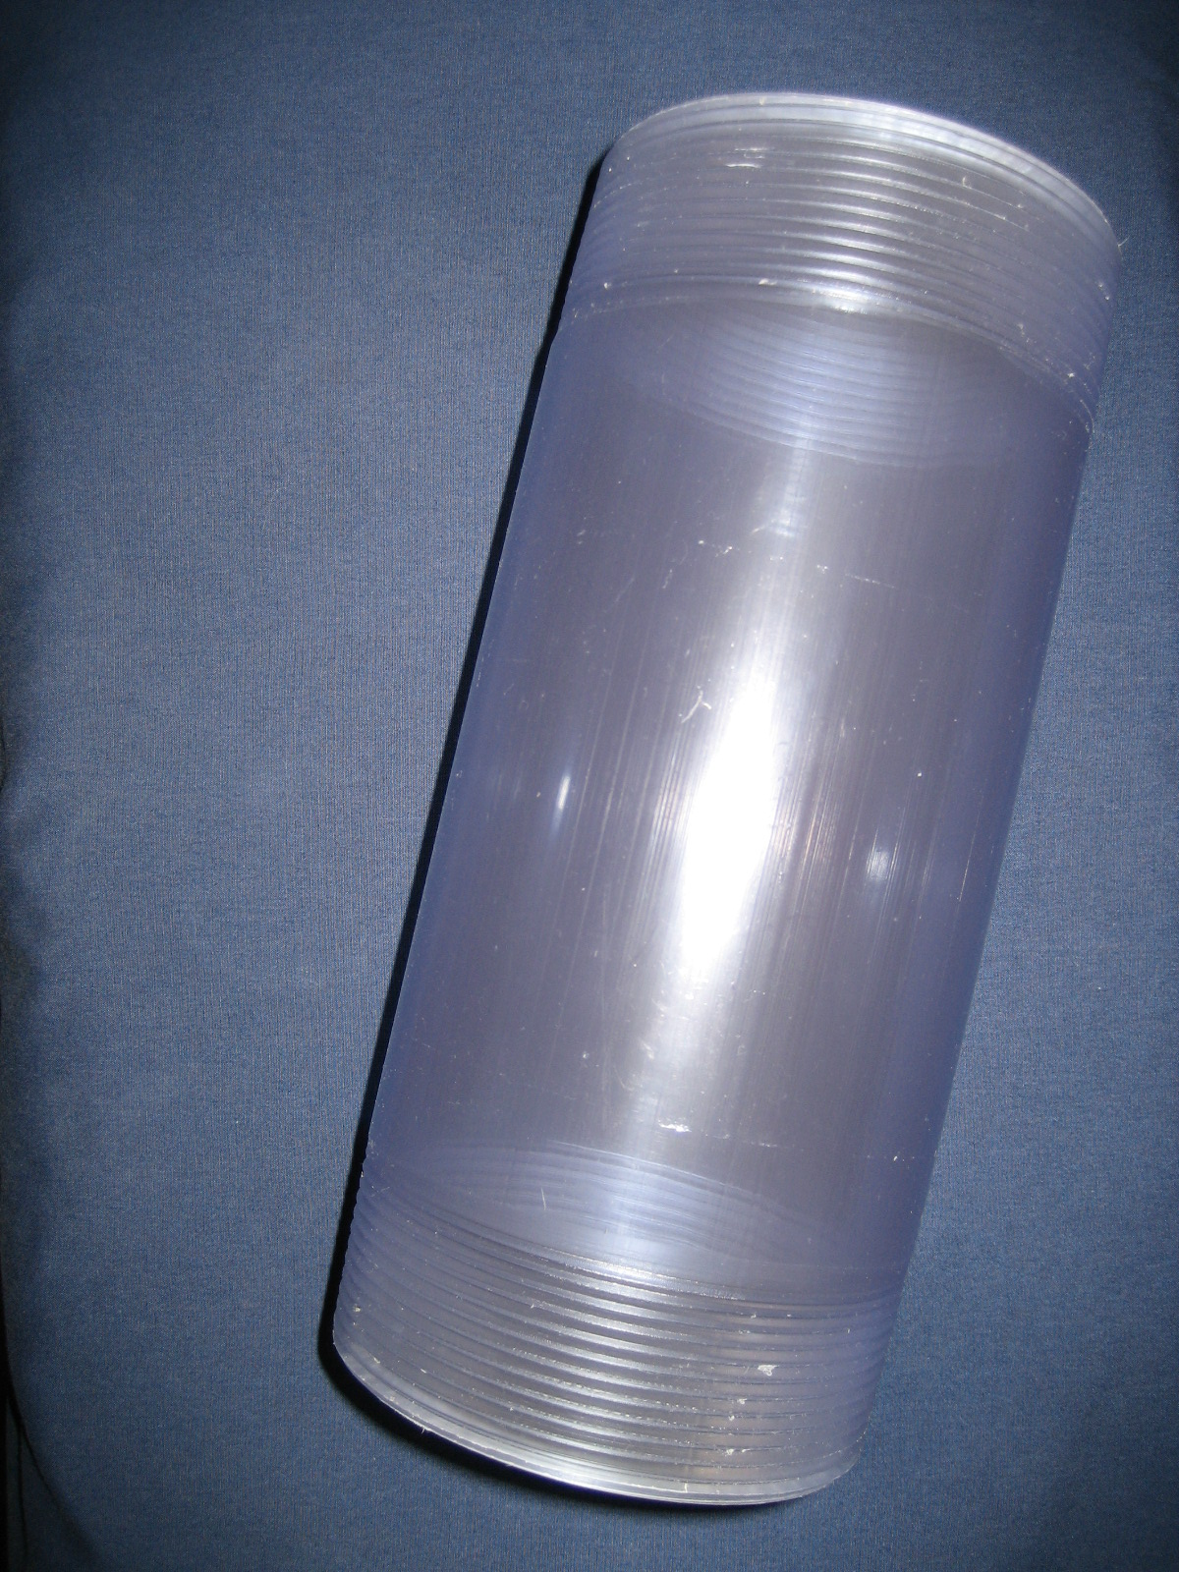
10” Clear Threaded PVC Pipe: Length-10.0in Inner Diameter-4.06in Outer Diameter-4.504in Weight-665.95g

Description: 4” diameter clear PVC pipe. Used along with 4” end caps to provide water tight seal to protect internal components. Threaded design allows for disassembly of the housing during testing. Clear PVC allows for sunlight to be absorbed by the photo voltaic cell. 4” diameter allows for maximum available buoyancy. Positive buoyancy is created by the displacement of the denser water with less dense air. The 4” diameter clear PVC was the largest diameter pipe available which could be threaded.

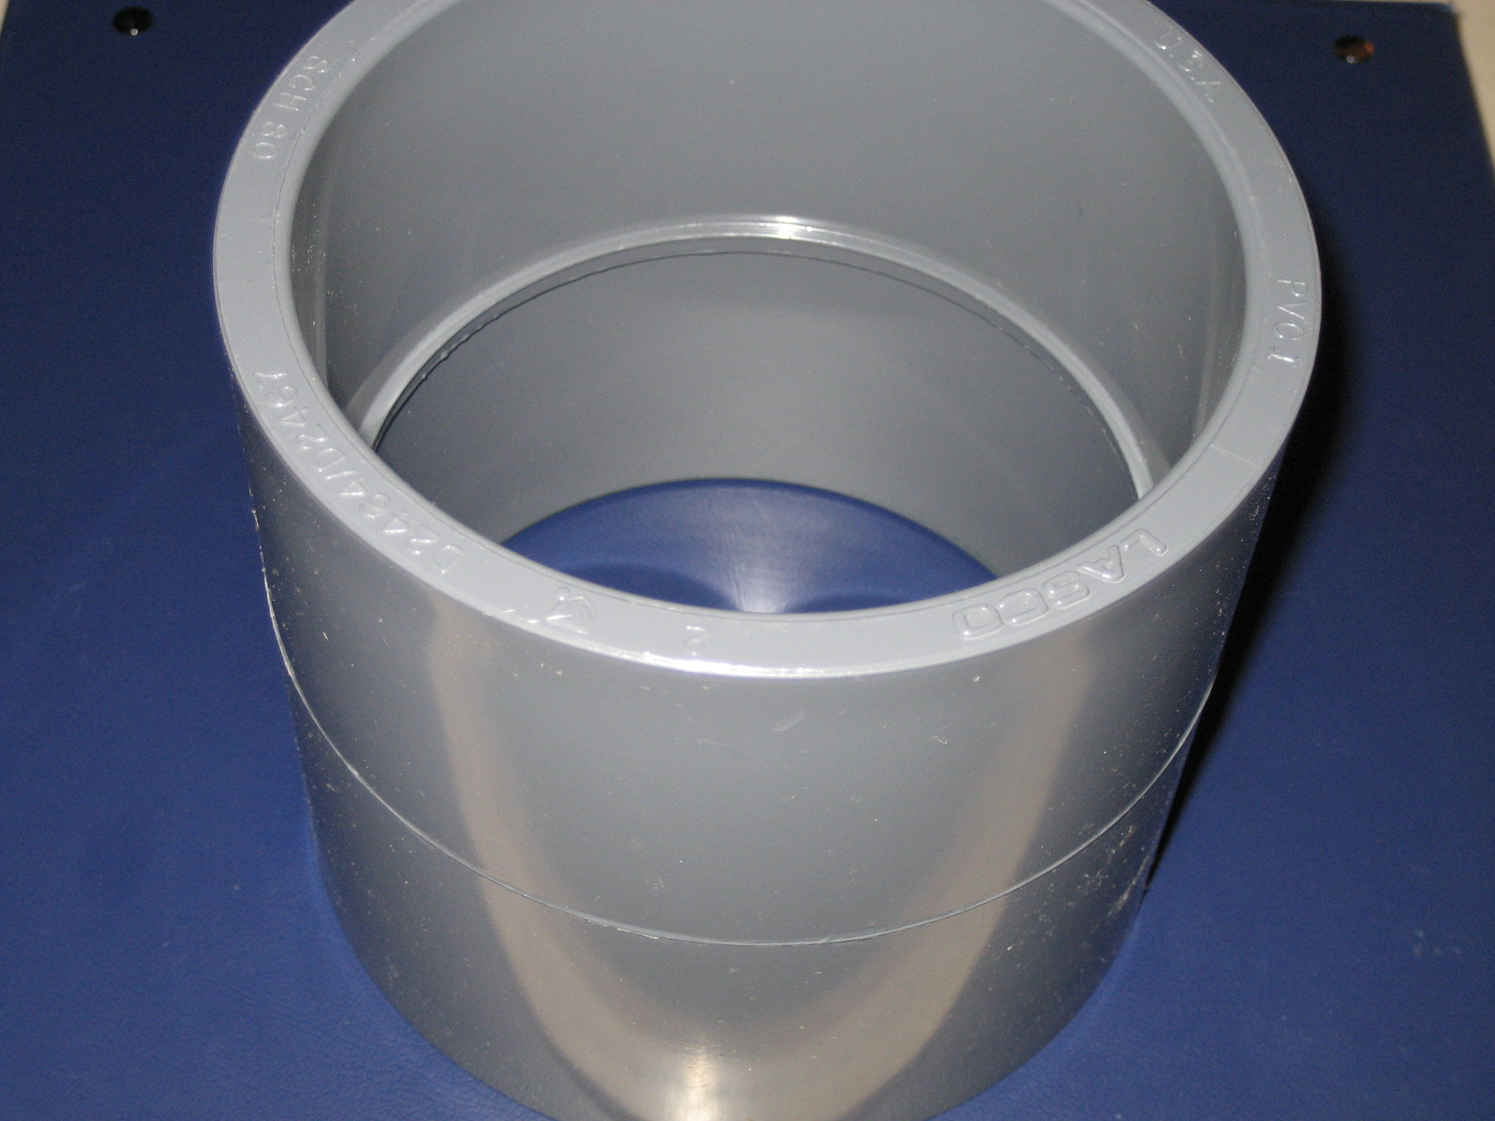
4” PVC Coupler: Length-4.725in Inner Daimeter-4.504in Outer Diameter-5.229in Weight-366.55g

Description: PVC coupler is used to join two PVC pipe pieces. The inside of the coupler contains a lip which is used to hold a divider. Using the coupler, divider and two halves of a PVC pipe the housing is separated into two compartments. One compartment is used to hold water and the air bladders. This provides for a protected area for the bladders and allows the bladders to displace water through holes in the end cap. The other compartment is dry area which houses components of the air delivery system and must remain air tight.

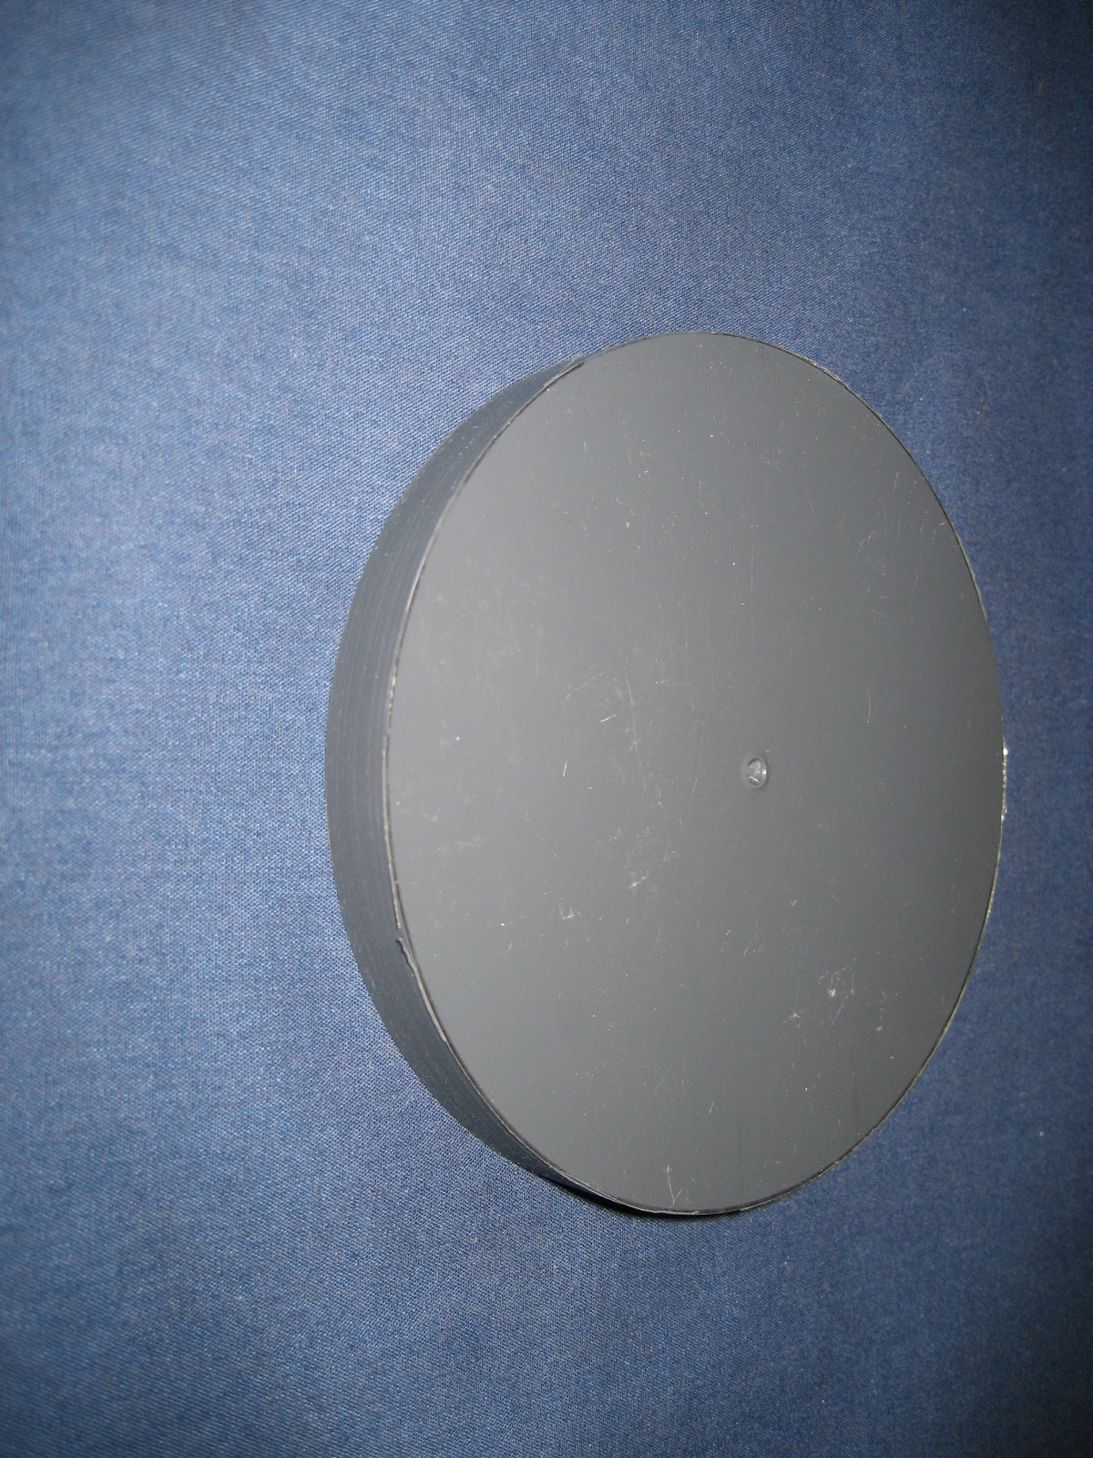
Round PVC Sheet: Width-.491in Diameter-4.508in Weight-180.45g

Description: PVC sheet used to separate PVC pipe into two compartments. PVC sheet was machined down to inner diameter of PVC coupler. Threaded holes through PVC sheet provides water tight seal with threaded fittings. One-way check valve, the fitting for the resurfacing bladder, and the fitting for buoyancy bladder are threaded through the sheet.

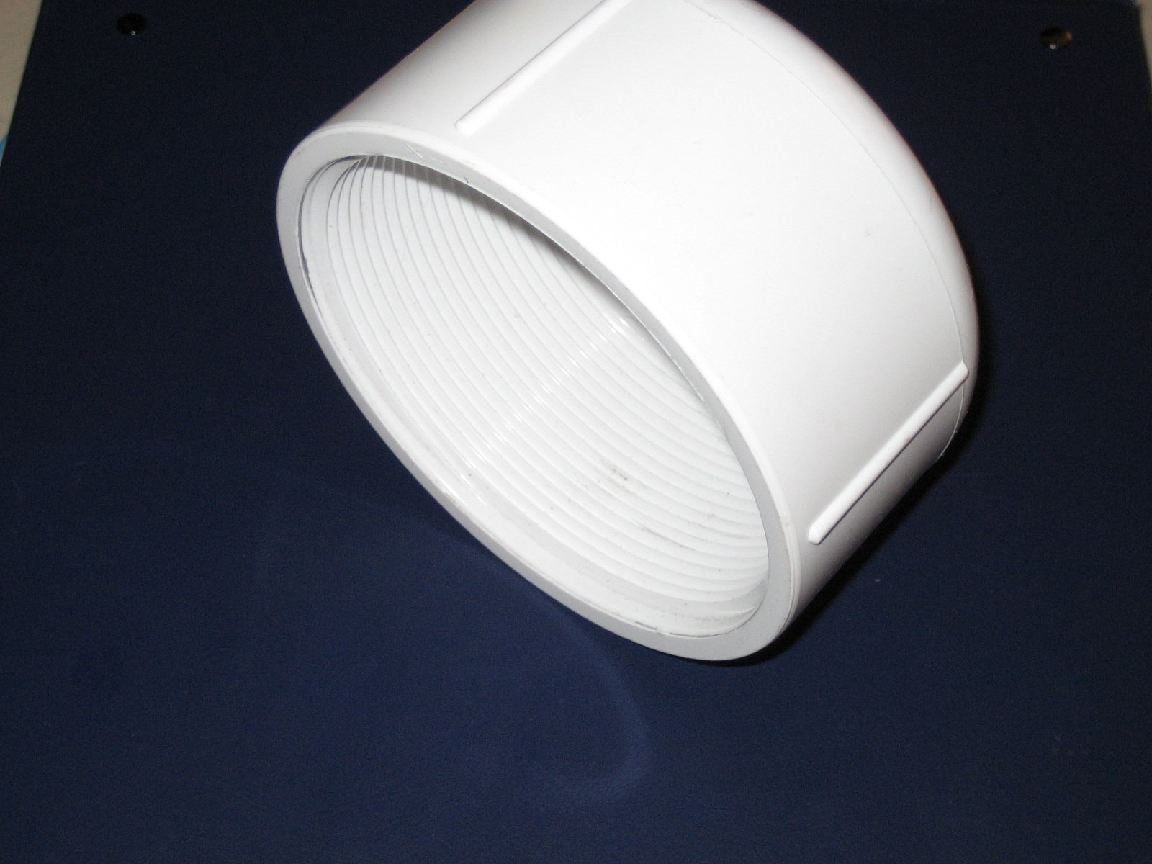
4” Threaded PVC End cap: Length-2.912in Inner Diameter-4.255in Outer Diameter-5.111 Weight-407.1g

Description: 4” diameter threaded end cap is used to provide water tight seal to the PVC pipe. Threaded design allows for assembly and disassembly during testing.

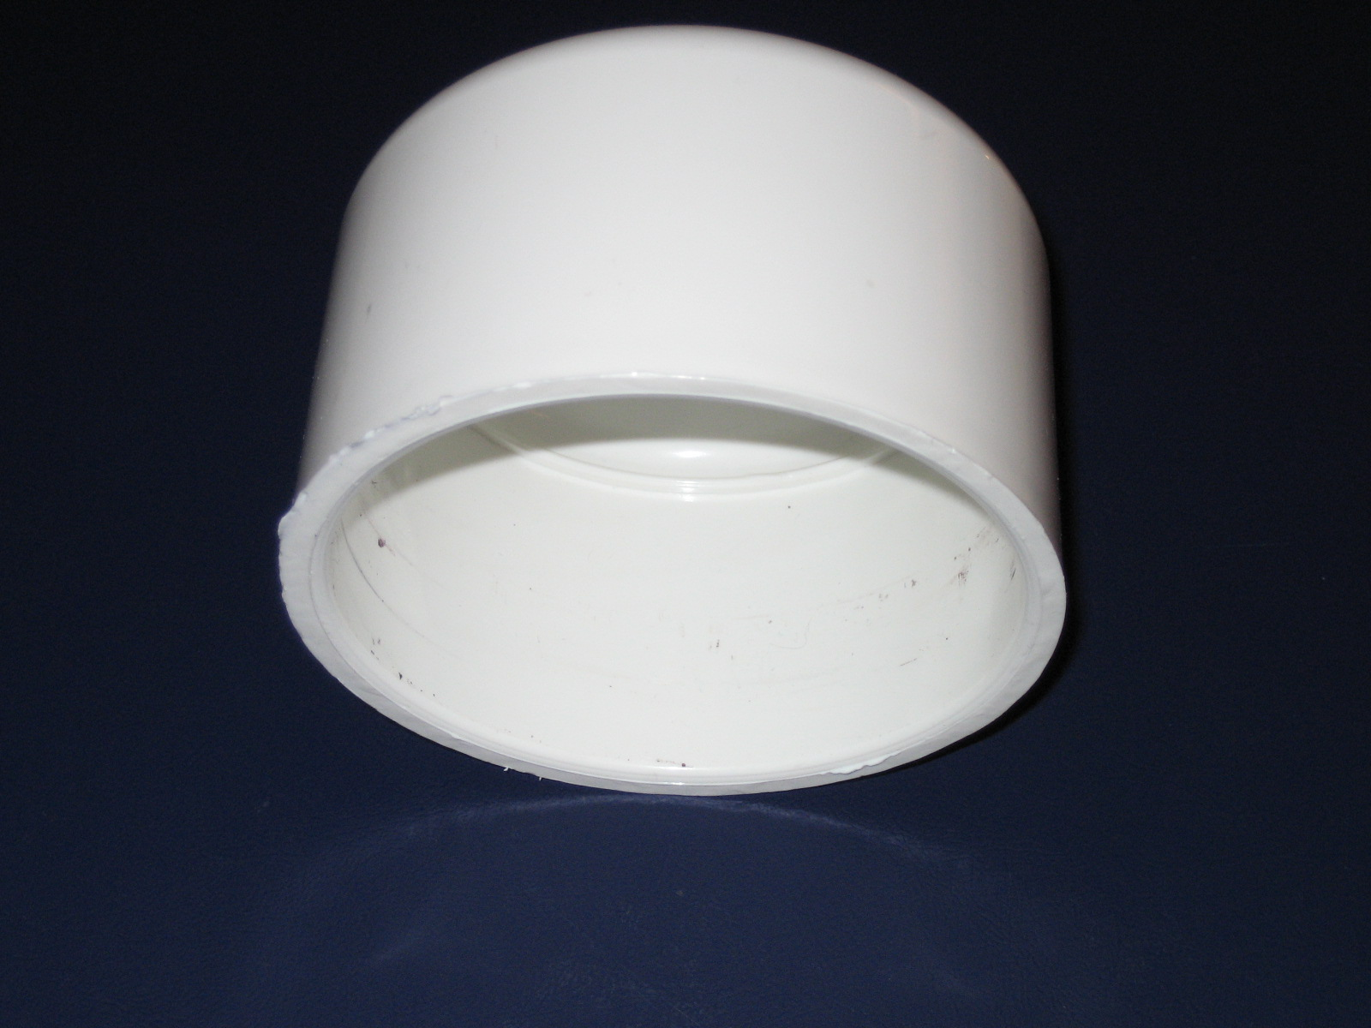
3.5” PVC End cap: Length-2.879in Inner Diameter-3.501in Outer Diameter-3.947in Weight-211.5g

Description: PVC end cap provides air tight connection to 3” diameter PVC pipe. The 3” diameter PVC housing is used to hold the CO2 canister and protect it from any impact. Also provides positive buoyancy by displacing water.

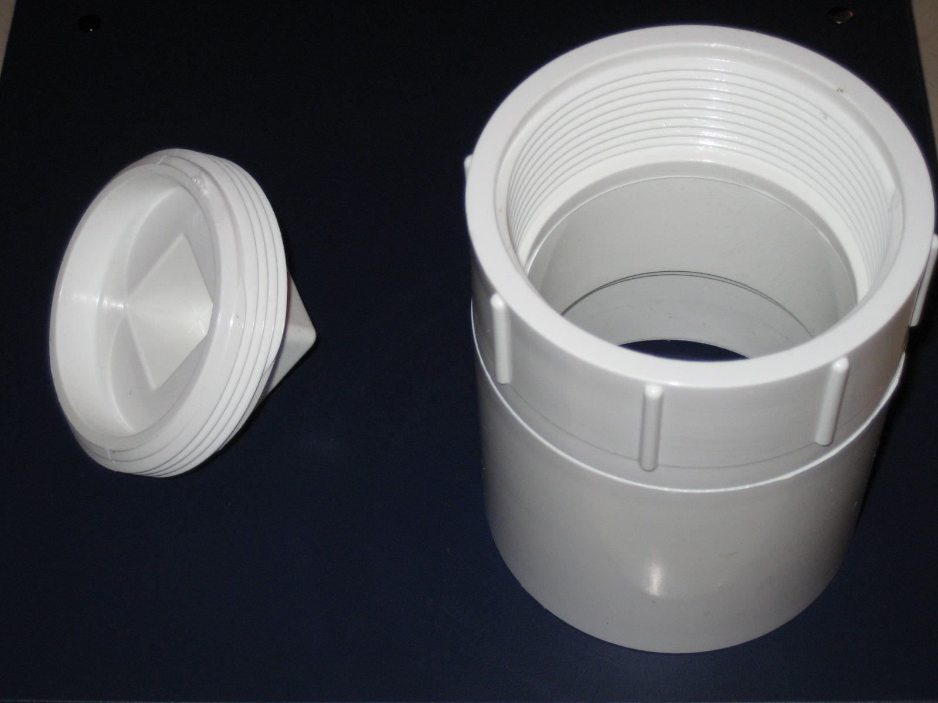
3.5” PVC Threaded End cap & Coupler: Length-4.866in Inner Diameter-3.514in Outer Diameter-3.991in Weight-547.0g

Description: 3.5” threaded PVC end cap and coupler. End cap is used to allow for the installation and removal of CO2 canister when the canister is emptied.

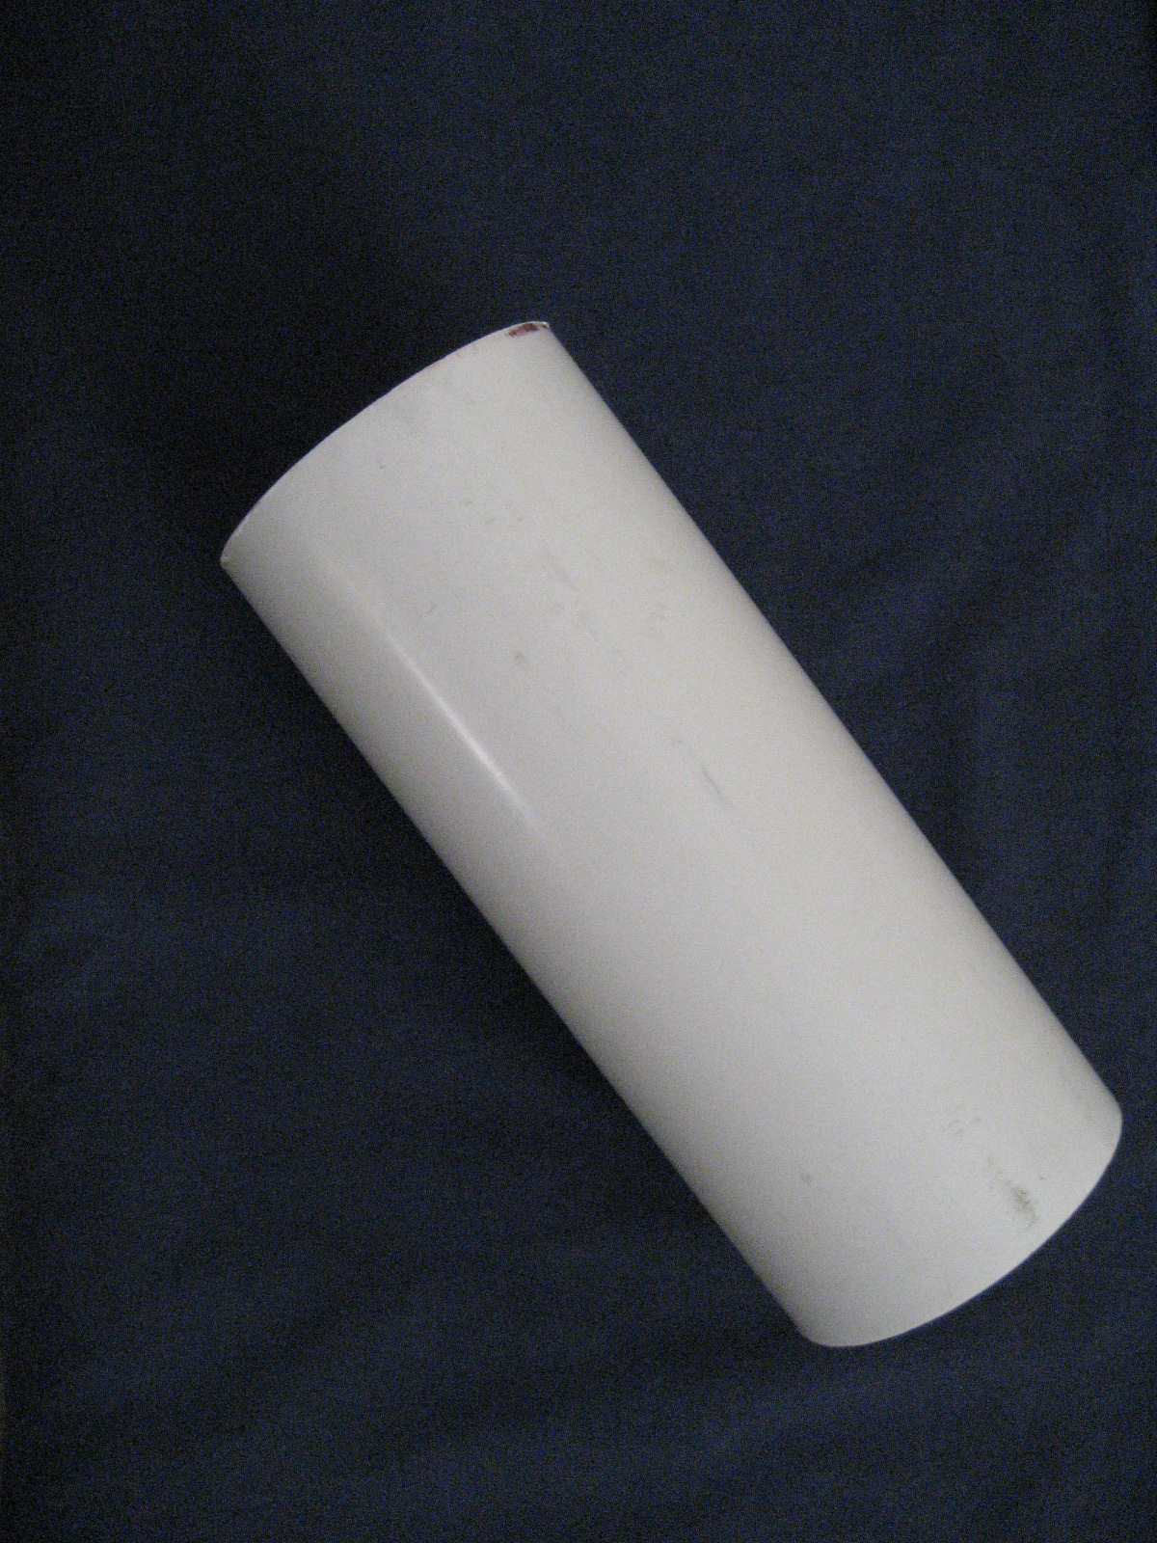
3” PVC Pipe: Length-8.1875in Inner Diameter-3.022in Outer Diameter-3.511in Weight-299.05g

Description: 3” diameter PVC pipe. PVC pipe is used to house the CO2 canister and protect it from any impact that may occur. PVC pipe provides positive buoyancy by displacing water.

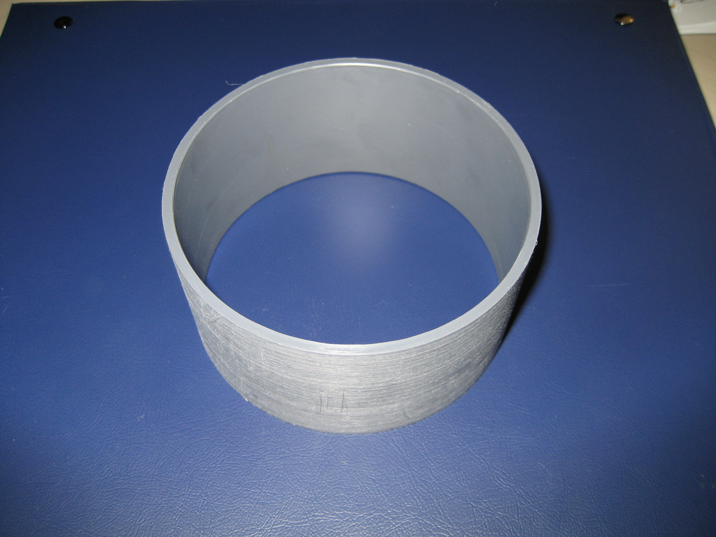
4” Diameter PVC Coupler: Length-2.0in Inner Diameter-3.754in Outer Diameter-3.986in Weight-66.4g

Description: The coupler was used after the team discovered the air system was longer then originally planned. Using the coupler to join the 10” housing to an additional 5” housing the length now allows for fitting the entire air system inside the housing. Additionally the extra length provides increased buoyancy which is another problem that had to be addressed.

