Housing Connections

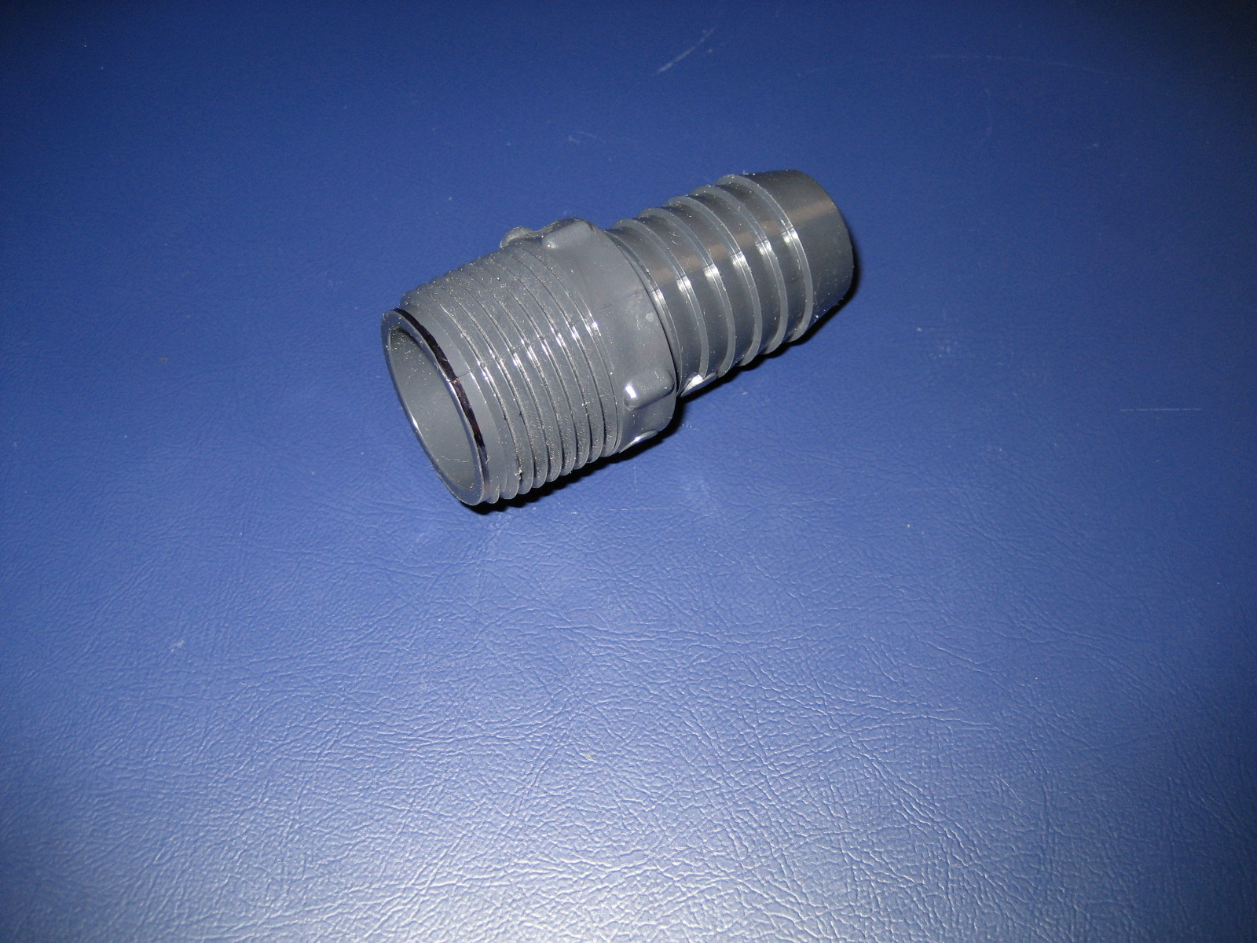
1” PVC Barb to Thread Fitting: Length-2.648in Diameter-1.081in Weight-26.5g

Description: The fitting is used to connect 1” inner diameter hose from one housing to another. The hose provides protection to wiring and copper tubing while also preventing water from entering the submersible robot.

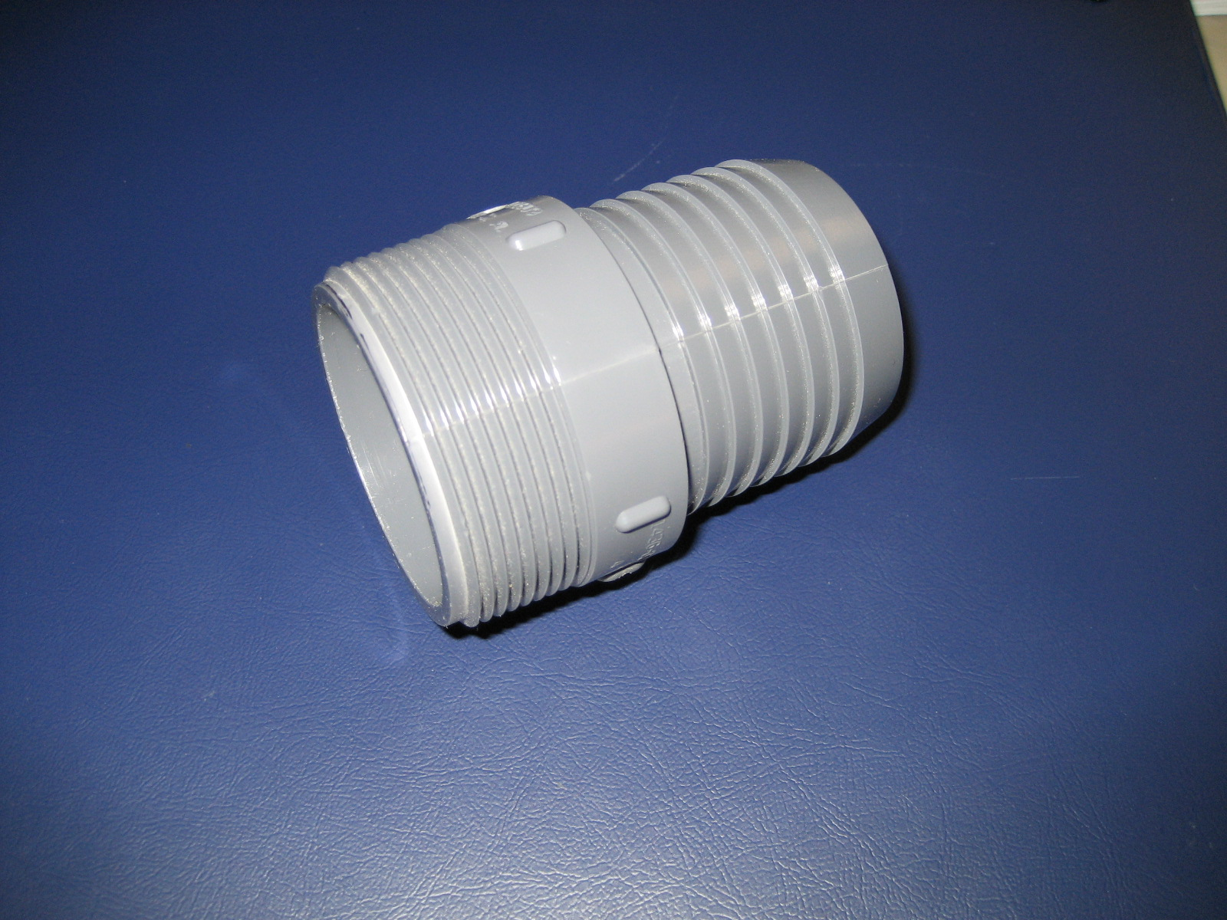
2” PVC Barb to Thread Fitting: Length-3.248in Diameter-2.115in Weight-82.2g

Description: The fitting is used to connect 2” inner diameter hose from one housing to another. The hose provides protection to wiring and copper tubing while also preventing water from entering the submersible robot.

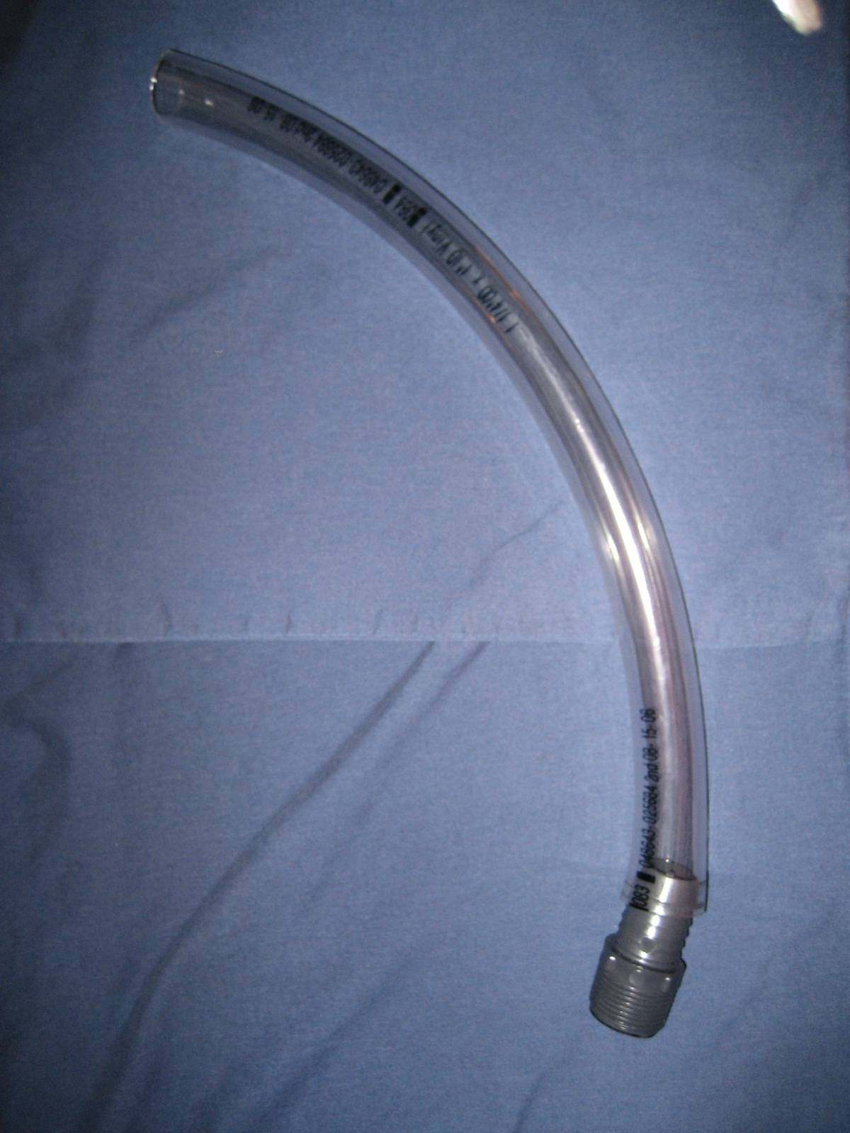
1” Inner Diameter Hose: Inner Diameter-1in Outer Diameter-1.25in

Description: Used to connect housing to housing to prevent water from entering the submersible robot and provides protection for wiring and copper tubing.

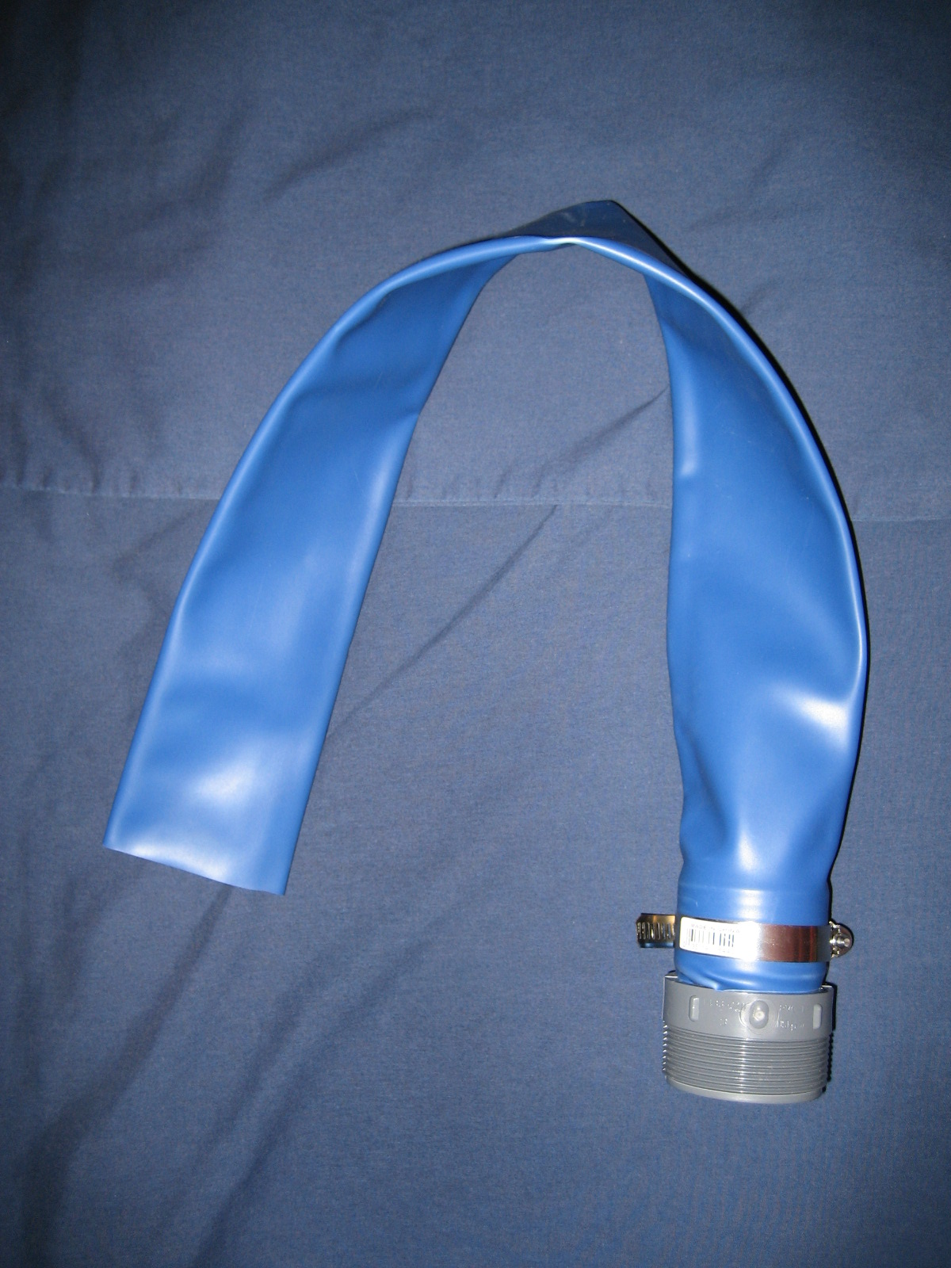
2” Inner Diameter Rubber Hose: Diameter-2in

Description: Used to connect housing to housing to prevent water from entering the submersible robot and provides protection for wiring and copper tubing. This rubber housing was chosen for it’s flexibility around the copper fittings not provided by other hoses.

