Electronics

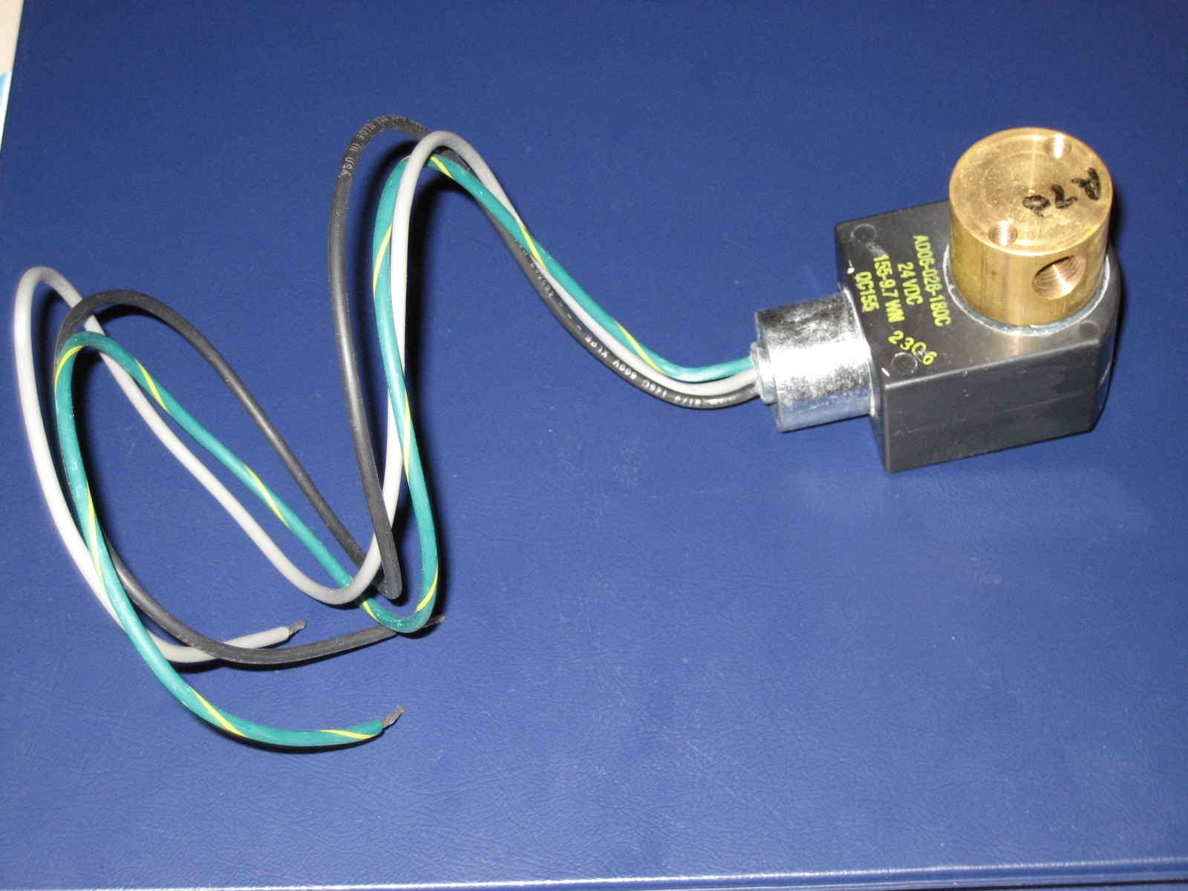
2-Way Direct Acting Solenoid Valve: Length-2.925in Height-2.308in Thread-.125in Weight- 454.35g

Operating Specifications: .4 Amps @ 24 Volts DC
Max Operating Pressure: 500psi

Description: Changes electrical power into mechanical power. As .4 amps of current @ 24 volt DC is run through the solenoid valve, a valve inside is opened to allow for the transport of a fluid. It is used to allow for the controlled release of CO2 throughout the air delivery system. Solenoid valves are used for both the buoyancy system and the resurfacing system. This solenoid valve was chosen for its high pressure rating and because it operates on direct current. The solenoid valves will be controlled using a programmable micro controller. The solenoid valves contain female 1/8” thread pattern and are connected to the system with a 1/8” to ¼” flare fitting.

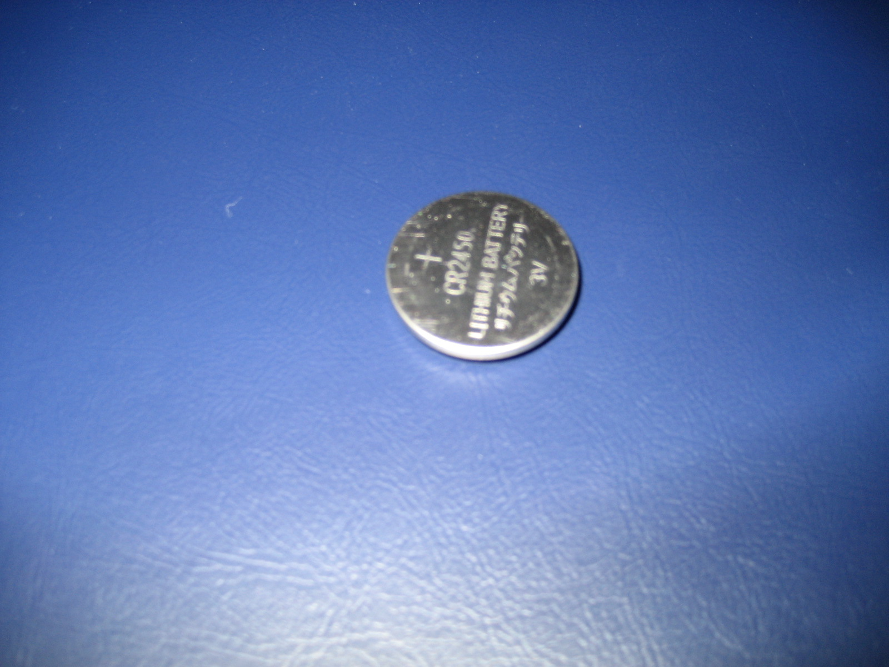
Lithium Coin Cell Battery: Diameter-.963in Height-.198in Weight-6.55g

Specifications: 560 milliamp hours @ 3 Volts

Description: 3 Volt coin cell battery selected based on several key specifications, voltage requirement, lightweight, smaller dimensions, and most importantly high milliamp hours. The batteries are used to supply power to the solenoid valves which operate at 24 Volt DC. The batteries were chosen primarily because of the demands that will be put on them. The batteries will be running for several days and therefore needed to provide higher milliamp hours.

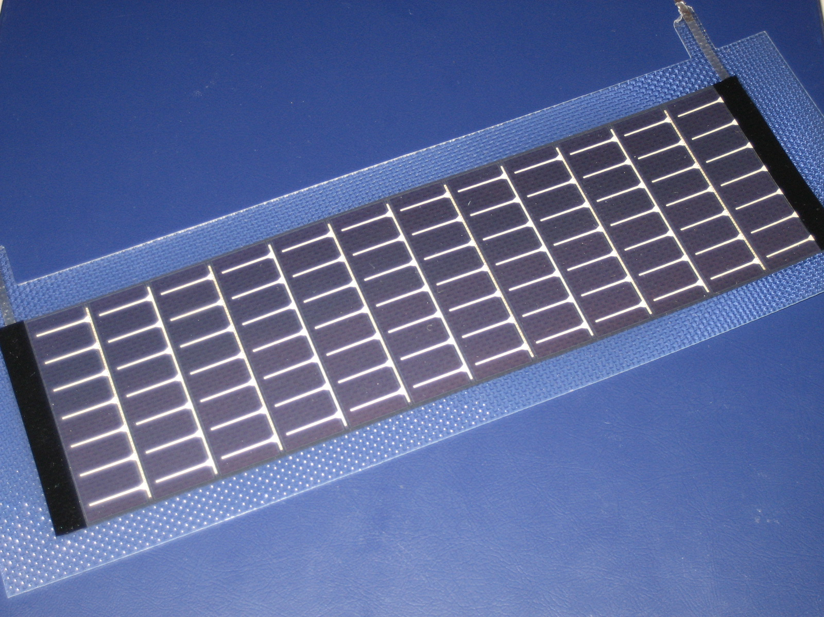
Photo Voltaic Cell: Length-11.5in Width-3.875in Weight-25g

Operating Specifications: 100mA @ 7.2 Volts

Description: Converts solar energy to electrical power. During ideal conditions this solar cell is capable of producing .1 amps @ 7.2 volts. The solar cell is used in part of the power requirement for the resurfacing system. As light is absorbed in the cell, power will be sent to one of the solenoid valves allowing CO2 to flow to a rubber air bladder which will displace water and create positive buoyancy inside the robot allow it to rise and return to surface. Solar cell is soldered to wire which is run to the controller that is connected to batteries.
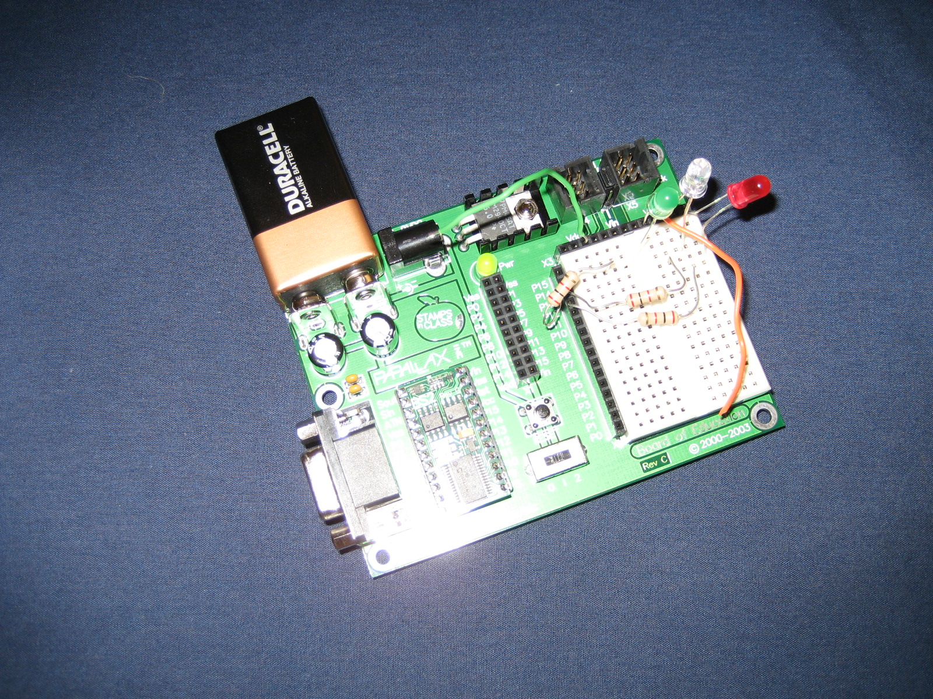
Microcontroller: Length- 2.0in Width-1.375in Weight-90.7g

Description: A microcontroller is small low powered comp0uter capable of interfacing with various components and performing basic calculations and logic checks. This model is typically used by hobbyist and educational institutions.

