D3 Imbalance Detection Machine
Operations Manual

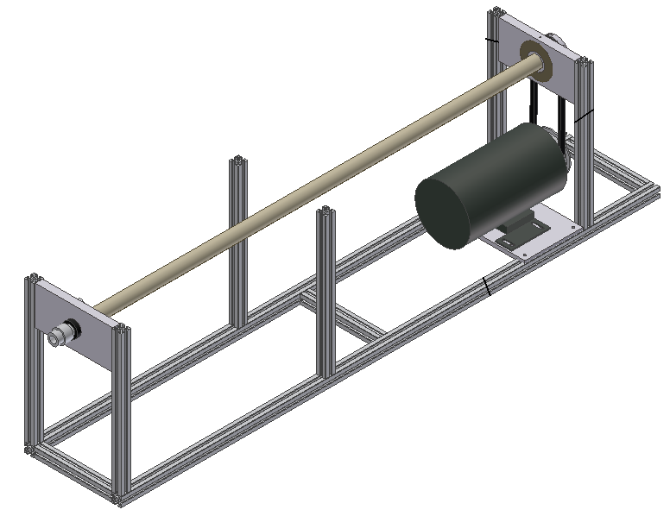

CERN Team
Collaboration with Romania

Group 13

Derrick Nickerson
David Sediles
Dumitru Moldovan

Table of Contents

I. Materials Needed 2
II. Tools Required 3
III. D3 Detection Machine Assembly 4
IV. Mounting Shaft Procedure 5
V. Electrical Setup 8
VI. Caution 10

Table of Figures

Figure III-I Corner connectors 4
Figure III-II Side connector 4
Figure IV-I: Split collar 5
Figure IV-II: Soft material in the bearing 5
Figure IV-III: Carefully running the shaft through the bearing into the bushing 5
Figure IV-IV: Bearing roller cage 6
Figure IV-V: Loose pulley belt 6
Figure IV-VI: Align pulley with motor shaft 6
Figure IV-VII: Tight pulley belt 7
Figure IV-VIII: Pulley Set screw 7
Figure 0-I: Motor controller set-up 8
Figure 0-I: Charged amplifier 8
Figure 0-II: Data acquisition Board set-up 9
Figure 0-I: Tachometer set-up 9

Materials Needed

Materials | Quantity
1/4" T-Nut Fasteners | 70
L-shape connector | 6
Corner connector | 4
Side connector | 2
(1.42 m) Long 6105-T5 aluminum structural 80/20 | 2
(19.69 cm) Long 6105-T5 aluminum structural 80/20 | 3
(36.52 cm) Long 6105-T5 aluminum structural 80/20 | 2
Pulley | 1
Pulley belt | 1
2" Dia. Aluminum Tube | 1
Bushing plate | 1
Open race bearing plate | 1
Motor base plate | 1
Split collar | 1
Open race bearing | 1
Tachometer raiser | 1
Bruel and Kjaer Tachometer | 1
BNT tri-axial cable | 1
Bruel and Kjaer Accelerometer | 1
BNC co-axial Accelerometer cable | 1
Data acquisition board | 1
Data acquisition board cable | 1
Accelerometer Amplifier | 1
Amplifier Power source | 1
One DC Horsepower motor | 1
14 V AC/DC Converter | 1
9 Volt battery | 1
Reflective tape (silver) | 1
Computer (not provided) | 1

Tools Required

- Small flat head screw driver
- 5/32 Allen wrench
- 3/32 Allen wrench

D3 Detection Machine Assembly

- Place the Bushing plate assembly on the left side of assembly (opposite end from motor). Using the T-nut fasteners and corner connectors, screw the bottom portion of the bushing plate assembly to the structural frame. | 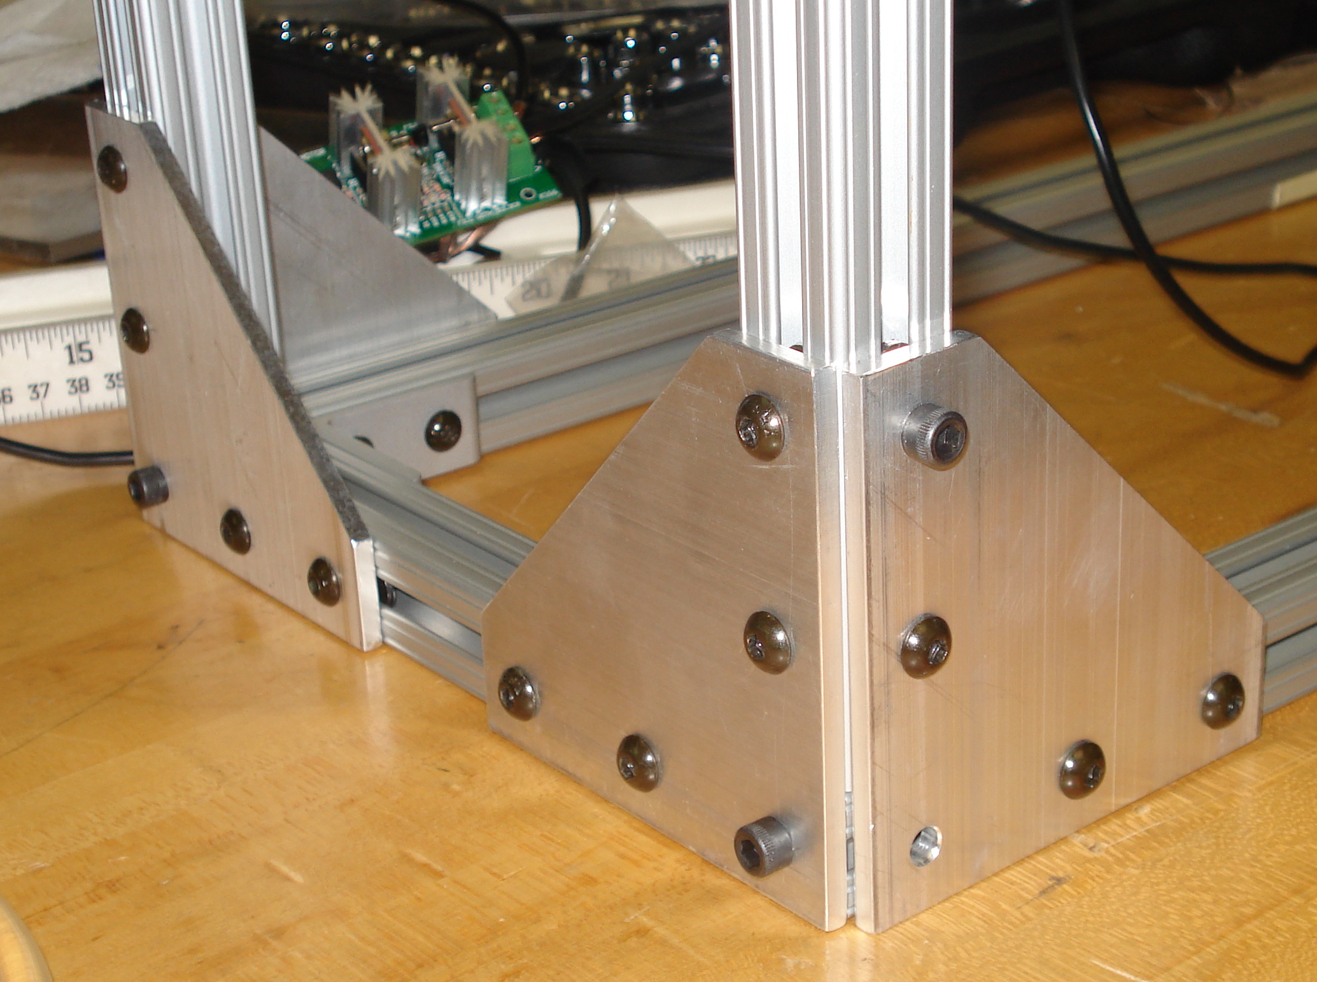  Corner connectors  Figure III-I Corner connectors
- Place the Bearing plate assembly on the motor side of the structural frame. Using T-nut fasteners and 2 side connecters, screw the bottom portion of the Bearing plate assembly to the structural frame. Ensure that the extruded lip on the bearing is pointing towards the bushing plate assembly. Also make sure that the bearing plate assembly is flush against the motor base plate in order to ensure proper alignment. | 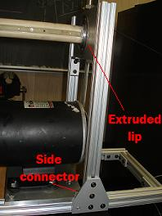  Figure III-II Side connector

Mounting Shaft Procedure

- Remove the four stems from the titanium bellow that of the opposite end of the bearing roller cage.

- Attach both halves of the split collar and place it on the side opposite of the bearing roller cage. Be sure that the flat edge of the split collar is aligned with flat edge of the shaft. Line the both halves of the split collar using the provided pins. Once together around the shaft, thread the provided screws into the proper holes of the split collar. | 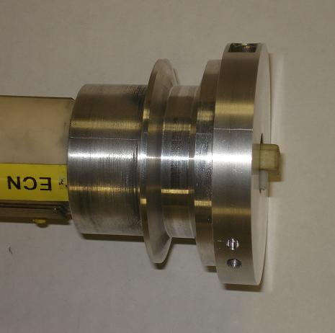  Hole  Figure IV-III: Split collar
- Place a segment of cloth (or very soft material) in the inner bore of the bearing. | 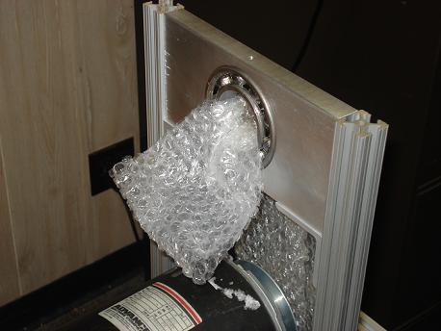  Figure IV-IV: Soft material in the bearing
- Very carefully. Run the bearing roller cage end of the shaft through the bearing plate of the D3 detection machine. When getting close to complete insertion of the bearing roller cage into the bushing, remove the cloth. | 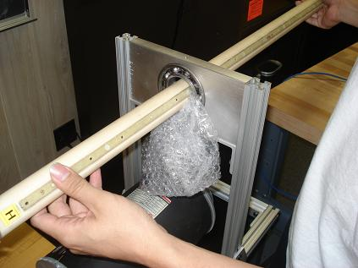  Figure IV-V: Carefully running the shaft through the bearing into the bushing
- Very carefully. Push down on the protruding rollers on the bearing roller cage, and insert the bearing roller cage into the bushing plate of the D3 detection machine. Pull shaft through until the pulley side of the split collar is 1 mm away from the bearing. | 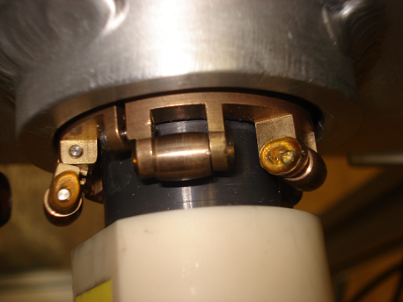  Figure IV-VI: Bearing roller cage
- Place elastic pulley belt in the grove of the split collar. | 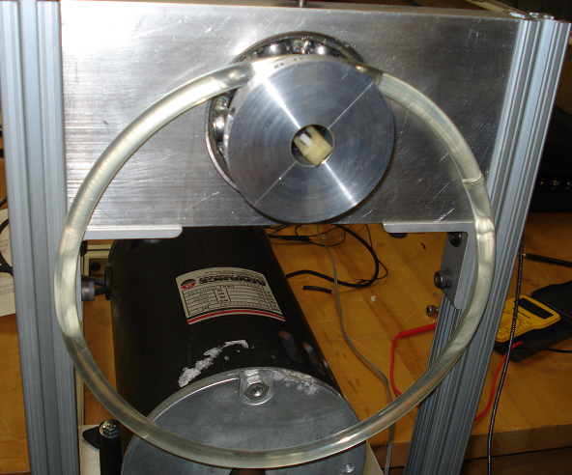  Figure IV-VII: Loose pulley belt
- Without tension in the pulley belt, place pulley on the bottom portion of the pulley belt. | 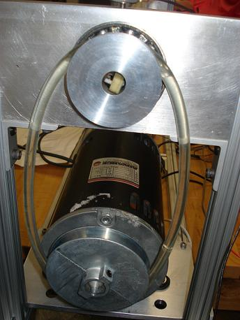  Figure IV-VIII: Align pulley with motor shaft
- While stretching the elastic pulley belt, align the pulley keyway hole with the keyway extrusion of the motor shaft. Insert the shaft of the motor into the hole of the pulley. The set screw holder on the pulley should be in the direction away from the motor. | 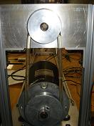  Figure IV-IX: Tight pulley belt
- Be sure the elastic pulley belt is vertical, by aligning the split collar pulley grove with the grove of the pulley. *As misalignment will induce vibration.

- Tighten the set screw provided with the pulley. | 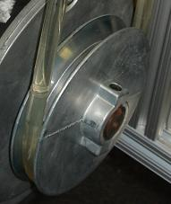  Figure IV-X: Pulley Set screw
** To accommodate for the lengths of a smaller shaft, one will have to loosen the bolts of the motor base plate and the bearing plate assembly. Measure the appropriate distance from the bushing plate assembly and mark it on the 80/20 for accurate repeatable changes. Then tighten the bolts back.

Electrical Setup

- Connect motor cables to motor controller inputs: M1 and M2.  - Connect power supply to the motor controller positive to positive, ground to negative. | 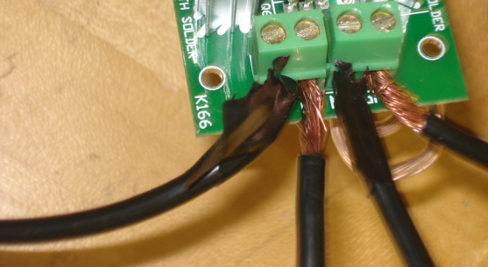  V+  V-  M 1  M 2  Figure V-XI: Motor controller set-up
- Turn the potentiometer such that the flat is in a horizontal position (parallel to the board). This is the zero position. | 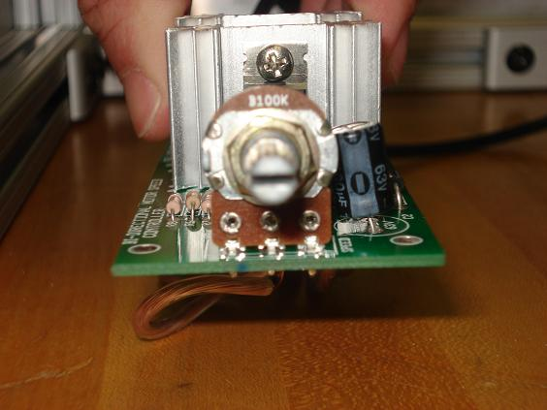
- Tightly screw the set-screw into accelerometer.  - Screw the accelerometer into the bearing plate for first reading.  - Repeat the same procedure for the bushing plate when taking the second readings. | 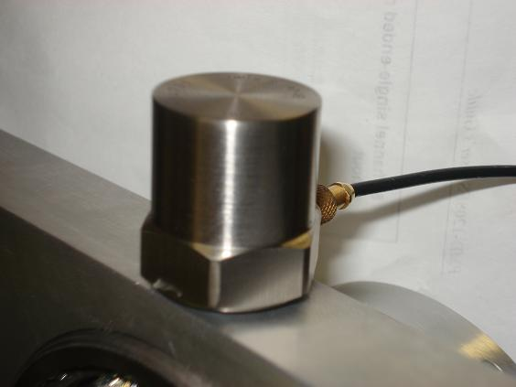
- Connect accelerometer to the input jack on the front face of Charge amplifier.  - Turn the Charge Amplifier knob to 10 mV/pC. | 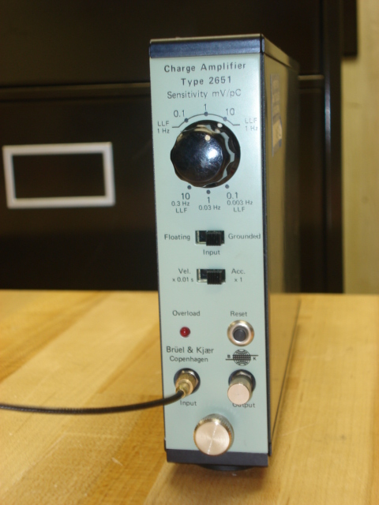  Figure V-XII: Charged amplifier
- Connect Charge Amplifier to Amplifier Power Supply. | 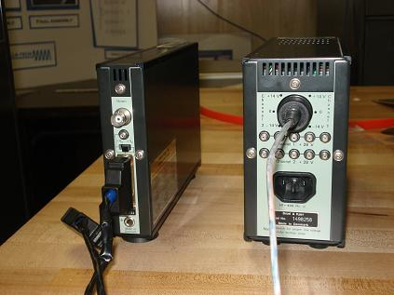  10 Mv/pC  Figure V-XIII: Data acquisition Board set-up
- Connect Charge Amplifier to DAQ: Channel 0 & Ground. | 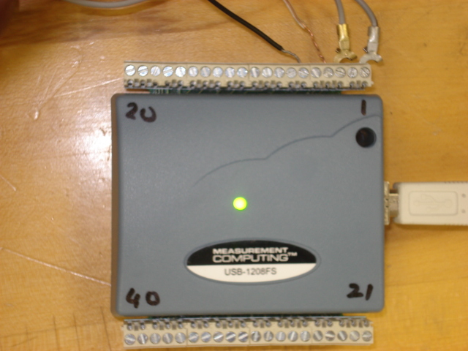  GND  GND  CH 2  CH 0  Figure V-XIV: Data acquisition Board set-up
- Connect the BNT cable to Tachometer. | 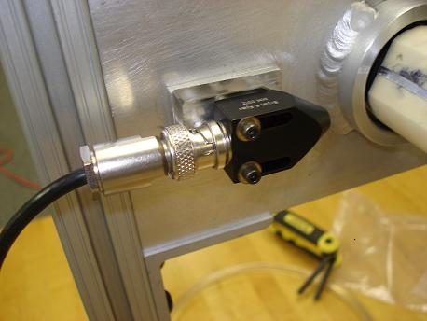  Figure V-XV: Tachometer set-up
- The other end of the BNT follow the labels: Infrared light, signal lead, and Ground  - Signal lead and one ground (black cable) to the DAQ (signal lead to channel 2, ground to ground of the DAQ).  - Infrared light and the other ground to 9 V battery. | 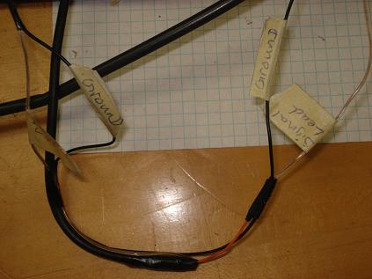  Ground  Ground  Figure V-XVI: Wire with the labels
- Connect DAQ to computer through USB.

- Plug Amplifier Power Supply into the wall, turn the switch to ON.
- Plug Motor Power Supply into the wall; make sure the power switch is in OFF position.

Caution

 Be sure no bare wires are touching each other!

Be sure to remove all loose fitting clothing and accessories!

Never run electric motor without the pulley tightened to the motor shaft!

Do not push the shaft by the split collar into the bearing plate, Pull the middle of shaft through the bearing plate! The same goes for removal of the shaft.
Be careful of sharp edges!

Do not touch the heat sinks on the motor controller!

Be sure the motor controller is in the zero position!

Be sure trial mass is securely attached to the shaft!

