

Project Needs Assessment
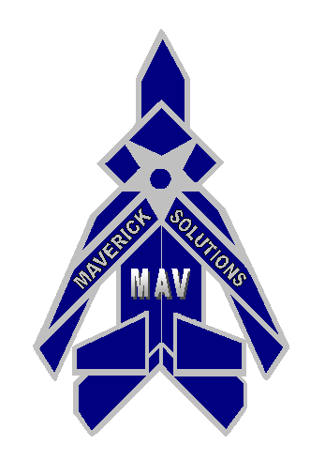

September 30, 2004

Brian Moore
Leroy Cohen Jr.

Adam Hollrith
Todd Adkins

Needs Assessment

- Design and fabricate component technology that will provide a MAV (Micro Air Vehicle) the capability to collapse/fold a 6” wing along the body of the fuselage

- Assess current materials and technologies that will maximize subsystem performance and minimize size and weight (i.e. composites, plastic actuators)

- Final cross section of MAV should fit into 3” diameter tube

- Final concept selection should be able to successfully operate (stow and deploy wing structures) in static and low air speed environments (< 30 mph).

- Demonstrate final concept design at Eglin AFB

- Furnish final report documenting project objective, approach, results, budget analysis for hardware used, and conclusions/recommendations

- Listed in Table 1 are the main design parameters and their level of importance using a scale of 1-5, with 5 being the highest.

Table 1 – Design parameters and level of importance

Parameter | Importance
Size | 5
Cost | 4
Material | 3
Durability | 3
Weight | 4
Performance | 5
Ease of Assembly | 3
Ease of Operation | 3

