Hybrid Magnet Support Column


National High Magnet Field Laboratory
1800 E. Paul Dirac Drive
Tallahassee, FL 32310

Presented to Dr. C. Luongo on April 4, 2002 in partial fulfillment
of EML 4551 and EML 4552, Mechanical Engineering Senior Design

Project Members
Thomas E. Adams
Gabriel C. Andrews
Regina A. Redmond

Table of Contents

Executive Summary 3
Introduction 4
Project Phases: Instrumentation 5
Project Phases: Assembly 8
Testing: Cryogenic Test 11
Results: Cryogenic Test 17
Testing: Structural Test 25
Evaluation of Design 27
Appendix A – Data A
Appendix B – Calculations B
Appendix C – Drawings C
Appendix D – Schedule/WBS D
Appendix E – Contact Information E

Executive Summary
The Hybrid Magnet Support Column is a model of a design that, if successful, will eliminate the complex maze of piping, wiring, and structure used to hold up and produce appropriate super conducting temperature gradients for the next generation hybrid magnets. The goal of the project is to achieve a 4.2K to ~300K temperature gradient along the column’s length as well as to determine the load bearing capabilities of the diffusion jacket surrounding the column. The model is composed of 300L series stainless steel that provides strength at low temperatures. This report details the major steps of the project: instrumentation, assembly, testing and the analysis of the tests. In the instrumentation phase, Cryogenic Linear Temperature Sensors (CLTS) and strain gages were placed inside of the column. After the instrumentation was secured, the assembly of the column began. During the assembly process, a few parts were discovered to be incompatible with some of the existing pieces. Subsequently, these parts were machined again to meet specifications. Once the column was assembled, the column was then tested to determine its thermal properties through the use of a cryogenic test. The structural characteristics were determined through the use of a hydraulic test machine that placed the column under compression. Unfortunately, the 4.2.K to ~300K temperature gradient was not achieved. However, a better understanding was gained as to how the test and construction of the column could be modified for future experimentation.

Introduction
The National High Magnetic Field Laboratory (NHMFL) has requested assistance in building and testing a new design of the magnet support system. The existing design is highly complicated and extremely bulky. Dr. John Miller, a scientist in the Magnet Science and Technology Department, has designed a new support system that is simpler and more compact in hopes of replacing the existing design. The purpose of this project is to test the feasibility of this new design. The existing support structure is used to support the Hybrid magnet and to keep the magnet at a desired temperature; the main goal of the project is to verify that the new design fulfills these properties.

The current Magnet Support system uses a series of thermal steps to achieve the proper temperature in which the Hybrid magnet must be kept. This process involves the use of super-cooled helium flowing through a network of pipes and tubing. If the finite number of steps used to cool the magnet were increased infinitely, the temperature of the system could be maintained more efficiently. This can be achieved if helium flow is introduced along the entire length of the support system. This is the basis for the new design to be constructed and tested.

Two tests will be conducted to determine the thermal and structural characteristics of the new design. A cryogenic test will be used to test the temperature profile of the system. This test introduces liquid helium in to the bottom of the design assembly. As the helium vaporizes it establishes a fluid flow through the jacket surrounding the column. The flow fluid intercepts heat energy as it passes over the column walls producing a temperature profile. This temperature profile is measured through the use of sensors located along the column length. A meter measures the rate of the flowing fluid. Once the ideal gradient is reached the flow is noted and the test is concluded. The structural characteristics of the new design will be determined with the hydraulic test machine. The column will be placed under compression up to 2/3 the yield strength of stainless steel. The measurements gained from these two tests will allow an informed decision about the validity of the design.

Project Phases: Instrumentation

The instrumentation of the design was the first phase of the project. This phase was used to mount the proper sensors to the column. There were two types of sensors that needed to be implemented onto the column for the purpose of obtaining data about the design during the testing conditions. These sensors were Cryogenic Linear Temperature Sensors (CLTS) and strain gages. There were four CLTS separately placed along the length of the column. These sensors were used to measure the temperature gradient along the length of the column as helium flowed through the outer jacket. Three strain gages placed along the circumference of one end of the column provided the means to determine static properties of the column during the hydraulic test.

The positions of the sensors are essential to the quality of data that would be obtained during the testing phase. The CLTS ideally should be spaced equally within the inner wall of the column in order to monitor the temperature gradient along the column successfully. The strain gages were initially chosen to be placed along the inner circumference in the center of the column. However, due to the length and the inner diameter of the column this position was not practical. It would not be possible to maneuver or accurately determine the position of the strain gages inside the column making them difficult to mount properly. After some thought and consideration, it was decided to move the position of the strain gages closer to the end of the column due to the idealized condition of a uniform load distribution. The uniform load distribution in theory should produce a uniform strain as long as the load applied is within the elastic limit of the material the column is made from. Moving the strain gages closer to the end of the column provided more maneuverability and better vision to mount the strain gages properly.

After the positions of the sensors were finalized, the next step in instrumentation was providing a clean surface for the sensors to adhere to. A thorough cleaning of the surface began with a well-documented procedure. The column was first sanded with 450-grain sand paper; this was used to get rid of ridges and debris on the surface of the steel. Then using a finer 320-grain sand paper the column was wet sanded using Acetone in order to remove dirt, oil and debris and smooth the surface to a finer scale. The surface was then dried and thoroughly wiped with Acetone in order to degrease the surface and to remove any residue left over from the stainless steel sanding. Methanol was continuously applied to the cleaned surface. After the surface was completely saturated with Methanol, the cleanliness of the column was verified by rubbing a q-tip swab along the surface of the cleaned area to test for the presence of dirt. If there were any discoloration due to grease or residue the process would be completed once again starting from wet sanding with the 320-grain sand paper. Once the column was cleaned it was then ready to be instrumented.

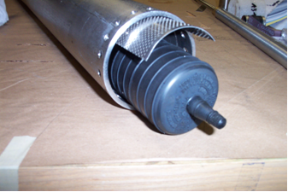
The CLTS were the first to be placed onto the inner wall of the column. Since the placement of the CLTS had already been established, the lengths of the wires coming from each sensor were chosen accordingly. One end of the column was chosen to be the exit end for the wires. The wire lengths were determined relative to their distance from the exit with the goal of having all wires leaving the column the same length. The wires were then tightly twisted together into two pairs. There were two pairs of wires designated for each sensor. One pair of wires identified the positive and negative leads for the input current and the other pair identified the positive and negative leads for the output voltage. Each wire was labeled accordingly; they were also numerically labeled according to a corresponding CLTS. Each CLTS had two solder pads to which the voltage and current leads would be attached. Thin copper insulated wires were chosen because they were fine enough to fit each of the soldering pads and they would also be able to withstand the extreme temperatures of the cryogenic test. In order to connect the wires onto the CLTS, the insulation on the tips of the wires was sanded off and then coated with a thin layer of solder. The wires were then ready to be soldered to the sensors. The CLTS had to be mounted down the length of the column with an epoxy resin that took several hours to cure, therefore there had to be some means of not only insuring the correct location of the CLTS but also means of applying pressure in order to hold the CLTS in place until the epoxy resin cured. A thin sheet of stainless steel as long as the column was formed to the same radius of curvature as the inside of the column for this purpose. The CLTS were taped to the thin stainless steel sheet at their proper location in respect to the column. The epoxy resin was then mixed for five minutes and applied to the back of each sensor. The stainless steel sheet was then positioned into the column and three pressurized bulbs were placed underneath it; one in the middle and the other two at the ends. These bulbs were then pumped with air until the stainless steel sheet was firmly pressed against the column. A heater strip was wrapped around the outer diameter of the column in order for the epoxy resin to cure. A variac was used to regulate its temperature. The epoxy resin took one day to cure. Unfortunately, when the stainless steel sheet was removed, the wires as well as the solder pads had been torn from one of the CLTS and the location of one CLTS was incorrect. The solder was removed from the wires and the wires were soldered to a new CLTS. The mounting procedure was again implemented. Once more misfortune struck. After the second mounting process, the new CLTS had not been attached to the column and the wires of another CLTS had been torn away.
Figure 1 Illustration of CLTS instrumentation procedure. Shown here are the column, stainless steel sheet and the inflatable bulbs

Table 1 List of CLTS Locations
CLTS # | Location (mm)
0 | 730
1 | 540
2 | 380
3 | 212
Fortunately, the solder pads were still attached to the CLTS and it was able to be recovered by resoldering the wires. This CLTS was not replaced but mounted once more with successful results however it could not be mounted in its proper position due to the presence of epoxy resin. Removing the resin and cleaning the surface would have been extremely time consuming. The CLTS was mounted near the location of the original CLTS.

The strain gages were mounted inside of the column next. A finer insulated wire was chosen for the strain gages to accommodate their smaller soldering pads. The insulation was burned off at the tips of the wires and covered with a thin layer solder to facilitate the wire strain gage attachment. The strain gages had three solder pads, one for the current lead, the voltage lead, and the other for calibration. The wires were labeled accordingly; they were also labeled numerically according to a corresponding strain gage. The accessibility of the column’s end made the placement of the strain gages effortless. The stainless steel sheet would not be used in this case. Like the CLTS, positioning of the strain gages was very important. The three gages were to be perfectly spaced 120° from each other. To ensure that they were in their proper locations, the positions were marked on the column with a permanent marker. The strain gages were then placed face down on a piece of transparent tape. The back was then covered with epoxy and taped into position. The tape was carefully removed the following day after the epoxy was cured. The mounting process was successful the first time around and no subsequent steps had to be implemented. The instrumentation of the column was now complete.

Project Phases: Assembly

Following the completion of the instrumentation process the different parts of the system had to be assembled in order to prepare the model for testing. This required several steps finally resulting in the welding of each of the parts.

The first step in this assembly process was to lay out all of the parts to visualize how they would fit together and in what order they should be welded. After completing this step it was realized that before any further assembly could take place some additional parts would need to be made to replace some of the original pieces. At this point, careful measurements were taken and engineering drawings were produced for the new pieces to be made. This list of pieces included a new cryostat flange, which would eventually mount the assembly in the cryostat, adaptive fittings for the Helium transfer line, inner reinforcement rings for the ends of the column, and mounting plates for the compression test load cell, which would eventually hold the assembly in place for the conduction of the strain test. It should also be mentioned at this time that the majority of these pieces were sent out of house to be made due to scheduling conflicts within the magnet laboratory machine shop.

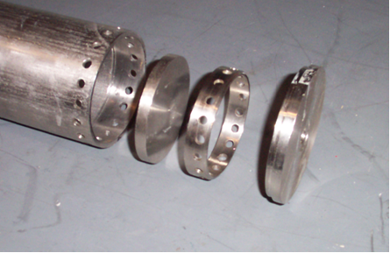
After the new pieces were manufactured, all of the parts were cleaned thoroughly and welded together in the proper order. First a feed through tube, for passing the instrumentation wires, was welded to one of the inner most plates. After securing the wires, the inner most plates, used to seal off the inner most chamber in the column for vacuum space, were welded in place and then leak checked to assure that a vacuum seal was attainable. Following a successful leak testing of this new inner chamber, the new reinforcement rings were welded in place. Once the rings were welded they were machined down flush with the edges of the column and then drilled to allow Helium flow to leave through the pre-existing holes in the column. After this was completed, the outer end-caps were welded in place over the ends of the column. At this time, the diffusion jacket was wrapped around the circumference of the column and formed in place with the use of multiple hose-type clamps. After the jacket was completely aligned and secured around the column it was welded along a seam running the length of the column and around each of the end caps. Once the diffusion jacket was welded in place it was leak checked to ensure that no helium would be capable of escaping except along the intended path.
Figure 2 Illustration of the pre-assembly stage. Shown here are the column, inside end cap, reinforcement ring and the outside end cap

At this time the column itself had been assembled however, further welding was necessary to adapt it for the cryogenic test. First, a second tube was welded to the end cap of the column; this tube was the means to which the helium would leave the column. The flange was then positioned down the two tubes which were welded to the end of the column until it was flush with the top of the column. The flange and the column were then tacked welded together. The next step in this process was to weld together the helium transfer channel, which attached to the base of the column assembly. The helium transfer channel made possible the movement of helium from an outside source into the system. This transfer channel consisted of three pieces: one which welded to the cryostat flange, a threaded adapter – which accepted the vacuum jacketed transfer line from the external Helium Dewar, and a “J-tube” that welded to the base of the column assembly. The adapter was first welded to the tube that would be welded directly to the flange. Then the tube was welded to the flange after which the J-tube was then welded to the bottom of the column and the adapter. This completed the assembly that would be inserted into the Dewar. The two tubes coming out of the top of the flange were then welded to the top of the flange. The center tube was used to transport the helium from the assembly. In order to measure the helium flow rate and the temperature of the exiting helium, a three channeled tee was welded to the top of the center tube. Tubes were then welded to each tee opening to extend the respective channel. One of the channels was designated to be the feed through tube. The other channel was designated for determining the helium flow rate. The feed through tube was used as the means of vacuuming the inside of the column. Another three channeled tee was also welded to the offset tube which contained the instrumentation wiring. Tubes were once again be welded to open ends of the tee to extend the respective channels. An additional tee was welded together to accommodate the incorporation of a CERNOX sensor into the design scheme. The sensor was used during the cryogenic test to verify the lower boundary temperature. Because all previous instrumentation had been completed, the CERNOX was positioned so that the wires that connected the sensor and the measuring device would exit out the side of the Dewar. Since the exit port of the Dewar is much larger then the tee, the tee was welded to an adapter. Then tubes were also welded to the open ends of the tee to extend the respective channels. At this point, the column is completely assembled and ready for the Cryogenic test.

Testing: Cryogenic Test

Once the support column was assembled, the next step was to connect all of the instrumentation to a computer to obtain a chart of the data. Four Cryogenic Linear Temperature Sensors (CLTS), one CERNOX, one thermocouple, and one anemometer flow meter were the measuring devices that were connected to a laboratory computer. Lab View was the data acquisition program used to cycle through the various sensors and output the data.

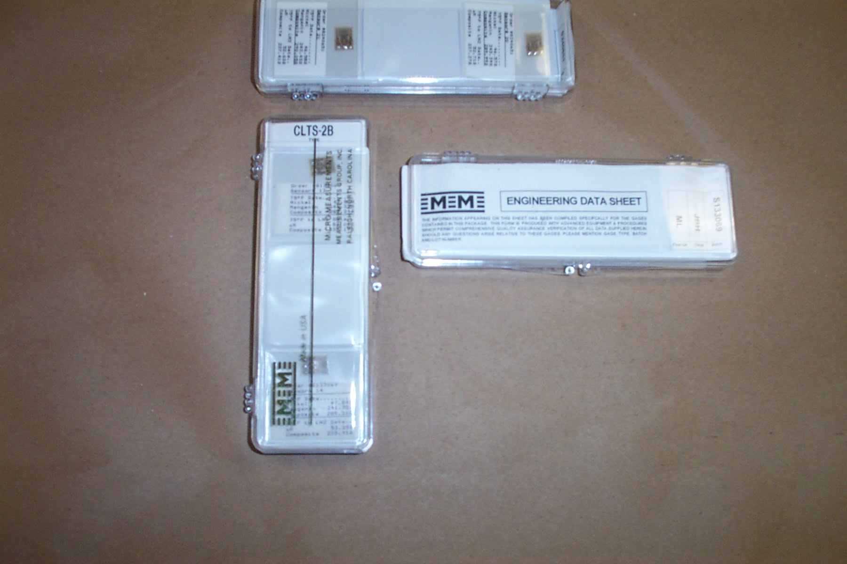
A CLTS has four leads that stem from and epoxy-resin containing sensitive circuitry used to measure the temperature of the contact surface. Two of those leads are used to power the CLTS. The two remaining leads are used to measure the voltage the CLTS produces. Each set of leads was labeled during the instrumentation phase of the project. Powering and reading the CLT sensors involved connecting the CLTS to a power supply and then connecting them to a sensor conditioner. The CLTS were powered by connecting the sensors in series to a 10mA analog power supply through the use of a terminal block. The other two leads of each CLTS were connected to the sensor conditioner via a second terminal block. First, the positive and negative voltage leads for each CLTS was connected to the second terminal block. Every positive and negative combination of a particular CLTS represented a channel on the sensor conditioner for a total of four channels. The channels were numbered 0-3. One twisted pair connected each positive and negative set of voltage leads of the CLTS from the second terminal block to the sensor conditioner. A twisted pair was use to provide a robust connection between the terminal block and the sensor conditioner as opposed to the fragile FORMVAR used previously.
Figure 3 Illustration of the CLTS in their protective cases

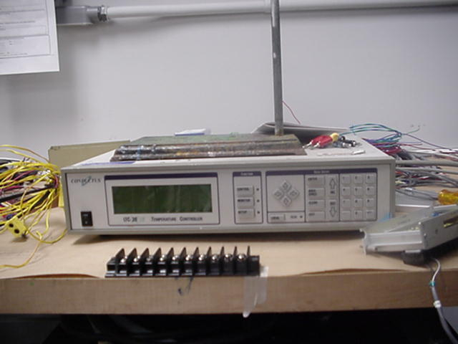
The CERNOX has four leads that extend from the base of the sensor. Two of these leads are used to supply power to the CERNOX and two of the leads are used to measure the voltage the CERNOX produces just as in the case of the CLTS. These leads were labeled accordingly. The CERNOX however, does not use a traditional power supply or sensor conditioner to operate or read measurements. The CERNOX uses a Conductus – LTC21. The Conductus – LTC21 is a self-contained power supply and voltage meter specifically used for CERNOX style sensors. Two sets of wires stem from the sensor 1 channel of the Conductus – LTC21. One set is used for providing a current source and the other set is used to acquire the voltage produced by the CERNOX. These sets of wires, used for both of the positive and negative current leads as well as the positive and negative voltage leads of the CERNOX, were connected to the second terminal block used to connect the voltage leads of the CLTS to the twisted pair. A thicker set of four wires was used to provide a robust connection from the terminal block to the Conductus – LTC21 connections. Two of these wires were connected to the Conductus – LTC21 current leads to supply power to the CERNOX and the other two wires were connected from the second terminal block to the Conductus – LTC21 voltage leads. The Conductus – LTC21 was then linked to the monitoring computer through the use of a General Purpose Interface Bus (GPIB) with an IEEE 488 connector.
Figure 4 Photograph of the Conductus - LTC21 used in conjunction with the CERNOX
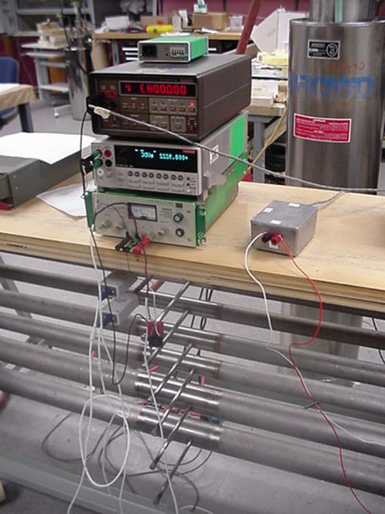
A K type thermocouple was used in the experiment to obtain the temperature of the escaping helium gas. Because the accuracy of the thermocouple’s measurement of temperature is dependent upon the resistance of the particular metals used in the thermocouple’s construction, the K type thermocouple was connected to the sensor conditioner with a wire made of the same alloy as the thermocouple. This thermocouple was directly connected to the sensor conditioner mentioned earlier at channel 4.
Figure 5 Shown above are the anemometer flow meters and the accompanying volt meters

The flow meter was used in the experiment to capture the resulting mass flow rate from a particular temperature profile. The voltage leads from the anemometer flow meter were connected to a digital multimeter to monitor the voltage levels that the helium flow rate produced. A twisted pair of wires was used to connect the digital multimeter to the sensor conditioner channel 5.
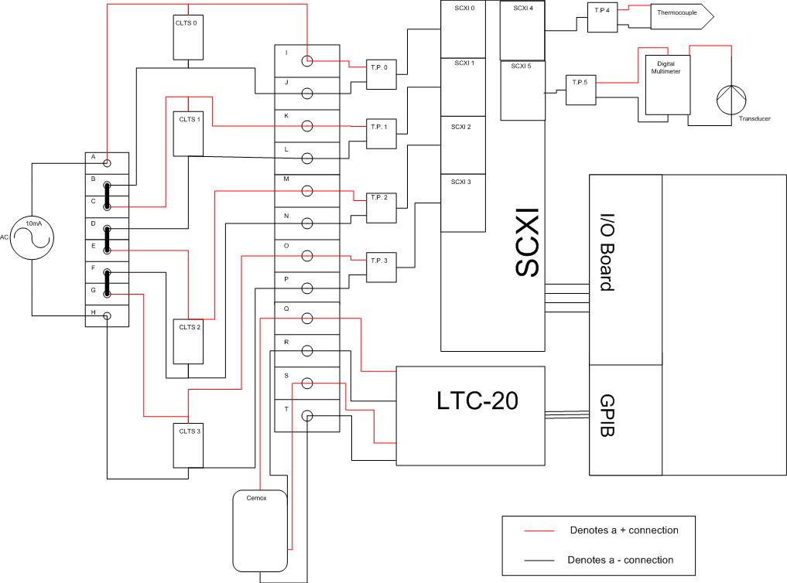
Figure 6 Wiring diagram of the Cryogenic Test.
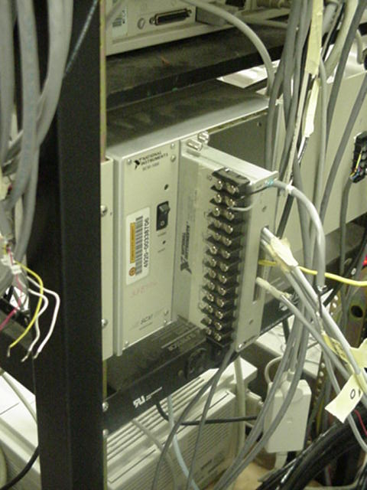
The sensor conditioner was the medium that linked the CLTS, thermocouple, and anemometer to the monitoring computer. The particular strain conditioner used in the experiment was a Sensor Conditioning Extension for Instrumentation (SCXI). The senor conditioner contains a total of seven channels. Each of these channels has the ability to be amplified by a gain setting ranging from 1 to 1000. The SCXI used for our purposes reached saturation at 5 volts. The gain for each one of the channels was adjusted accordingly to achieve the maximum voltage reading without exceeding the saturation limit. Two of the seven channels were short circuited as they were not to be used by any form of instrumentation.

Figure 7 Shown here are the SCXI inserted into the signal amplifier.
Once all of the electronic equipment necessary to obtain and record the desired data from the Cryogenic Test was properly connected, several steps were taken to thermally insulate the column assembly from the outside world. First, through the use of several tee fittings and metal reinforced plastic hoses, the inner space of the column assembly and the inner space in the cryostat surrounding the column assembly were connected to both a common vacuum pump and a common room temperature Helium gas supply cylinder. In order to ensure proper insulation, both the inner space of the cryostat and the inner space of the column needed to be evacuated. To achieve this correctly several iterations were preformed. Initially the space was vacuumed down to 100 milli-torr. Once this was achieved, the pump was shut off and the recently initiated vacuum drew Helium gas from the Helium gas supply into the evacuated space. After the aforementioned spaces were filled with the room temperature Helium gas they were once again vacuumed to 100 milli-torr. This process was repeated approximately three times to ensure that all of the air and moisture had been removed from the dead space in and around the column assembly. From this point on these spaces were maintained at a vacuum ranging from 100-50 milli-torr. The final step taken to insulate the column assembly was to fill the outer jacket of the cryostat with liquid nitrogen at approximately 77K.

Following the preparation of the instrumentation, and the thermal insulation of the assembly, the final step was to connect the liquid Helium Dewar to the system and initiate the test.
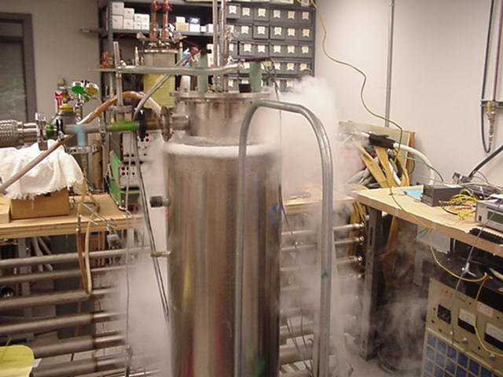
Figure 8 Illustration of the Cryogenic Test being conducted.
In order to properly connect the Liquid Helium source to the column test assembly, several pieces of a transfer line had to be installed. First a vacuum insulated flexible metal hose was connected to the pre-inserted transfer line in the column test assembly. Secondly a portion called a “stab” had to be slowly inserted into the Liquid Helium Dewar through several fittings and valves. During this procedure, special attention was paid to the internal pressure of the Liquid Helium Dewar, and the safety valves located on the top of the Dewar. If the stab was inserted too fast, the large temperature gradient between the stab and the Liquid Helium would over pressurize the Dewar and jeopardize the safety of those involved. Once the stab was properly inserted into the Liquid Helium Dewar, it was connected to the flexible vacuum insulated metal hose attached to the column test assembly.

Helium flow was then established throughout the column test assembly by opening the valve on the top of the Dewar stab. Once flow was established, Lab-view was initialized and the boundary temperature conditions as well as the internal column gradient and Helium mass flow were monitored.

Upon initializing flow through the column, the first goal was to try and achieve the lower boundary temperature condition of approximately 4.2K. This was attempted several ways, including fluctuating the amount of Helium flow through the column test assembly, and pressurizing the Liquid Helium Dewar with the aid of an internal Dewar heater. This was done in order to push liquid Helium at approximately 4.2K into the column test assembly. The lowest temperature achieved at the bottom of the assembly was 11.4K.

The initial cryogenic testing attempts failed to achieve the desirable temperature boundary conditions as well as a valid temperature gradient or helium mass flow rate. However, these tests did produce results that were beneficial in evaluating both the testing procedure, and the test setup.

During the initial attempt at reaching desirable results, the first step was to try and achieve the lower temperature boundary condition of 4.2K. This was done by continually increasing the Helium flow through the column test assembly without any regard to the other test parameters, (i.e. temperature profile, upper temperature boundary condition, or mass flow rate). This exercise resulted in several things. Primarily, the minimum temperature sustained at the base of the column test assembly was approximately 11.4K as stated earlier. However, by the time this occurred, all of the external connections to the assembly were covered in frost, including the Helium escape tube, the hose to the flow meter, the flow meter, and the cryostat flange. This was a good indication that liquid Helium had not only been collected in the base of the column assembly, but was flowing through it as well. This observation lead us to question how this could be possible without achieving the desired lower temperature boundary condition of 4.2K
The answer to this question resided in the insulating vacuum being pulled on the system. Throughout the testing procedure, the vacuum being pulled on the inner column space, as well as the space around the column in the cryostat, was maintained at 50 milli- torr. Though this initially seemed sufficient to insulate the specimen, it was the additional heat load due to an inadequate vacuum that ultimately prevented us from achieving the lower boundary condition of 4.2K. This conclusion was arrived at upon reviewing the test results with John Miller, the project coordinator and mentor.
The first step taken in alleviating this problem was to individually vacuum-check all of the connections to the test assembly. Once it was established that they were satisfactorily vacuum tight, the next step was to check the column assembly itself for leaks. This was done by connecting a vacuum to both the original vacuum spaces in and around the column test assembly, as well as the helium flow path itself. In this manner, if the pump itself was sufficient, and the column/jacket assembly was leak tight, a vacuum of absolute zero should have been achievable. Upon leaving the vacuum pumps running in this configuration over night, it was found that the assembly was still at 50 milli-torr. From this it was deduced that, not only was the column/jacket assembly leak tight, it was the pump itself that was insufficient. Following this observation, the original vacuum pump was removed and a turbo pump was used in its place. With this new turbo pump in place vacuum pressures as low as 10^-9 were reached. At this point the assembly was prepared for another battery of testing.

Results: Cryogenic Test

A total of four tests were conducted. The data from the first test was unable to be analyzed due to the accelerated cooling of the entire test setup. The second test was conducted under the auspices of Dr. John Miller. The flow of the helium was closely regulated and the temperature profile was closer to the expected. In the third test, the goal was to reach a steady state temperature profile with an unsaturated flow reading. The fourth test was an effort to obtain a better approximation of the temperature profiles. The following is a compilation of the results obtained from the tests. 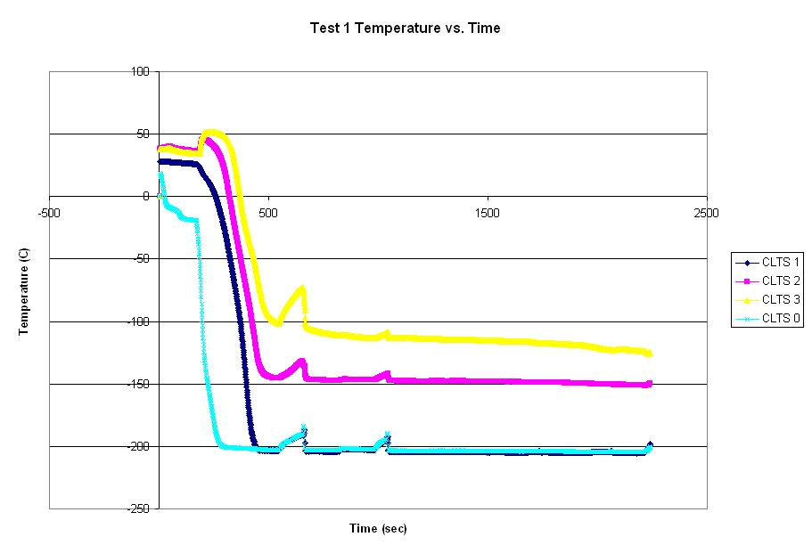
Region I
Figure 9 Illustrates the region of linearity Region I from which a temperature profile is produced. This graph was produced from Test 1. Unfortunately, the flow rate from this test was unreadable due to saturation even though it exhibits good linear ranges.

Region I defines a linear portion of the Temperature vs. time graph. This section provided a constant temperature profile of the temperatures along the column’s length. The temperature gradient and subsequently the rate of heat transfer through the system can be determined. The rate of heat transfer is given by
$\overset{˙}{Q}=κ(T)A\frac{\text{dT}}{\text{dX}}$ (1)
Equation (1) is adequate across small ranges in temperature. However, κ(T) varies greatly over the large temperature range of 4.2K to 300K used for the cryogenic experiment. To accommodate this expansive range of thermal conductivity the ideal rate of heat transfer becomes
${\overset{˙}{Q}}_{o}=\frac{A}{L}\int{\frac{κ(T)\text{dT}}{1+(\frac{C_{p}}{C_{L}})(T−T_{o})}}$ (2)
Equation (2) becomes
${\overset{˙}{Q}}_{o}=\frac{A}{L}\int{κ(T)\text{dT}}$ (3)
where an 8th order polynomial describes κ(T).
$κ(T)=C_{o}+C_{1}T+C_{2}T^{2}+C_{3}T^{3}+C_{4}T^{4}+C_{5}T^{5}+C_{6}T^{6}+C_{7}T^{7}+C_{8}T^{8}$ (4)
This approximation of the thermal conductivity made it possible to calculate the ideal rate of heat transfer over the entire length of the column.

The second test provided two linear regions, Region I and Region II.
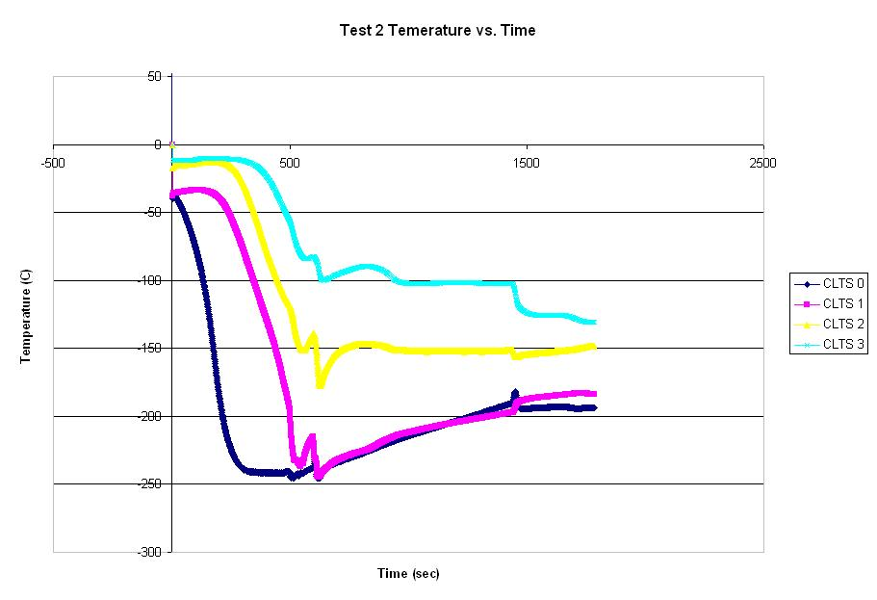
Region I
Region II
Region I (1016 – 1445) provides the following temperature profile:
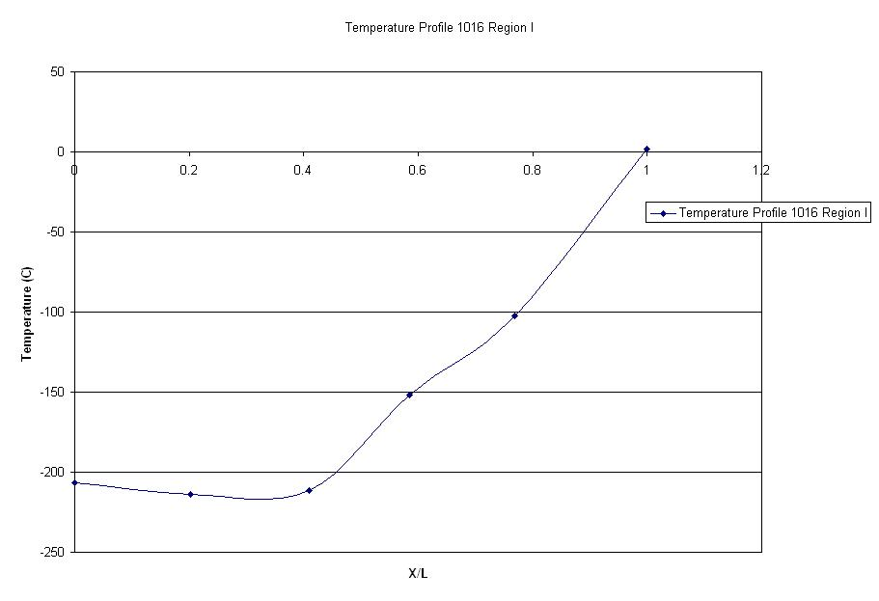
Figure 10 Generalized temperature profile for Region I
Region II (1545 – 1774) provided the following temperature profile:
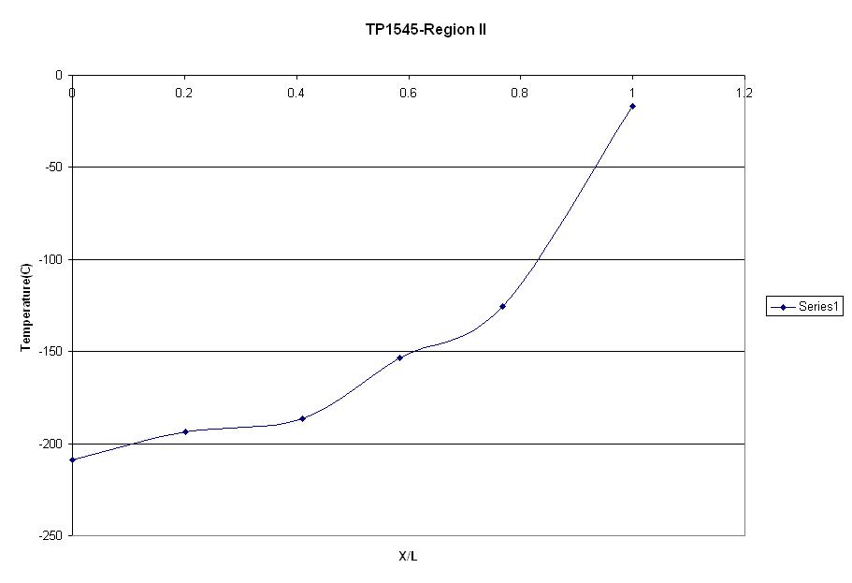
Figure 11 Generalized temperature profile for Region II
Even though these two temperature profiles demonstrate similar behavior, the temperature in Region II was used to calculate values of the rate of heat transfer based on the readings of the CLTS. The temperature gradient dT/dX was obtained through the use of the temperature profile graph. The thermal conductivity was obtained by using the 8th order polynomial for each of the temperatures describing the profile. The cross sectional area was calculated to be 809.02 mm². The combination of these parameters led to the value of the rate of heat transfer at each individual point.

Table 2 List of Q values for Cryogenic Test 2
^{Q(W/mm*K)}
^{CLTS 0} | ^{CLTS 1} | ^{CLTS 2} | ^{CLTS 3}
^{-36.33} | ^{13.51} | ^{407.27} | ^{71.58}

The third test was analyzed in a similar fashion with a slight difference. In an effort to better approximate the temperature gradient, the Temperature vs. time graph was created, linear portions, Region I and Region II defined and a temperature profile produced from Region I. However, the alteration was a best fit line passed through each of the data points on the temperature profile graph.

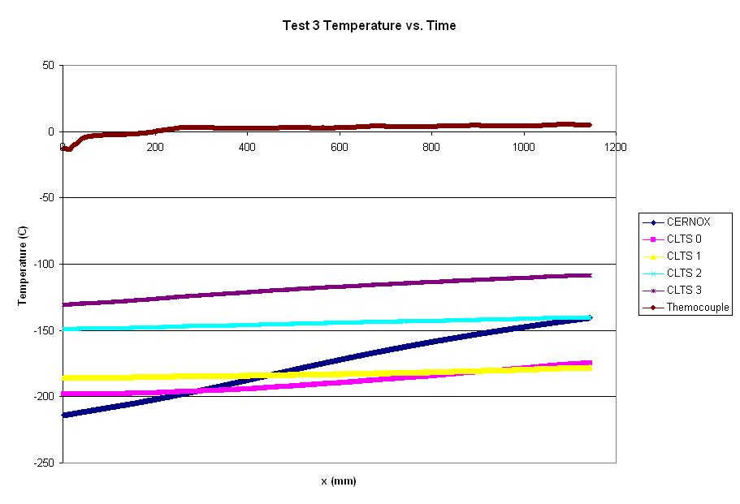
Region I
Region II
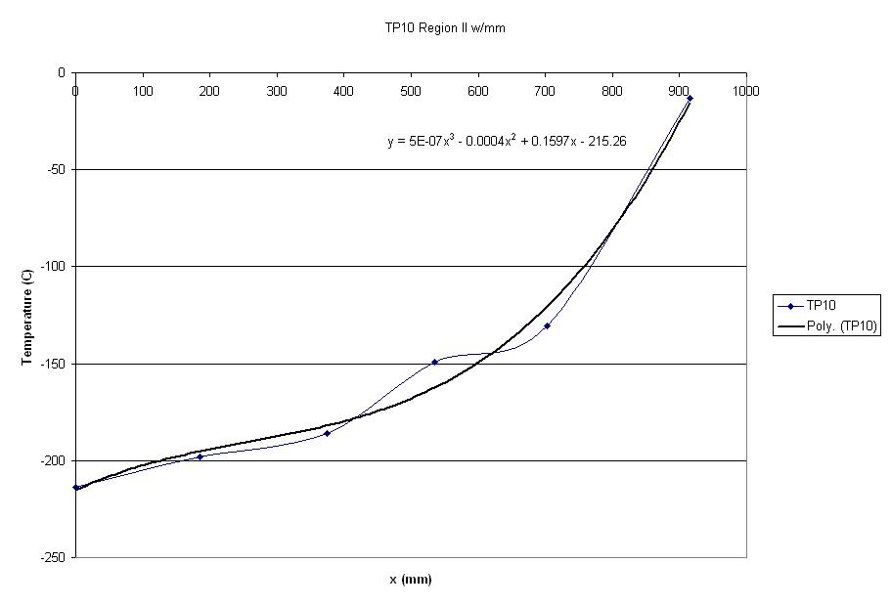

The best fit line was a 3rd degree polynomial in the form of

$T=5×{\text{10}}^{−7}x^{3}−0\text{.}\text{0004}x^{2}+0\text{.}\text{1597}x−\text{215}\text{.}\text{26}$ (5)

which describe the temperature at any point along the column’s length. The temperature profile now had an expression which could be differentiated to determine the gradient at any point along the column. Equation (5) was used to obtain the gradient. The x values location of the sensors were placed into the differentiated equation (5) to obtain points along the gradient curve. The thermal conductivity values were again calculated for the different positions. The rate of heat transfer was calculated with the aforementioned parameters.
Table 3 List of Heat Transfer values for Test 3
CERNOX | CLTS 0 | CLTS 1 | CLTS 2 | CLTS 3 | Thermocouple
0.9378 | 2.5909 | 5.246 | 8.763 | 14.323 | 26.76

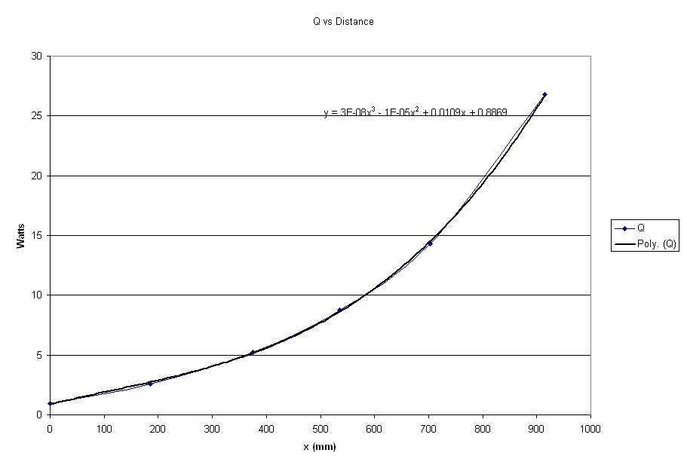
Figure 12 Illustration of the rate of heat transfer vs. distance along the column.

Testing: Structural Test

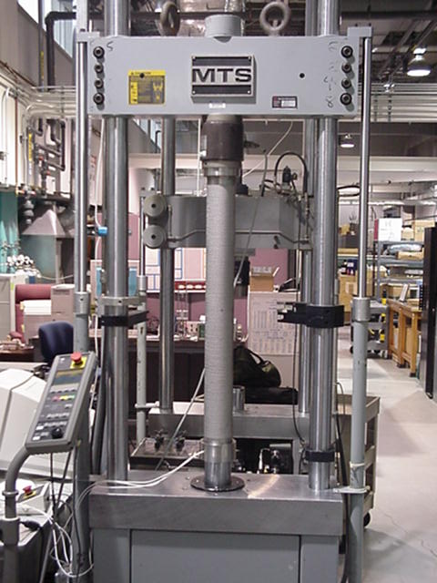
Once the Cryogenic Testing of the column assembly was completed, the next step was to prepare the assembly for structural testing. This preparation involved several steps. The first step was to safely cut away and remove all excess tubing used to adapt the column assembly for cryogenic testing. This included removing all of the vacuum hoses, cutting away all of the metal tubing above the flange, cutting the flange itself off of the top of the column test assembly, and cutting away the Helium Transfer channel which extend below the flange and connected to the base of the column assembly. During the process great care had to be taken not to damage any of the instrumentation wiring. After this was completed, all that remained of the previous assembly was the column itself with the end-caps and diffusion jacket still in tact.
Figure 13 Magnet Column placed in Hydraulic Test Machine

The next step in preparing the column test assembly for structural testing was to safely transport it to the machine shop where the faces of the end-caps could be machined smooth and perpendicular. This was done to ensure that the assembly would be mounted squarely into the structural testing load cell.

In addition to the machining that the column assembly required, extra components had to be manufactured to properly secure the assembly into the load-cell. This was necessary for several reasons. First of all, a secure connection would be necessary to guarantee that all of the load would be transmitted directly from the Hydraulic testing machine to the test assembly. The second focus of this secure connection was on the safety issues surrounding the structural test to be preformed. Due to the large amount of compressive load to be applied to the test specimen, it became crucial to ensure that the column assembly could not be forced out of the load-cell, thereby endangering those individuals present for the test. Finally, the adaptive pieces would act as a buffer between the test specimen and the load cell itself so that the machine would not be damaged during the conduction of the test. After dimensions were taken from both the column assembly and the load-cell, engineering drawings for these new pieces were produced and submitted to the in house machine shop at the NHMFL where they were manufactured.
With the end caps of the column test assembly machined down, and the new adaptive pieces manufactured, the next step was to install these components into the load-cell of the Hydraulic testing machine. This was done by first threading one of the new adaptive pieces into the top of the test load cell. Following this, the instrumentation wiring was guided through the second adaptive piece, which was then secured into the bottom of the load-cell. At this point the column test assembly was set in place between the upper and lower adaptive pieces of the load-cell. The upper press was then lowered to hold the column test assembly securely in position.

Following the installation of the test assembly into the load-cell, the next step was to connect the instrumentation in order to record the desired data from the test. For this test, the positive and negative leads from the strain gages are wired directly to a strain gage conditioner. The strain gage conditioner has an internal wheat stone bridge circuitry which measures an offset voltage when the strain gages within the column are subject to strain from an applied load. This voltage is calibrated to relate to a given strain based on the sensitivity of the gage. From the Strain gage conditioner, this voltage is sent to a control box, which is connected directly through the use of twisted pair wires. The control box saves this data in a predetermined data file. The information from this data file can then be opened on a computer, in an excel spreadsheet where it can be converted into strains. For the purposes of conducting the test, a template program is written, on the operating lab-top computer, which tells the Hydraulic load-testing machine to increase its compressive load by a given amount over a certain interval of time for a predetermined number of intervals until the desired load is achieved. Information from this computer is also saved into a excel spreadsheet documenting the individual load increments and time intervals.

After all of the instrumentation was connected, executing the computer program template and pressing the start button on the Hydraulic testing machine initiated the test.

Results: Strain Test

Upon the initiation of the test the column was subjected to 50kN which compressed the column 2 mm every minute. During the conduction of the test a stress-strain graph was displayed, since it was important that the column remained within its elastic region the column would be loaded until a clearly linear region was displayed but would not exceed 2/3 of the yield strength of stainless steel. The goal of this test was to test the structural integrity of the dimpled jacket around the column; the purpose of the dimpled jacket was not only to aid in the heat transfer but to also add structural support. In order to determine the amount of support the dimpled jacket was actually supplying to the assembly, it was calculated using the following equation:

$F=E(A_{\text{column}}+{\text{CA}}_{\text{jacket}})ε$ (1) (6)

where F is the force exerted on the assembly, E is the modulus of elasticity of stainless steel, A_{column} is the cross-sectional area of the column, A_{jacket} is the cross-sectional area of the dimpled jacket, C is the percentage coefficient of structural support provided by the dimpled jacket, and ε is the strain on the assembly. If the value of C is substantial then the jacket will have proved to provide a sufficient range of support to the assembly, in the case that this is not true then the design will have to be modified.

Evaluation of Design

The criteria for determining the effectiveness of the magnet column design is based on the thermal and structural data obtained from the cryogenic test and the Hydraulic test. To reiterate, the thermal objective of the design is to produce a temperature gradient from 4.2K to ~300K along the length of the column. The results of the first cryogenic test did not produce this gradient. The lower boundary condition of the temperature gradient only reached 11.4K. The upper boundary condition can only be estimated to be between the ranges of 90K to 100K. The exact temperature value of the upper boundary could not be determined because it did not fall within the sensitivity range of the K type thermocouple. The temperature gradient resulted in approximately 80K to 90K over the column’s length of 91.5 cm. Unfortunately, the ideal gradient was not accomplished. The reason for the unsuccessful test determined to be the presence of an extra heat load introduced by the helium transfer line. The lower temperature boundary was never achieved because the liquid helium was vaporized before it could reach the bottom of the column assembly. Even with the throttle valve on the helium supply Dewar completely open, allowing the maximum flow rate of liquid helium through the transfer line, the heat load was substantial enough to sustain helium vaporization. A current possibility to correct this issue is to better insulate the vacuum jacketed helium transfer line. Market research will produce other transfer lines that exceed the current insulation specifications. Once an alternative helium transfer line has been discovered, an executive decision will be the only barrier to better results.

To accurately state whether or not the magnet support column is a feasible design cannot truly be determined without the modification or replacement of the helium transfer. When the transfer line is replaced and liquid helium is allowed to reach the bottom of the column assembly, the feasibility of the design can evaluated.

Appendix A – Data

Cryogenic Test I: March 29th 2002, NHFML Lead Development Laboratory

The following is a compilation of the data obtained from the cryogenic test. The first test was conducted on the 29th of March. During this test, only 11K was achieved opposed to the desired 4.2K. Also, the anemometer flow meter became saturated and would only read 0.0359 volts. Please refer to accompanying electronic copy.

Cryogenic Test II: April 2nd 2002, NHFML Lead Development Laboratory

Appendix B – Calculations

- Linear Calibration of Cryogenic Linear Temperature Sensors (CLTS), March 21st 2002
- Strength of Column, November 29th 2002

Appendix C – Drawings

The following is a compilation of the drawing for the parts that were remade in order to assemble the magnet support column or facilitate the testing of the support column.

- Reinforcement Ring Drawing, January 18th 2002, Regina Redmond
- Compression Bottom Plate, March 27th 2002, Regina Redmond
- Compression Top Plate, March 27th 2002, Thomas Adams

Appendix D – Schedule/WBS

The following is compilation of all schedules and work breakdown structures that were used to produce the final project.

- Complete Project Schedule – Details the idealized key events of the project from beginning to completion and the submittal of all deliverables.
- Events for the Spring Semester – Visual timeline of the Spring Semester events.
- Work Breakdown Structure – Categorizes the major project phases and the sub-components of each phase.

Appendix E – Contact Information
Personnel | Job Title | E-mail Address | Phone Number
Gabriel Andrews | ME student | gandrews@eng.fsu.edu  greatgabe@hotmail.com | Work: 599-8167  Home: 574-5915
Thomas Adams | ME student | tadams@eng.fsu.edu | Cell: 321-0696
Regina Redmond | ME student | rredmond@eng.fsu.edu | Home: 222-8047
John Miller | Scientist | miller@magnet.fsu.edu | Work: 644-0929
George Miller | Coordinator, Research Programs/Svcs. | millerg@magnet.fsu.edu | Work: 644-2031
Bob Walsh | Assistant in Research | walsh@magnet.fsu.edu | Work: 644-5088
Michael Haslow | Sr. Engineering Technician/Designer | haslow@eng.fsuedu | Work: 644-2819
Robert Stanton | Sr. Engineering Technician/Welder | stanton@magnet.fsu.edu | Work: 644-6990
Donny Richardson | Technician | richards@magnet.fsu.edu | Work: 644-8546
C. Lee Windham | Sr. Engineering Technician/Designer | windham@magnet.fsu.edu | Work: 644-0421
Andy Harper | Head of the Machine Shop, Coordinator., Research | harper@magnet.fsu.edu | Work: 644-1055
John Farrell | Sr. Engineering Technician/Designer | harper@magnet.fsu.edu | Work: 644-4975
Bob Smith | Sr. Research Engineering Support Specialist | rsmith@magnet.fsu.edu | Work: 644-8517
Kevin Bryant | Sr. Research Engineering Support Specialist | bryant@magnet.fsu.edu | Work: 644-8517
Andy Powell | Sr. Engineer | powell@magnet.fsu.edu | Work: 644-1910
Scott Maier | Sr. Research Engineering Support Specialist | maier@magnet.fsu.edu | Work: 644-1782
Bruce Brandt | Director, DC Fields Facilities | brandt@magnet.fsu.edu | Work: 644-4068
Tom Painter | Associate in Engineering | painter@magnet.fsu.edu | Work: 644-5752
Hamid Garmestani | Associate Professor of Mechanical Engineering | garm@magnet.fsu.edu | Work: 644-5993  COE: 487-6167

