Final Report

Rear Wheel Mount Team

Daniel Mammolito

Juan Gonzalez
Robert Waters

Senior Design I
November 29, 2001

Table of Contents

Abstract

1.0 Introduction………………………………………………….1
1.1 Problem Statement
1.2 Project Scope
- Project Planning……………………………………………..3
  - WBS Diagram
  - Schedule
  - Project Procedures
3.0 Design Specifications……….………………………………4
3.1 Customer needs and wants
3.2 Quantification
3.3 Basic Concepts
4.0 Concept Selection…………………………………………...8
4.1 Concept Selection Process
4.2 Final Design Concept
5.0 Bearing Selection…………………………………………..10
6.0 Material Selection………………………………………….15
7.0 Conclusions………………………………………………...16

Abstract

The objectives of the design of the rear wheel mount were to create both a spare tire for the solar car team and to allow for dynamic testing of the car. This was accomplished with the use of several off the shelf parts and some produced parts. The bearing that will be used in the rear wheel mount called for detained calculations in order to determine the proper size bearing to be used. At the customers demand the mount is similar in shape, size, and weight as the actual assemble. The design created uses a stationary axle with a hub that contains a bearing. All parts at will be produced will be constructed of stainless steel which will be sufficient to withstand the stress that will be placed on the parts during use. The design was created with the safety of the driver in mind.

Introduction
1.1 Problem Statement
The college of engineering solar car team designs and produces a solar car every two years to compete in national races against other universities. The team uses the experience and knowledge gained from the prior design in order to make improvements in future designs. As one of the improvements, this project will provide relief from problems faced during removal of the rear wheel engine assembly from the car. The customer, the solar car team, currently has no means of transporting the solar car because the rear wheel engine assembly has been removed due to damage done to the electric motor during operation. This damage requires dynamic testing of the car. The project proposed is to produce a spare rear wheel mount for the solar car that will be similar in properties to the original design and allow for both transportation and testing.
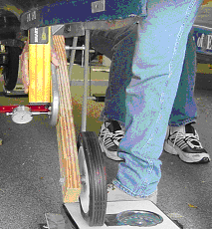

Figure 1: Current Solar Car Spare Tire

1.3 Design Process
The design process is a series of steps that are used by the engineer to develop a product. First the problem must be defined and quantified. Proper planning and scheduling are then used to set goals for the project. After a clear understanding of the necessary steps and tasks are developed, the designer quantifies the problem and considers the constraints that will limit design options. Using these constraints, basic design concepts are developed to provide options for solutions to the stated problem. When a final concept is decided upon, the designer must then convert that concept into an actual detailed design.
The Design Process
Identification of Need
Background Research
Goal Statement
Performance Specifications
Ideation and Invention
Analysis
Selection
Detailed Design
Prototyping and Testing
Production
Figure 2: Design Process

1.4 Project Scope
The solar car team has noticed problems with the rear wheel assembly of the driving wheel. The current design of the solar car requires the removal of the rear wheel in order to service the electric motor. The solar car team is experiencing problems with situations in which the motor fails and the car cannot be towed. In addition, the team is questioning whether the strut design is causing damage to the bearings in the motor. Currently, our team is expected to design a means of replacing the motor/wheel configuration in the event that something goes wrong with the engine so the car can be easily towed.
The rear wheel mount will be designed for use in the testing of the dynamic loading in the rear wheel assembly. Therefore, it should have a metal disc that can simulate the presence of the motor. This test also includes the design of a quick release system for the solar car while in tow, so both drives can release the car while in tow for safety purposes. After collecting the data, the existing design will be evaluated for application on the new car as well as the old. The rear wheel mount team will take part in these tests to attempt to correct the problem to reduce the need to use the spare tire assembly. Also, the spare rear wheel assembly will be designed to be adaptable with the addition of a gear for use with a spare chain driven electric motor.

Project Planning
2.1 WBS diagram
The Work Breakdown Structure (WBS) Chart displays the structure of a project showing how a project is organized into a summary (phase) and detail levels. The WBS is a great way to organize a project into a schedule of duties and events that must take place throughout the project scope. Using a WBS chart is an intuitive approach to planning and displaying a project. As a planning tool, the WBS Chart can be used to quickly create a project by drawing a picture.
Our WBS, which is attached in the appendix, shows the relationship between each of the activities the team is undertaking. This will help give a clear view of the task that will be performed in this project.

2.2 Schedule
The schedule, which is attached in the Appendix shows the breakdown of all project activities. The chart shows all dates by which activities will be scheduled to be started and/or completed by. All deliverables have been included on the schedule, allowing for preparation time before they are due. The dates on the schedule are tentative and may be changed in order to complete the project in a timely fashion or to account for problems that may arise in design of the rear wheel mount.

2.3 Project Procedures
Documentation and e-mails:

- All Documents will be dated as received; a copy of all documents will given to every team member as a hard copy or e-mail.
- All e-mails concerning the project will be sent to every team member regardless of relevance to individual tasks.
- The official copy of all documents will be held by Juan Gonzalez, and will be brought to every group meeting.

Meetings:

- Regular meetings with the customer will be held no less then every other week to update him on the progress of the project.
- Regular team meetings will be held no less then once every week to update group members on project progress.
- All team members must contact Daniel Mammolito at least 24 hour before the meeting if they cannot attend.

Reports and deliverables:

- All group members will approve all reports.
- Deliverables will be started no less then four days before they are due.
- All team members must be present to prepare deliverables.
- If a team member cannot be present to help in the preparation of the deliverables, he must give notice to Robert Waters.

3.0 Design Specification
3.1 Customer Needs and Wants
The customer wants the system to be designed for easy installation onto the existing rear strut of the solar car without any modifications being made to the existing parts. The design of the rear wheel mount must support the weight of the solar car and driver both statically and dynamically. The design of the rear wheel mount must be similar to the existing system in many respects: the wheel must be at approximately the same distance from the strut as on the current system and contain a mockup of the existing motor that is similar in size and shape. The mockup motor must also be removable when not in use. Below is a chart of the basic needs and demands that were set for this project.

Design Needs
Supports Weight of Car and Driver, 325 lb per Wheel
Will operate at speeds up to 60 mph
Useful in transporting car as spare tire
Used in dynamic testing of car
Quick release system that allows both vehicles to release car while in tow

Design Wants
Mockup motor can easily be removed when not needed
Addition of gear for use with spare motor
Easy to install on car
Figure 2: Design Needs and Wants

3.2 Quantification
The design of the rear wheel mount must fit with all existing parts on the solar car; therefore, the dimensions of these existing parts will limit the options. These existing dimensions are a vital part of the structuring of the new rear wheel mount and have been placed in the following tables.

Dimensions of strut | X (mm)
Thickness | 19.1
Hole Radius | 50.8
Number of bolts | 5
Bolt Pattern Radius | 76
Figure 3: Dimensions of existing strut

Dimensions of motor | X (mm)
Thickness | 70
Weight | 17.27 Kg
Diameter | 315
Number of Bolts | 6
Figure 4: Dimensions of electric motor

Dimensions of Rim | X (mm)
Thickness | 24.2
Number of Bolts | 6
Hole Diameter | 94.1
Bolt Pattern Radius | 57.97
Figure 5: Dimensions of wheel rim

3.3 Basic concepts
Using the basic needs of the customer’s problem, the basic concepts used to solve the problem were developed. These first concepts were tabulated into a morphological chart; all are viable solutions to the problem.
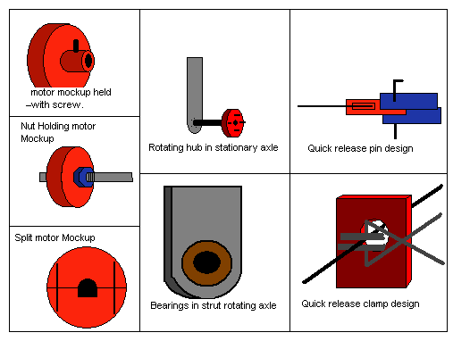

Figure 6: Morphological Chart

The first column in the morphological chart shows the concepts developed for the mockup electric motor and how it will be held in place. The first concept uses a notch that would contain a setscrew, which would be tightened down when the mock up is in place. The second concept for the mock up is to thread both the axial and the inside of the bore in the mockup motor, this concept would then allow for the mockup motor to be screwed onto the axle and into place. The third and final concept developed for the mockup motor is to create the mockup in two pieces; one with a half circle and the other with a half square. The axle would then have the same shape on it so the mock up could be tightly clamped down into place.
The second column on the morphological chart is concerned with the rotation of the wheel on the axle. This section of the concept was very limited because the axle used must be attached to the existing hole in the strut. The first concept that could be used for the axle is that of a fixed axial on the strut with a rotating hub which would contain a bearing. The second concept is to have a bearing placed in the strut and have the entire axle rotate from that point.
The final column in the morphological chart is the quick release system that will allow both the driver of the vehicle in tow and the driver towing to release in case of emergency. The team agreed that this should be a simple system. Therefore, the first concept is to attach the rope to a piece of wood or metal, then a pin is put into place, and when the pin is pulled the car is released. The second concept is to have a hole in a piece of metal or a two-by-four, a rope is then be place through the hole and clamped at the other end, and when the clamp is opened the car is released.

4.0 Concept Selection
4.1 Concept Selection Process
In order to choice the best concept for the design the team considered each option separately, the best option from each column of the morphological chart was chosen. Since each option is interchangeable with the others this is the best way to decide the final concept. After using the evaluation chart, which was created to weigh the pros and cons of each concept, a final concept was developed. The figure below is an example of the evaluation sheet used in the selection process. The actual completed evaluation sheet for each concept can be found in the appendix.

Figure 7: Concept evaluation sheet

4.2 Final Concept
After every individual concept was evaluated the final concept was created. This early design concept incorporated the use of a fixed axle with a rotating hub containing a bearing. For the mockup motor it was decided that the bolt pattern would be placed on the back of the motor and the bolts would go through the strut and bolt into the mockup motor. Below is a rough drawing of the final design concept that will be used.
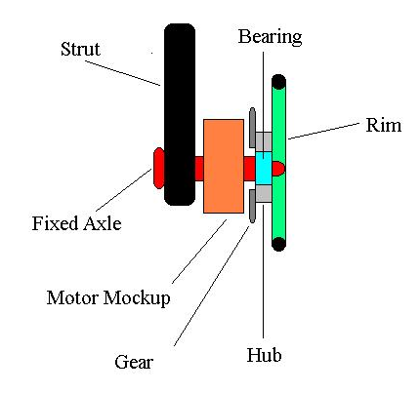
Figure 8: Final Concept Design

5.0 Bearing selection
The bearing the team initially planned on using was a pressed bearing in the hub. Later calculations led the team to believe that if the hub were under large axial stress the pressed bearing might become loose; this could be very dangerous to the driver of the solar car. To fix this problem, the idea of using a c-shaped clamp on both sides of the hub to prevent the bearing from coming loose was introduced. This can be seen in the picture below.
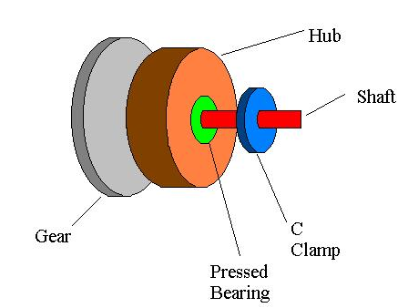
Figure 9: Use of a c-clamp
.
One of the most important components of the current design is the bearing that will allow the rear wheel to rotate. This bearing will need to support one-fourth the weight of the car, at speeds up to 60 miles per hour. The first step in designing the bearing is determining the forces that are acting directly on the bearing. The most important forces acting on the bearing are the applied constant radial force and the applied constant thrust load.
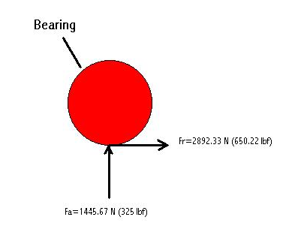
Figure 10: Forces on bearing

The figure above shows the forces acting on the bearing to be designed. Fr is the constant radial force on the bearing and Fa is the applied constant thrust load. The applied constant thrust load is the weight of the car divided by the number of wheels. The constant radial force is obtained by determining a maximum lateral acceleration of one G-force. One G-force of lateral acceleration means that the vehicle will sustain a lateral force equal to the weight of the car. To calculate the constant thrust load that the bearing will be subjected to, we have divided the car’s weight by half and multiplied it by the gravity constant.
There are certain parameters that are important to the design at hand. The most important characteristic of the bearing is to be reliable and safe for the solar car. We have decided to design the bearing to have a life of 500 million revolutions. This will allow the whole design to last a long time and to be reliable while in use.
The following is the procedure used to determine which bearing is suitable for the job. The first step is to determine the minimum properties the bearing needs. The following equation allowed us to determine the dynamic load rating on the bearing.

(1)

Where C is the dynamic loading rating, F is the force the bearing is subjected to in Newtons or lbf, and one is the life of the bearing in millions of revolutions.
The dynamic loading of a bearing is a specific characteristic of each bearing given by the bearing manufacturer. This characteristic ensures that the bearing will be durable and that it will withstand the rigors of the design. With equation one we will be able to calculate the initial dynamic loading using the applied constant radial load as the force. Because all measurements made for the solar car were given in millimeters, all calculations are done in SI units.
Once the dynamic loading of a bearing is obtained we can look through a table of dimensions and load ratings for ball bearings. (See appendix table 1). This will allow us to select a dynamic load rating close to or higher than the one obtained. Once the dynamic loading rating is found it is possible to obtain a static loading rating from table 1.
Manufacturers of bearings give static loading ratings. The Static load rating obtained will allow us to determine if the initial assumption we made about using only the applied constant radial load was correct. In order to use table 2 (see appendix) we must obtain ratios using information we already know. Two important ratios are obtained using the following equations:

(2)

(3)

Where Fa is the applied constant thrust load, Fr is the applied constant radial load and C₀ is the static load rating.
In order to use table two a sequence of operations has to be used. The first is determining the ratio of applied constant thrust load and the static load rating (equation 2). This allowed us to determine a value of “e” which is another specific characteristic of the bearing. Once this value is established we use the relationship given for single row bearings (see table 2) which states that equation 3 has to be greater than the value of “e”.
If this relationship holds true we will be able to obtain a bearing that will suit our needs. With this in mind we are able to determine values of X and Y in table 2 using the single row bearing column and e as the parameter.
Once these values are obtained we use the following formula to determine the actual load in the bearing.

(4)

Where X and Y are values obtained from Table 2, P is the actual force the bearing is subjected to, Fr and Fa are values given at the beginning of the bearing calculations and V is given a value of 1 because of the properties of the bearing.
With the new value of p obtained using equation 4 we have now determined the actual load of the bearing. We will now use this value on equation 1 and replace F by the new value obtained of P.
Using equation 1 we obtain a new value for C. We compare the initial value of C with the new one obtained. The process is repeated until a constant value of C is obtained. Our actual calculations are located in the appendix.
From the calculations done for the bearing the following specifications were obtained. Bearing properties can be seen in figure 11.

Bearing Properties Required
Property | Value
Maximum load on bearing (N) | 5003
Dynamic load rating C (N) | 40700
Static load rating Co (N) | 36000

Figure 11. Properties of bearing obtained from calculations.

From the information obtained for the bearing the next step is to use a bearing catalogue and determine the kind of bearing to be selected. The bearing catalogue used is SKF Interactive Engineering Catalogue. When dealing with combined loading applications the catalogue recommends deep groove bearings, spherical roller bearings, taper roller bearings or angular contact ball bearings. The decision is made to select a spherical roller bearing because of its compact size and specific features.
The main characteristics of spherical roller bearings include the use of two rows of rollers with a common raceway which is insensitive to errors of alignment of the shaft and the capacity to accept radial and axial loads acting on both directions of the bearing. Other important features of the spherical bearing include the capacity to operate at low temperatures and high speeds; high load capacity because of double rollers and good reliability because of low operational temperature.
Once the type of bearing is selected the next step is to find a bearing that is suitable for the design. Browsing through the SKF catalogue the bearing is obtained with its properties listed in figure 12.

Bearing Properties
Property | Value
Inner diameter (mm) | 25
Outer Diameter (mm) | 52
Thickness of bearing (mm) | 18
Dynamic Load Rating (N) | 49000
Static Load Rating (N) | 44000
Mass (Kg) | 0.19
Speed Rating (rpm) | 8500
Fatigue Load Limit | 5600

Figure 12. Properties of bearing model 22205e from SKF Engineering Catalogue.

The bearing selected for the application in hand is a spherical roller bearing model number 22205e from the SKF engineering catalogue. The bearing that is selected from the catalogue exceeds the requirements obtained from the calculation so it is possible for the bearing to exceed the life that was determined for it.

6.0 Material Selection
After all the drawings and dimensions were finalized, consideration was turned to the materials that would be used in the creation of parts that are not off the shelf. These parts include the axle, hub and mockup motor. In the interest of saving both time and money, it was decided that producing all the parts from the same material would be most useful. The bearing and the bolts used in this design are common parts and will be purchased.
The largest concern for the materials used in the design is that of the deflection that will take place in the axle when the car is fully loaded.
Using MS solids allows the analysis of a beam with specific loads. Figure 13 shows the beam that was used represent the fixed axle in the design.

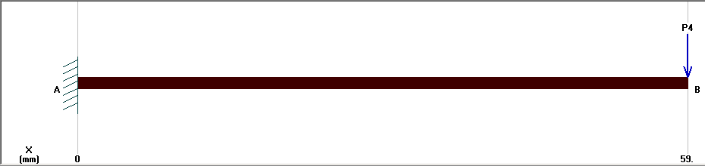
Figure 13. Solid axle used in MS solids to represent the fixed axle in the design.

After MS solids runs, all the properties of the beam are determined. Figures 14 through 16 show shear, moment, and deflection diagrams of the fixed axle after it is subjected to a load of 325 pounds of force.

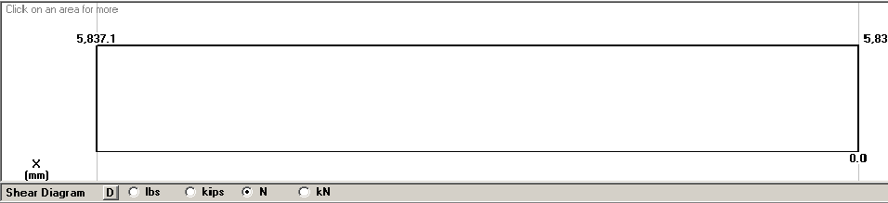
Figure 14. Shear diagram of fixed axle. Shear units in Newton

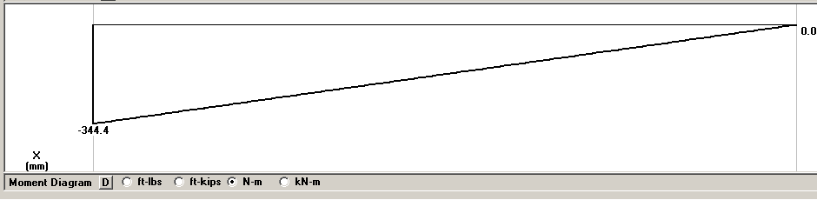
Figure 15. Moment diagram of fixed axle. Moment units are in Newton per meter

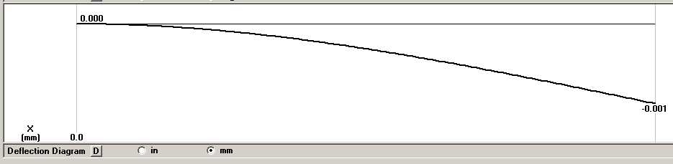

Figure 16. Deflection diagram with fixed axle. Deflection units are in millimeters.

Stainless steel was selected as the material to run MS solids. The program calculates that the deflection in the axial direction at maximum loading will be approximately .001 mm as shown in figure 16. As the deflection is minimal, stainless steel will be an adequate material to support the design.

7.0 Conclusions
After completing the design process of the initial problem given by the customer, the demands of the customer have been meet and the final product, when constructed, will safely perform the objectives. All parts created in this design where done with the safety of the driver in mind. Also the bearing chosen to be used in the rear wheel mount will be durable and effective. The design created represents the actual assembly as requested by the customer: the tire is at approximately the same distance away from the strut, and the mockup motor has a similar weight.

Appendix
Evaluation for the Mockup motor
Concept Screening
Selection criteria | A | B | C
Time of Construction | 1 | 1 | -1
Ease of use on Field | -1 | 0 | 0
Similar properties of original | -1 | 1 | 1
Sum (+) | 1 | 2 | 1
Sum 0 | 0 | 0 | 1
Sum (-) | 2 | 0 | 1
Net Score | -1 | 2 | 0

Evaluation for the axle system
Concept Screening
Selection criteria | A | B | C
Time of Construction | 1 | 1 | -
Ease of use on Field | 1 | 0 | -
Similar properties of original | 1 | 0 | -
 |  |  | -
Sum (+) | 3 | 1
Sum 0 | 0 | 0
Sum (-) | 0 | 0
Net Score | 3 | 1

Evaluation of quick release system
Concept Screening
Selection criteria | A | B | C
Time of Construction | 1 | 1 | -
Ease of use on Field | 0 | 1 | -
Similar properties of original | 1 | 1 | -
 |  |  | -
Sum (+) | 2 | 3
Sum 0 | 0 | 0
Sum (-) | 0 | 0
Net Score | 2 | 3

