I. Introduction

Thank you for choosing Aquatek. For optimum use, performance, and safety, please read this manual carefully.
For further information, please visit our website at http://www.aquatek.com.

II. Table of Contents

I. Introduction 1
- Assembly of system 2
  - Main Tank 2
    - Parts 3
    - Construction 4
  - Main Tank Base 5
    - Parts 5
    - Construction 5
  - Main Tank Sub Base 6
  - Circulation System 7
    - Parts 8
    - Construction 8
  - Water Exchange System 10
    - Parts 10
    - Construction 11
  - Solar Collector 12
    - Parts 12
    - Construction 13
- System Operation 14
- Troubleshooting 15
- System Specifications 16

III. Assembly of System

Tools needed for main tank assembly

1 | Hammer
2 | Phillips Screwdriver
3 | Flathead Screwdriver
4 | PVC pipe cleaner
5 | PVC pipe cement
6 | Hacksaw
7 | Silicon
8 | Drill/ screwdriver

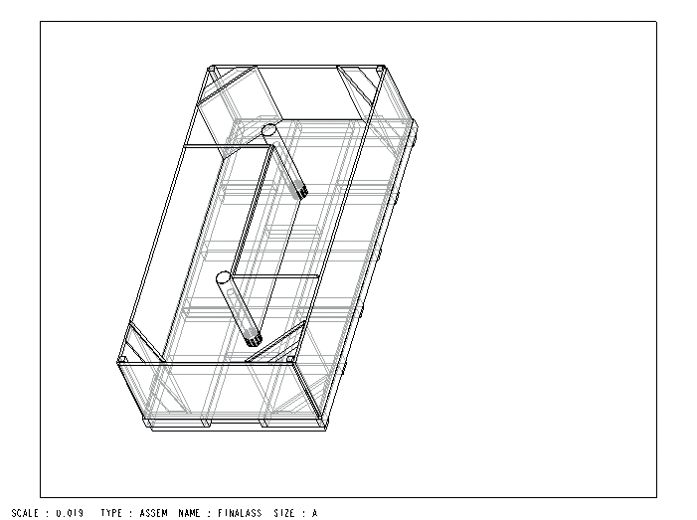

Figure 3A Three-Dimension Drawing of Fully Assembled Main Tank

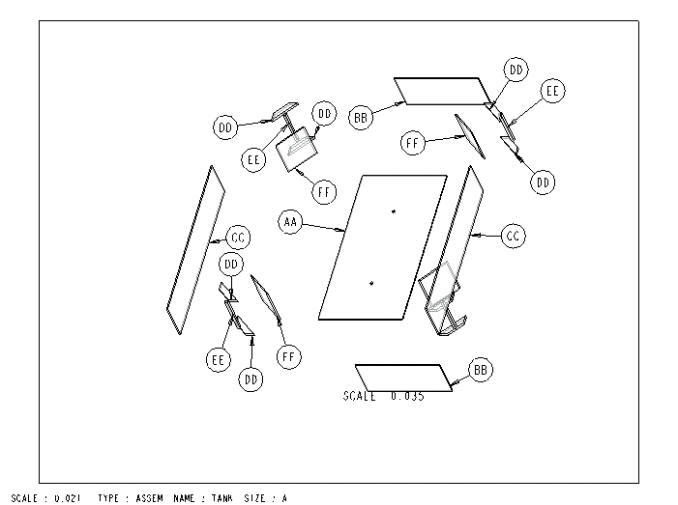

Figure 3B Exploded View of Main Tank

Table 3A List of Parts for Main Tank
Part # | Description | Quantity
AA | Bottom Panel 4’x 8’ (two holes 1.5” diameter) | 1
BB | Side Panel 2’ x 4’ | 2
CC | Front Panel 8’ x 2’ | 2
DD | Corner Braces 2” x 4” x 15” w/ 45degree cuts | 8
EE | Corner supports 2” x 2” x 24” | 4
FF | Corner walls ¾” x 15” x 24” | 4
GG | 1 ½” power wood screws | 50

Instructions for Construction

CAUTION – Parts must be aligned and flush to each other to prevent future leakage problems.

- Attach BB to EE with screws, make sure flush with edge. Do this for each side of panel leaving ¾” edge at bottom of panel.
- Stand one of BB up with ¾” edge on bottom, next set panel CC perpendicular to this making sure edges are flush to each other and attach. Repeat until all sides are attached and standing.
- Take braces DD, place at top of each corner flush with edge of panel as seen in figure 3A, and attach. Repeat until all four corners are complete.
- Next with assistance, place floor on level surface, pick side structure up and set onto floor. All edges should wrap around floor. Then attach sides to floor about 3/8” up from bottom. Do this around entire structure.
- Take 4 remaining DD braces and set in each corner flush with walls and attach.
- Place corner walls FF in each corner making sure flush with edges and attach.
- Using two or more people, place entire structure onto base support and attach.
- Using two or more people, place entire structure on extra base support. Do not attach.
- Seal all inside edges with a generous amount of silicon.

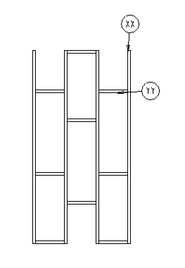

Figure 3C Base Support of Main Tank

Table 3B list of Parts for Base Support
Part # | Description | Quantity
YY | 2” x 4” x 15” Pressure Treated | 9
XX | 2” x 4” x 96” Pressure Treated | 4
ZZ | 2 ½” power screws | 36

The base support is the easiest part to assemble.
Important note – YY pieces must be 40 inches apart to prevent complications with drain system.

- Take part XX, and mark, using pencil, 40” intervals on three of the four pieces from only one end.
- Attach parts YY using wood screw at marks making sure part XX is opposite each other to allow full coverage of floor for support.

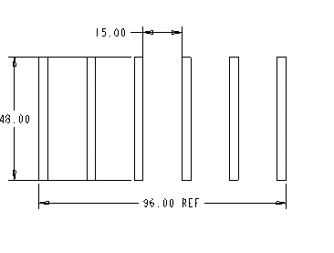

Figure 3D Main Tank Sub-Base

The sub-base structure is composed of 4” x 4” which should be 4 feet in length and placed 15” apart. The extra base is used to raise the tank for the pipes to fit underneath.

Circulation System

ATTENTION: ALL FITTINGS MUST BE CLEAN CUT, CLEANED, DRYED, AND EVENLY GLUED.

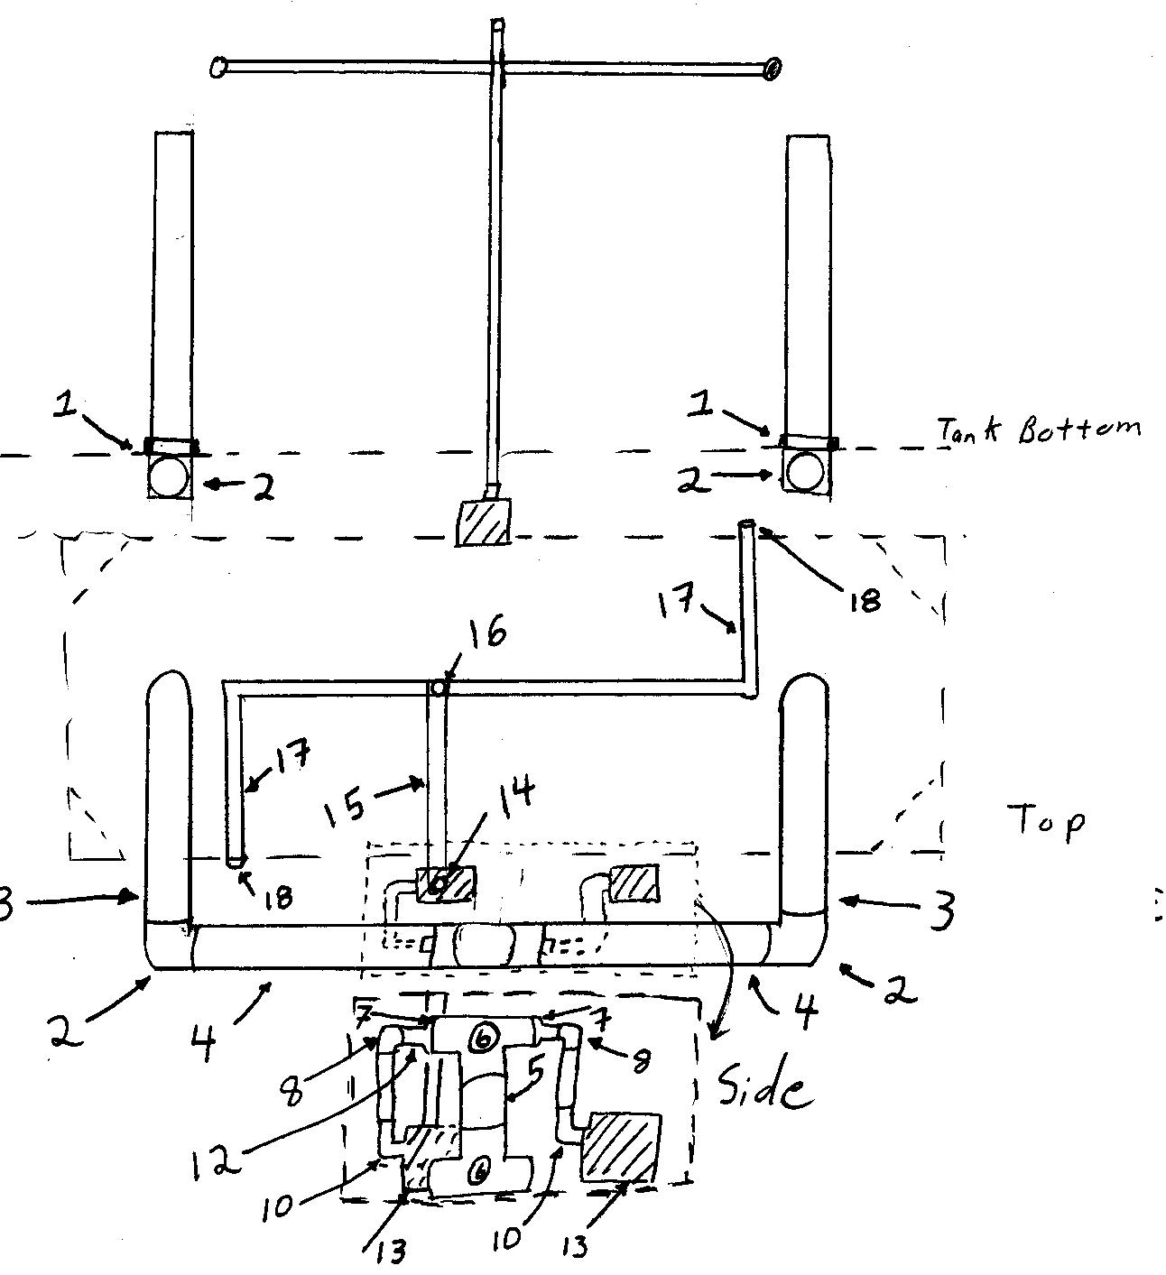

Table 3D List of Parts for Circulation System
Part # | Description | Quantity
1 | 1 ½” Drain Fitting with Rubber gaskets | 2
2 | 1 ½” 90⁰ PVC elbow fitting | 4
3 | 3’ section of 1 ½” PVC pipe | 2
4 | 2’ section of 1 ½” PVC pipe | 2
5 | 6” section of 1 ½” PVC pipe | 1
6 | 1 ½” PVC tee fitting | 2
7 | 1 ½” to ¾” PVC reducer fitting | 2
8 | ¾” 90⁰ PVC elbow fitting | 5
9 | ¾” to 1” PVC bushing | 2
10 | 1” rubber flex elbow | 2
11 | 1” hose clamps | 4
12 | 2” section of ¾” PVC pipe | 2
13 | Pumps (max. flow 10 GPM; max head 11 ft.) | 2
14 | 1 to ¾” pipe adapter | 2
15 | 2’ section of ¾” PVC | 4
16 | ¾” PVC tee fitting | 1
17 | Spray jets ( 2’ ¾” pvc with 9-- 1/8” holes two inches apart) | 2
18 | ¾” PVC cap fitting | 2
Note: All PVC parts are schedule 40 or greater (pressure rated)

Instructions
- Screw in drain fittings placing rubber gaskets on inside of tank.
- Take 2 of part 2 and part 3. Connect; making sure that one elbow is facing upward and one to the right. Repeat procedure except face this one to left.
- Attach to fitting, making sure that pipes are parallel to each other and parallel to side panels.
- Connect part 2s to each side of a part 6.
- Connect this section between the two elbows making sure the open part of the T is facing upward.
- Take remaining part 6 and insert part 7 into each side, then place part 12s into these two openings. Next place elbows onto these part at a 45 degree from opening of T.
- Take this and place unto pipe from first section.
- Insert remaining part 12s into two remaining openings.
- Connect flex hose with clamps to pipes and pumps.
- Connect adapter to pump followed by part 15.
- Separately, place caps on one end of each spray jet (part 17 ). Next attach elbow (part 8) to free end of spray jet. MAKE SURE THAT THE HOLES ON THE SPRAYJET ARE LINED UP PARALLEL TO ELBOW OPENING. Then attach part 15 to elbow for both jets.
- Connect these two pieces with a part 16, making sure these holes are facing each other, but on opposite sides of the T.
- Attach a 5” section of pipe to the T and then an elbow on to this.
- Connect the last remaining part 15 to the last elbow and complete the connection of the spray jet to the pipe from the pump.
- This section is now complete.

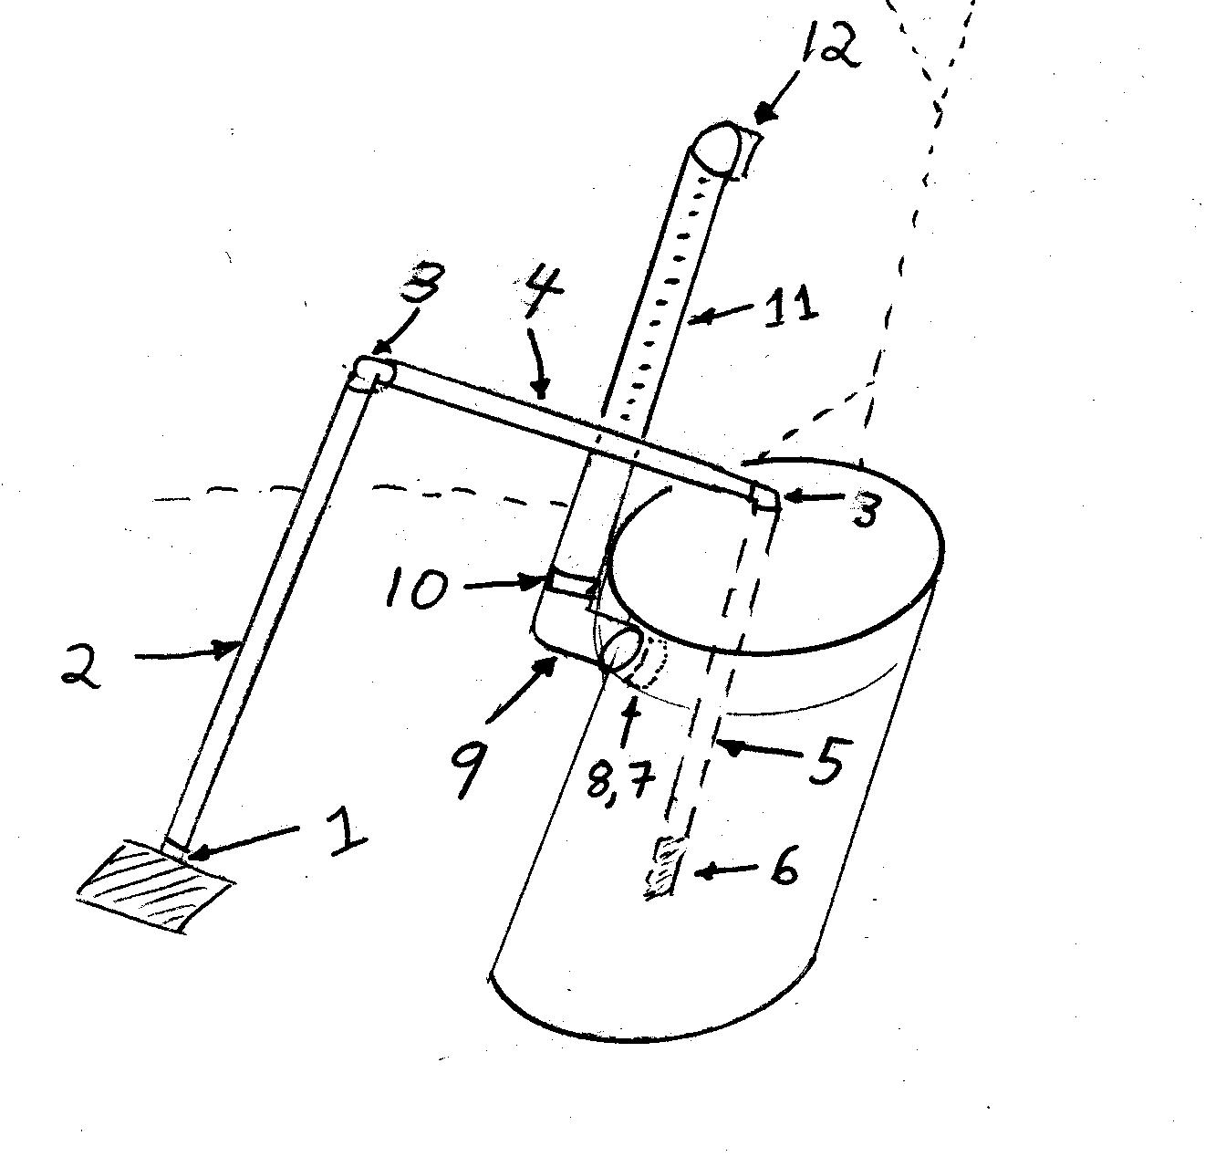

Table 3E List of Parts for Water Exchange System
Part # | Description | Quantity
1 | ¾” NPT to PVC pipe adapter | 2
2 | 3’ section of ¾” PVC pipe | 1
3 | ¾” 90⁰ PVC elbow fitting | 4
4 | 2 ½’ section of ¾” PVC pipe | 1
5 | 2’ section of PVC pipe | 1
6 | ¾” check valve | 1
7 | 2” PVC coupler | 1
8 | 2” section of 2” PVC pipe | 1
9 | 2” 90⁰ PVC elbow fitting | 1
10 | 2” to 1 ½” PVC reducer | 1
11 | 3’ section of 2” PVC with last two feet containing 20 ¼” holes | 1
12 | 1 ½” 90⁰ PVC elbow fitting | 1

Note: All PVC parts are schedule 40 or greater

Instructions

- Screw pipe adapter into pump.
- Connect part 2 to part 1.
- Connect part 3 to both ends of part 4 facing the same direction.
- Attach part 5 to remaining part 1 then screw on part 6.
- Connect this to one side of step 3.
- Place the check valve part into reservoir tank and connect to part 2.
- Connect part 7 to Part 8. Put part 8’s free end through hole in side of reservoir tank.
- Connect part 9 to end sticking out of hole. Then connect part 10 to open end.
- Attach part 11 to part 12 with part 12 being at the end where the holes go to the end of the pipe.
- Connect the straight end to the elbow from the reservoir tank.
- This completes this section.

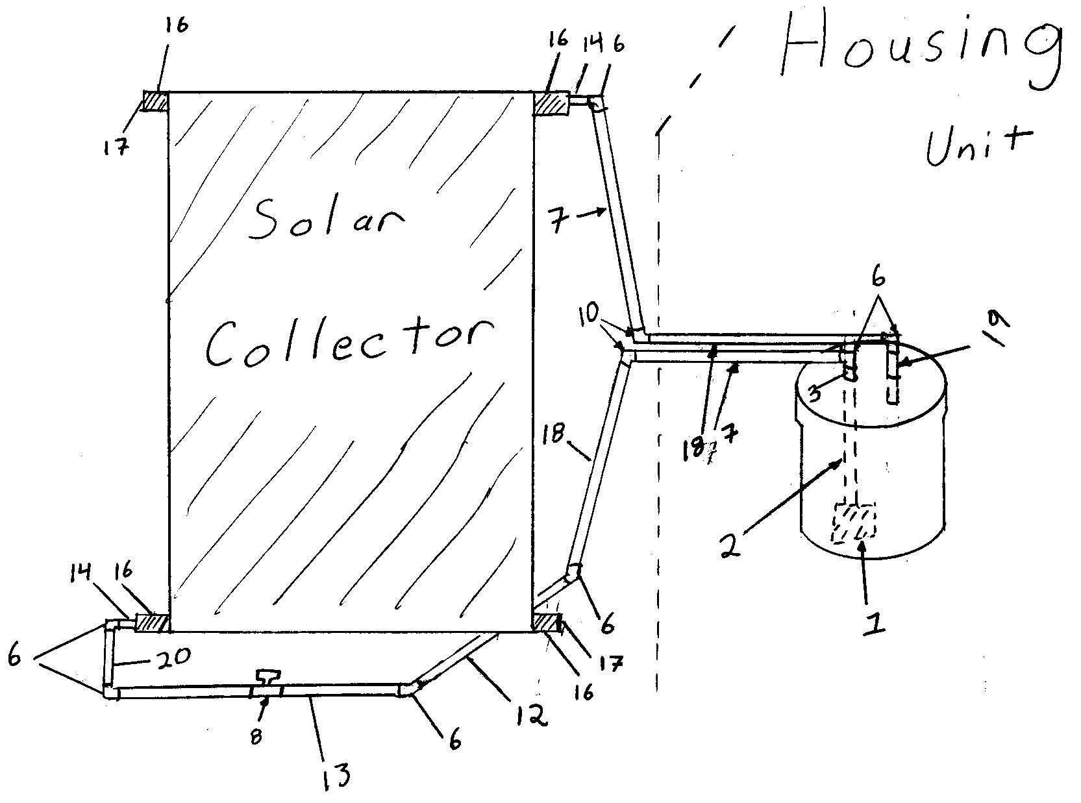

Table 3F List of Parts for Solar Heater
Part # | Description | Quantity
1 | Pump (max. flow 10 GPM; max head 11 ft.) | 1
2 | 3’ section of ¾” flex hose | 1
3 | ¾” NPT thread to barb | 1
4 | 1” hose clamps | 2
5 | 1’ section of ¾” PVC pipe | 1
6 | ¾” 90⁰ PVC elbow fitting | 9
7 | 5’ section of ¾” PVC pipe | 1
8 | ¾” PVC valve | 3
9 | 3’ section of ¾” PVC pipe | 1
10 | 45⁰ PVC elbow fitting | 2
11 | 1 ½’ section of ¾” PVC pipe | 2
12 | 8’ section of ¾” PVC pipe | 1
13 | 6’ section of ¾” PVC pipe | 2
14 | ¾” to 2” PVC bushing | 2
15 | 2” flex pipe coupler | 4

16 | 2” coupler | 4
17 | 2” caps | 2
18 | 4 ½’ section of ¾” PVC pipe | 3
19 | 3” section of ¾” PVC pipe | 2
20 | 6” section of ¾” PVC pipe | 1
21 | 44 gallon heavy duty trash can with lid | 1
22 | Heavy Duty electrical power strip | 1

Instructions

- Connect pump to part 2 with a hose clamp and part 3.
- Place in reservoir tank and attach elbow (part 6) to free end.
- Connect part 7 to elbow followed by a part 10 followed by part 11.
- Connect an elbow to the free end aiming downward, followed by part 18.
- Connect an elbow facing the front of the solar collect and then connect part 12.
- Connect an elbow to free end, followed by part 13, followed by an elbow facing upward.
- Now get collector ready. Place part 15 on each corner of collector followed by part 16. Then on top left corner and bottom right corner place caps. The two remaining corners place part 14, bushings. This sets up the collector.
- Connect part 3 to bushings on each corner of collector followed by elbows facing down.
- On bottom part connect collector to pipe from tank with part 20.
- From the top of collector attach part 18. Follow it with an elbow that faces the housing unit, parallel to the pipe from tank.
- Continue to follow lead pipe with remaining part 11, part 10, and part 18.
- This should put the pipe above the reservoir tank. Next attach the remaining elbow and part 19.
- This section is now complete.
IV. System Operation

- After system has been properly set up, be sure all valves are in the open position.
- Be sure tank and reservoir are full of water.
- Turn on the main tank circulation pump (pump A).
Note: Pump A should be running continuously for filtration and aeration of system.
- Turn on the pump inside the reservoir (pump C) to begin heating the water in the reservoir.
- When the temperature of the water in the pipe going to the reservoir, is less than the temperature of the water in the pipe leaving the reservoir, turn off pump C. Likewise, When the temperature of the water in the pipe going out of the reservoir, is less than to the temperature of the water in the pipe going to the reservoir, turn on pump C.
- When the temperature in the tank falls below the optimum temperature of 82°F and the temperature in the reservoir is above 82°F, then pump B should be turned on to heat the tank when needed. Note: This will not work until the reservoir tank temperature is elevated to at least 85°F.
- After the optimum tank temperature is reached then pump B should be turned off.
If you experience any problems that were not addressed by this manual, please visit our website at http://www.aquatek.com for further information and customer support.

V. Troubleshooting

Problem | Possible cause | Solution
Pump does not work, or water flow is insufficient | Pump is not receiving power | - Inspect electrical wiring and connectors  - Reset GFCI outlet  WARNING: If electrical malfunction is suspected, be sure to turn off main circuit breaker before touching any electrical components.
 | Water line is blocked | Remove obstruction
 | Too much air in pump line | Turn pump off for 5 seconds then restart. Repeat until pump water flow resumes.
 | Water level below top of intake pipe | Add water to system until main tank water level is at least ½ inch above water intake pipe
 | Pump has been run dry (with no water flowing through it) for extended period of time | Replace pump or impeller assembly.  Contact pump manufacturer.

Troubleshooting (continued)
Solar collector is not heating water | Collector not receiving enough sunlight | Reposition solar collector so that it receives optimal sunlight
 | Solar collector veins obstructed | Remove all end caps from solar collector and flush internally with water from the top down.
 | Insufficient water flow to/from solar collector | See “pump does not work” section above.
Insufficient main tank circulation speed or insufficient water aeration | Water jets in aerators obstructed | Disconnect aeration pipes and flush with water.
 | Insufficient water flow to aeration pipes | See “pump does not work” section above.
 | Large obstruction in main tank | Check and remove any large obstructions from main tank

VI. System Specifications

Parameter | Requirement
Minimum Tank Velocity | 0.12 ft./sec.
Tank Water Depth | 18-24 inches
Shrimp Density | 100-150 shrimp/m^2
System Turnover Rate | >= 1 turnover/hour
Tank Dimensions | 4ft. X 8ft. X 20in.
Tank Water Temperature | 82-85 degrees F
Pump size | 660 GPM (11ft. max. head)
Reservoir Capacity | 44 gallons
Tank Capacity | 350 gallons
Solar Collector Weight | 54 lbs.
Solar Collector Capacity | 3.5 gallons
Solar Collector Dimensions | 4 ft. X 12 ft.
Solar Collector Flow Rate | 3-5 gpm

