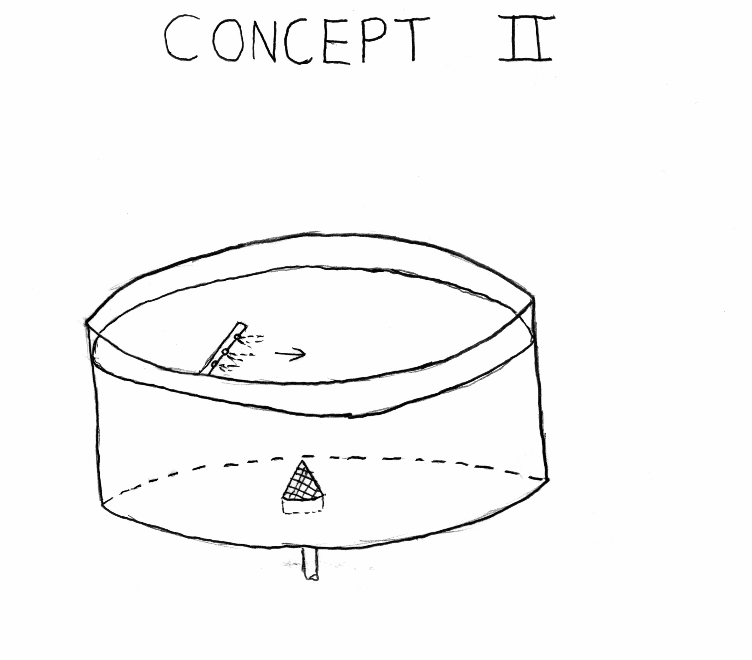

Figure B6 Concept Developed from Morphological (not used)

