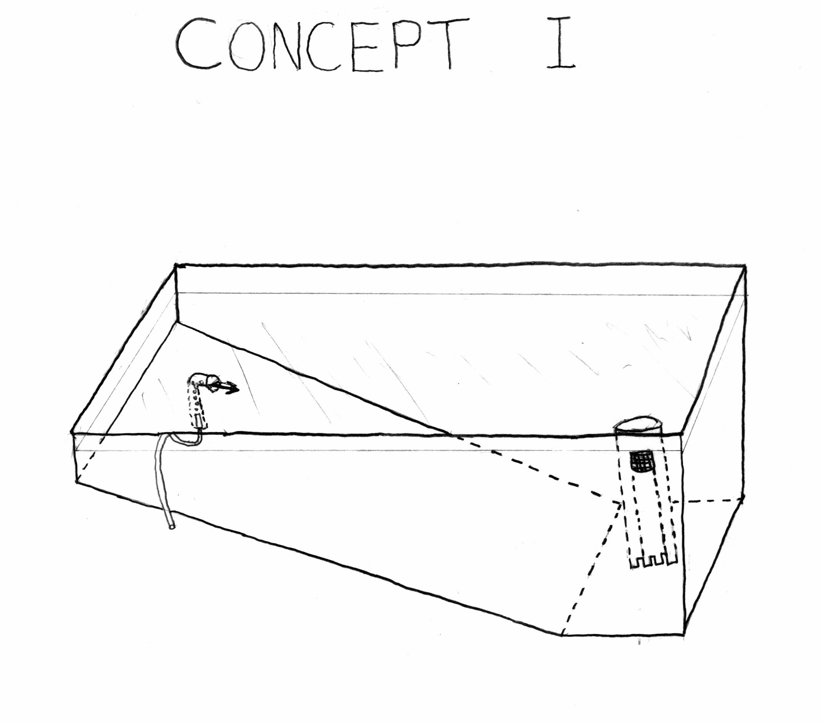

Figure B5 Concept Developed from Morphological Chart (not used)

